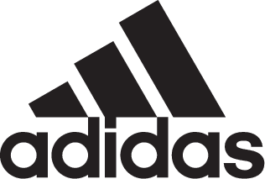

ADIDAS SOCCER REVEALS ENERGY MODE NEMEZIZ 18+ 360 AGILITY

- Nemeziz 18+ 360 Agility arrives in new electric orange colorway -
- To be worn on field for the first time at the 2018 FIFA World Cup Russia -
- Available in Stadium, Cage and Street versions -

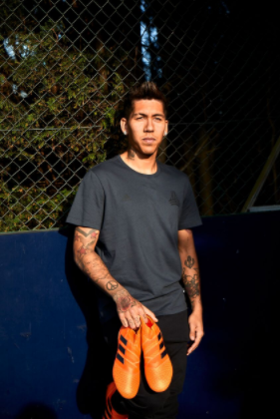

Portland, Ore., May 28, 2018 – adidas Soccer has today released the Energy Mode Nemeziz 18+ 360 Agility, part of the new Energy Mode pack. Coming in a new electric orange colorway the cleat will be worn on field by some of adidas’ biggest players at this summer’s FIFA World Cup.

The Energy Mode Nemeziz 18+ 360 Agility is available from today at adidas.com and adidas retail stores.

Designed to enhance the performance of the game’s most agile players, the latest Nemeziz colorway includes an Agilitybandage with Torsiontapes technology, providing ultimate lockdown of the foot. A dual-lock collar secures the ankle and allows for explosive change of direction while an Agilityknit 2.0 interlocking yarn structure provides a soft direct touch and a lightweight feel.

Players who will be premiering the latest Nemeziz colorway this summer are Roberto Firmino, Jesse Lingard and Julian Draxler.

Energy Mode Nemeziz 18+ 360 Agility is also available in Cage and Street versions. Featuring the same electric orange coloring as the on-field cleat, both shoes include the same performance technology.

For more information visit http://www.adidas.com/us/soccer and join the conversation on Twitter​ and Instagram​ with #HereToCreate.

- END -

For further media information please visit http://news.adidas.com/US/home/SOCCER or contact:

Cristina Maillo Belda
PR Manager, adidas Soccer
Email: Cristina.maillobelda@external.adidas.com
Tel: 503.915.9129

About adidas Soccer
adidas is the global leader in soccer. It is the official sponsor / official supplier partner of the most important soccer tournaments in the world, such as the FIFA World Cup™, the FIFA Confederations Cup, the UEFA Champions League, the UEFA Europa League, the UEFA European Championships and Major League Soccer. adidas also sponsors some of the world’s top clubs including Manchester United, Real Madrid, FC Bayern Munich, Juventus and AC Milan. Some of the world’s best players also on the adidas roster are Leo Messi, Paul Pogba, Gareth Bale, Karim Benzema, Roberto Firmino, Thomas Müller, Luis Suárez, James Rodríguez, Diego Costa, Mesut Özil, Renato Sanches and Julian Draxler.

