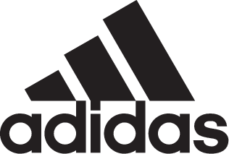

ADIDAS SOCCER LAUNCHES NEW ENERGY MODE X18+

- New X18+ available as part of the Energy Mode pack in stadium, cage and street versions -
- New design features a lightweight and minimal construction with new product innovations designed to maximize speed -
- Cleat to be worn on-field during the 2018 FIFA World Cup Russia by the likes of Gabriel Jesus, Mo Salah and Luis Suarez -

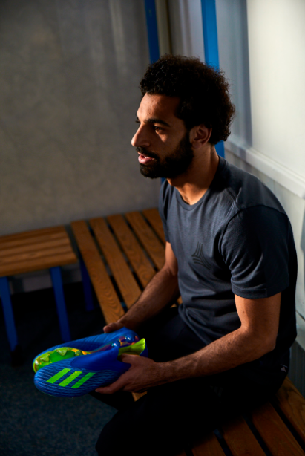

Portland, Ore., May 24, 2018 – adidas Soccer has today launched the all-new X18+, a cleat designed to unleash the speed of the game’s most dangerous players. Released as part of the Energy Mode pack - alongside Predator, Nemeziz and Copa silos – the cleat takes inspiration from previous adidas models while being brought up to date through modern tooling and innovation.

The Energy Mode X18+ cleat will be available to purchase from adidas.com and selected retailers starting today.

The cleat is designed with new innovations to provide stability and support at high speed. A laceless upper locks-down the mid-foot, crucial when accelerating and during high speed moments. It also ensures minimal interference between the foot and ball. A new low-cut claw collar construction features a new stretch material that secures the foot in place and provides increased stability and support.

An updated speedframe outsole features lightweight, drillium engineered tooling and minimalistic construction to offer extreme traction during rapid acceleration. A 3D molded heel provides a snug and stable fit, designed to lock the foot in place during acceleration.

Innovative materials ensure complete control even at high-speed. The skeletal weave is compiled of an ultra-thin woven grid of optically charged speed yarns to allow for responsive touch and lightweight feel. The new, ultra-soft speedmesh offers a controlled touch without restricting the movement of the foot.

The Energy Mode X18+ is also available as a cage and street shoes. The cage version features the same coloring and claw collar construction and laceless upper as the on-field cleat; along with a full length BOOST™ midsole and traction studs.

Sam Handy, adidas Vice-President of Design said: “The World Cup is the pinnacle of any player’s career. The challenge for us as designers is producing a boot which highlights the natural talents of these incredible athletes on the world’s biggest sporting stage. With the new Energy Mode X18+ we have produced something that is really lightweight and minimalist in its design, which removes the barriers between foot and ball while still achieving the elite touch and support at high speed required by the game’s most explosive players. As we continue to innovate in footwear design, we believe this product opens up new potential for players and I can’t wait to see them in action in Russia.”

The Energy Mode X18+ will be worn on field by some of the game’s biggest players at the FIFA World Cup Russia and can be seen for the first time at the UEFA Champions League Final on Saturday, May 26.

For more information visit http://www.adidas.com/us/soccer and join the conversation on Twitter​ and Instagram​ with #HereToCreate.

- END -

For further media information please visit http://news.adidas.com/US/home/SOCCER or contact:

Cristina Maillo Belda
PR Manager, adidas Soccer
Email: Cristina.maillobelda@external.adidas.com
Tel: 503.915.9129

About adidas Soccer
adidas is the global leader in soccer. It is the official sponsor / official supplier partner of the most important soccer tournaments in the world, such as the FIFA World Cup™, the FIFA Confederations Cup, the UEFA Champions League, the UEFA Europa League, the UEFA European Championships and Major League Soccer. adidas also sponsors some of the world’s top clubs including Manchester United, Real Madrid, FC Bayern Munich, Juventus and AC Milan. Some of the world’s best players also on the adidas roster are Leo Messi, Paul Pogba, Gareth Bale, Karim Benzema, Roberto Firmino, Thomas Müller, Luis Suárez, James Rodríguez, Diego Costa, Mesut Özil, Renato Sanches and Julian Draxler.

