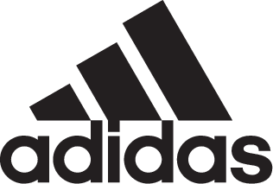

ADIDAS SOCCER UNVEILS NEW DEADLY STRIKE COLLECTION

- Deadly Strike collection includes updated colorways for Predator, Nemeziz, X and Copa franchises -
- Predator 18+ and Nemeziz 17+ Agility available in Stadium, Court and Street versions –
- Copa 18 and X17+ 360 Speed available in Stadium and Court models -

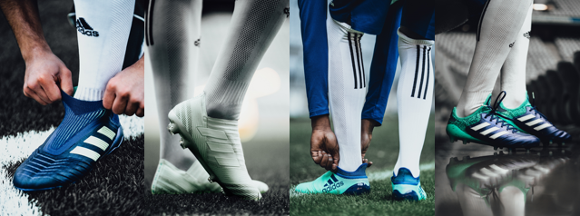

Portland, Ore., March 28, 2017 – adidas Soccer has today launched the new Deadly Strike collection, which features updated colorways of the Predator 18+, Copa 18, Nemeziz 17+ 360 Agility and the X17+ 360 Speed franchises.

All four franchises are available for purchase in their cleated versions from today at adidas.com. All Court and Street silos will be available starting April 4.

PREDATOR 18+
The Deadly Strike Predator 18+ Stadium boot offers:
- A mint green and blue colorway to be worn on-field by the likes of Dele Alli, Mesut Ozil, Paul Pogba and LAFC midfielder Benny Feilhaber starting this weekend
- A purecut laceless system to deliver maximum surface control
- A forged knit integrated midfoot structure and a controlframe designed to create medial and lateral stability
- A new hybrid stud tip configuration that amplifies rotation and traction, and a full-length boost™ midsole to provide energy return with every step
- A red Primeknit sockfit collar featuring a layer of controlskin and an anatomical upper

The updated Predator 18+ Court shoe features:
- The same sockfit collar construction, purecut laceless upper and controlskin as the on-field boot
- A full-length BOOST™ midsole and traction studs

The new Predator 18+ is also available in a lifestyle shoe for soccer players to take their game from the stadium to the street.

NEMEZIZ 17+ 360 AGILITY
The Deadly Strike Nemeziz 17+ 360 Agility Stadium boot features:
- A mint green colorway to be worn by the game’s most agile players including Jesse Lingard, Roberto Firmino and U.S. Men’s National Team and Atlanta United nifty midfielder Darlington Nagbe
- An agilitybandage with torsiontapes technology to deliver the perfect fit
- A torsionframe outsole with torsionribs to provide dynamic push off support
- The new agilityknit 2.0 interlocking yard structure to provide a soft touch, and a lightweight, adaptable feel

The new Nemeziz Court and Street silos offer the same green mint coloring as the on-field cleat, and include the same performance technology.

X17+ 360 SPEED
The Deadly Strike X17+ 360 Speed Stadium boot includes:
- A bold white colorway with a red graphic design to be worn on-field by some of the game’s supreme finishers including Luis Suárez, Gabriel Jesus, and Mo Salah. In Major League Soccer, New York City FC’s striker David Villa, who recorded his 100 MLS appearance on March 11 vs. LA Galaxy, and Norway’s international and LA Galaxy goal-scorer Ola Kamara will also be wearing the Deadly Strike X17 boots
- A non stop grip (NSG) finish, providing unrivalled levels of control
- A purecut sock system, with laces hidden under an upper layer
- A sprintframe outsole to create stability when changing direction at high speed

The Deadly Strike X17+ Court shoe includes the same features as the stadium boot, plus a gum finish used on the outsole.

COPA 18
The Deadly Strike Copa 18 Stadium silhouette features:
- A bold blue and mint colorway
- An all-new leather embossed vamp and an innovative sock construction system
- A classic premium K-leather, and an internal X-ray vamp cage to bring the foot closer to the ball to reduce slippage
- A compression fold-over tongue, a comfort internal construction and a new ortholite sockliner offering an enhance cushioning experience

The new Copa 18 Court silo offers the same blue and mint green colorway and performance technology as the on-field cleat.

For more information visit http://www.adidas.com/us/soccer and join the conversation on Twitter​ and Instagram​ with #HereToCreate.

- END -

For further media information please visit http://news.adidas.com/US/home/SOCCER or contact:

Cristina Maillo Belda
PR Manager, adidas Soccer
Email: Cristina.maillobelda@external.adidas.com
Tel: 503.915.9129

About adidas Soccer
adidas is the global leader in soccer. It is the official sponsor / official supplier partner of the most important soccer tournaments in the world, such as the FIFA World Cup™, the FIFA Confederations Cup, the UEFA Champions League, the UEFA Europa League, the UEFA European Championships and Major League Soccer. adidas also sponsors some of the world’s top clubs including Manchester United, Real Madrid, FC Bayern Munich, Juventus and AC Milan. Some of the world’s best players also on the adidas roster are Leo Messi, Paul Pogba, Gareth Bale, Karim Benzema, Roberto Firmino, Thomas Müller, Luis Suárez, James Rodríguez, Diego Costa, Mesut Özil, Renato Sanches and Julian Draxler.

