EMBARGOED UNTIL 20 MARCH, 10am CET
Download high-res imagery of:
Argentina
Belgium
Colombia
Germany
Japan
Mexico
Russia
Spain
Sweden here

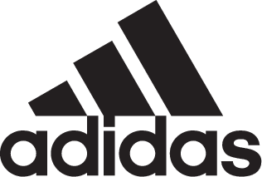

ADIDAS SOCCER REVEALS NEW FEDERATION AWAY KITS FOR 2018 FIFA WORLD CUP RUSSIATM

- Away kits of Argentina, Belgium, Colombia, Germany, Japan, Mexico, Russia, Spain and Sweden all revealed -
- New kits feature bold designs that combine references to famous kits of the past or iconic landmarks with the latest adidas performance technology -

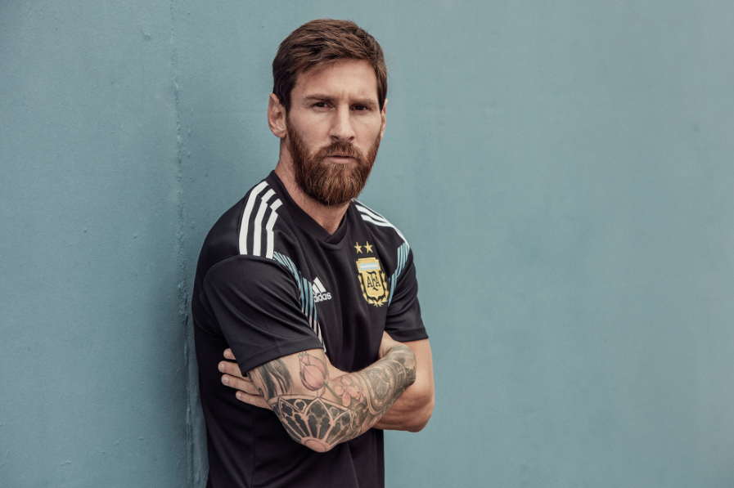

Portland, Ore., March 20, 2018 – adidas Soccer today revealed the away jerseys that will be worn by adidas federations as they seek to win the ultimate prize in soccer at the 2018 FIFA World Cup RussiaTM. With the adidas Soccer mantra of authenticity to progression at the heart of each design, the kits have been inspired by jerseys of the past or iconic landmarks, while also featuring the latest adidas product innovations.

The away kit for the current FIFA World Cup holders Germany is a modern interpretation of the famous green 1990 World Cup away jersey worn in the semi-final vs. England. The graphic on the front takes inspiration from the pattern on the Germany home kit while a new collar execution with a two-fabric component construction incorporates the shirt’s graphic, along with the official "DIE MANNSCHAFT" wording on the back.

Host nation Russia’s away kit is a celebration of the country’s street soccer scene and is a combination of two key elements. The white jersey features a unique grey graphic depicting an abstract vision of Russian architecture and pays homage to the architectural landmarks and industrial cities of the country.

The Argentina away kit will see the team take to the pitch in black for the first time in the AFA’s history. The jersey is a reinterpretation of previous adidas Argentina away jerseys, brought up to date with the inclusion of a bold and progressive graphic inspired by the colors of the nation’s flag.

The Spain away shirt features a new and unique color combination. The light blue kit includes subtle shades of blue in a graphic inspired by the pattern seen on adidas jerseys of the late 1980’s alongside, sleeve cuffs and three stripes in bright red. The kit features a two-colored crest to complete a fresh new color concept.

Juergen Rank, Senior Design Director said, “For adidas, the World Cup has always been the stage to showcase some of our most iconic products, innovations and designs. Many of these classic designs remain hugely popular with fans, and we want to continue to celebrate them while introducing new innovations, combining authenticity with progression.

“The new official World Cup away kits feature both the latest product technologies to ensure peak performance on the pitch and easily identifiable classic looks, making them perfectly suited to both the stadium and the street.”

Colombia’s striking blue away jersey features a bold graphic inspired by traditional scarf patterns worn by Colombians for special occasions. It includes bright orange accents in the form of the three stripes, adidas logo and trimming on the collar. A sign-off on the collar with the team’s slogan, “Unidos Por Un Pais” - translating to “United as one Nation” - completes the jersey.

The Japan shirt takes inspiration from the nation’s streetwear scene and is the perfect transition from the stadium to the street for fans of the JFA. A modern interpretation of the 1991 home jersey, the kit features a bold graphic and a sign-off on the collar which celebrates important moments of the nation’s soccer history.

The away jersey for Mexico is a simple and sleek design. It takes inspiration from the nation’s flag colors, with a bold red and green stripe running across the chest. A sign-off on the collar features the slogan “Soy Mexico”, translating to “I Am Mexico”.

In contrast, the Sweden away jersey is a progressive shirt oozing with style through the rich detailing within the fabric. The jersey features a graphic design with light and dark shades of navy blue, alongside yellow trimmings seen on the collar and adidas three stripes.

Belgium’s away kit is a true representation of the country’s flag colors. The bold yellow jersey features subtle horizontal lines alongside red and black accents seen on the collar and the adidas three stripes.

The away jerseys are available for purchase starting today at http://www.adidas.com/us/soccer.

For more information visit http://www.adidas.com/us/soccer and join the conversation on Twitter​ and Instagram​ with #HereToCreate.

- END -

For further media information please visit http://news.adidas.com/US/home/SOCCER or contact:

Cristina Maillo Belda
PR Manager, adidas Soccer
Email: Cristina.maillobelda@external.adidas.com
Tel: 503.915.9129

About adidas Soccer
adidas is the global leader in soccer. It is the official sponsor / official supplier partner of the most important soccer tournaments in the world, such as the FIFA World Cup™, the FIFA Confederations Cup, the UEFA Champions League, the UEFA Europa League, the UEFA European Championships and Major League Soccer. adidas also sponsors some of the world’s top clubs including Manchester United, Real Madrid, FC Bayern Munich, Juventus and AC Milan. Some of the world’s best players also on the adidas roster are Leo Messi, Paul Pogba, Gareth Bale, Karim Benzema, Roberto Firmino, Thomas Müller, Luis Suárez, James Rodríguez, Diego Costa, Mesut Özil, Renato Sanches and Julian Draxler.

