adidas Introduces AMPHI for the Versatile Female Athlete

– First Class Active Wear for Those Taking Their Training to the Beach or Water -
– Tops And Bottoms Available As Separates, Allowing A Mix And Match Look –
– Available from 1st April 2018–

Herzogenaurach, 1st April 2018 — Continuing to innovate and create, adidas introduces a brand first in AMPHI, a versatile swim collection for spring/summer 2018, designed for the modern female athlete adopting a versatile training programme, whether at, on or in the water.

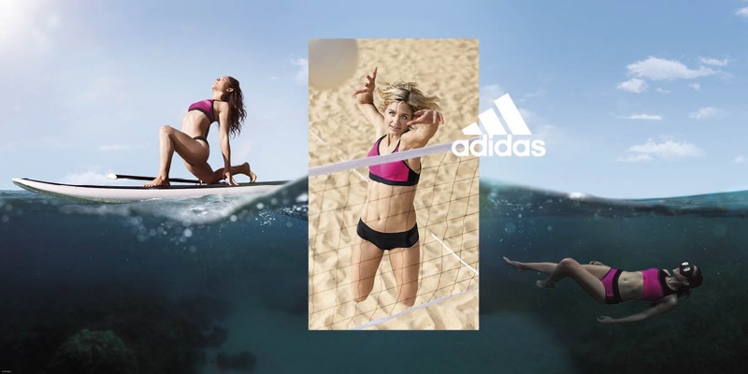

With aqua fitness trends on the rise, adidas has created a swim apparel collection catering for female athletes with an appetite for training and performing. Whether passionate about performance sports, such as beach volleyball or swimming, or strength and conditioning, such as pilates or yoga, AMPHI is for all.

The new collection brings out the best in versatile female athletes, allowing them to push and exceed their limits. Thanks to three different levels of support across the collection’s tops and bottoms, women can excel in their chosen training regime, no matter the intensity. The three different top designs each feature a power mesh, inner bust support and integrated padding to ensure every female can perform at their best. Each top can be mixed and matched with any of the collection’s three bottom designs, showcasing bold pinks and blacks throughout, allowing athletes to create their own style whilst performing.

As workout regimes evolve and training programmes modify, striving for success never changes for the modern female. Adjusting to change, AMPHI’s breathable and supportive tops and bottoms fit like a second skin, allowing athletes to adapt at every turn, connect to their movements and thrive within their chosen activity, whenever, and wherever, they wish.

Bettina Weiss, adidas Senior Designer said, “We created AMPHI to offer hybrid, stylish and high performing pieces for females who regularly connect with water through their versatile lifestyles. The AMPHI mix and match concept with three levels of support, not only allows females to find their perfect fit, but also gives the opportunity for unique styles to be worn in, on and at the water.”

In addition to style and optimum support, the AMPHI collection is made out of Econyl®, recycled yarn. The fabric is chlorine resistant and has been created with a UPF 50 rating, limiting the UV radiation falling on the surface of the garment, making it a durable product in, on and at the water.

In 2018, adidas continues to strive to be the most sustainable swimwear brand and beyond. The SS18 adidas AMPHI range will be available online from 1st April 2018 on adidas.com/swimming and in adidas retail stores worldwide.

-ENDS-

Emma Falconer Hall – Hill + Knowlton Strategies
Email: emma.falconerhall@hkstrategies.com
Tel: +44 (0) 2074133063

