Download high-res imagery for X17+ 360 SPEED here

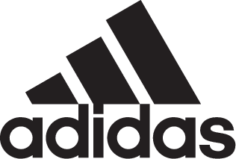

adidas Soccer Unveils New Cold Blooded X17+ 360 SPEED

- Latest adidas Soccer release comes in striking white and red colorway -
- Cold Blooded X17+ 360 SPEED to be worn by the game’s most lethal players -
- Key features include PURECUT SOCK SYSTEM, NON STOP GRIP (NSG) and a SPRINTFRAME outsole -

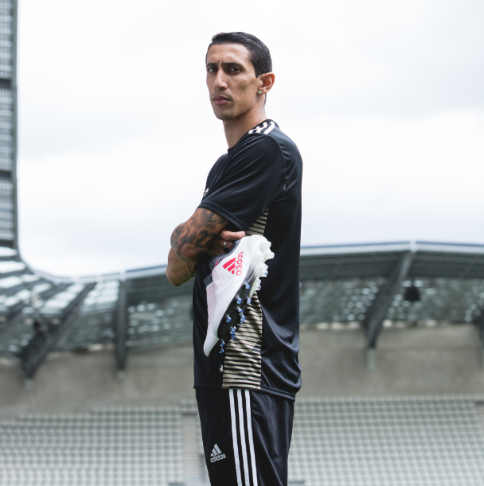

Portland, Ore., January 25, 2018 – adidas Soccer has today released the new Cold Blooded X17+ 360 SPEED, part of the Cold Blooded collection. The cleat is built for the game’s most lethal players and will be worn on-field by some of adidas’ brightest stars, including Luis Suárez, Gabriel Jesus and Gareth Bale.

The Cold Blooded X17+ 360 SPEED is available from today at adidas.com.

The Cold Blooded X17+ Stadium boot features:
- A bold white colorway with a red graphic design
- A NON STOP GRIP (NSG) finish, providing unrivalled levels of control
- A PURECUT SOCK SYSTEM with laces hidden under an upper layer
- A SPRINTFRAME outsole to create stability when changing direction at high speed

The Cold Blooded X17+ Cage shoe includes the same features as the stadium cleat, plus a gum finish used on the outsole.

For more information visit http://www.adidas.com/us/soccer and join the conversation on Twitter​ and Instagram​ with #HereToCreate.

- END -

For further media information please visit http://news.adidas.com/US/home/SOCCER or contact:

Cristina Maillo Belda
PR Manager, adidas Soccer
Email: Cristina.maillobelda@external.adidas.com
Tel: 503.915.9129

About adidas Soccer
adidas is the global leader in soccer. It is the official sponsor / official supplier partner of the most important soccer tournaments in the world, such as the FIFA World Cup™, the FIFA Confederations Cup, the UEFA Champions League, the UEFA Europa League, the UEFA European Championships and Major League Soccer. adidas also sponsors some of the world’s top clubs including Manchester United, Real Madrid, FC Bayern Munich, Juventus and AC Milan. Some of the world’s best players also on the adidas roster are Leo Messi, Paul Pogba, Gareth Bale, Karim Benzema, Roberto Firmino, Thomas Müller, Luis Suárez, James Rodríguez, Diego Costa, Mesut Özil, Renato Sanches and Julian Draxler.

