Download high-res imagery for NEMEZIZ 17+ 360 AGILITY here

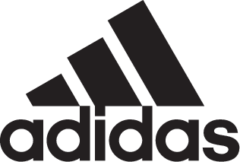

adidas Soccer Launches NEMEZIZ in New Cold Blooded Colorway

- NEMEZIZ 17+ 360 AGILITY arrives in latest triple red colorway -
- Designed for the game’s most agile players -
- Available in Stadium, Cage and Street versions for all surfaces -

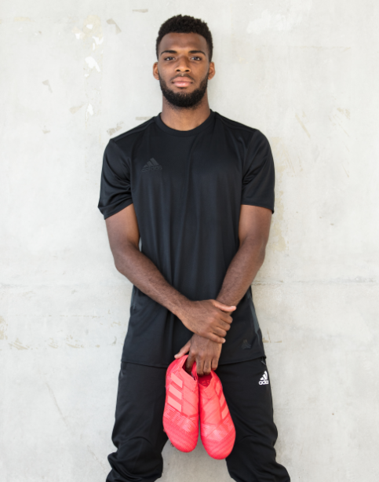

Portland, Ore., January 25, 2018 – adidas Soccer has today released a bold new triple red colorway for the NEMEZIZ 17+ 360 AGILITY, a cleat designed to enhance the performance of the game’s most agile players.

The Cold Blooded NEMEZIZ 17+ 360 AGILITY is available from today at adidas.com.

The latest NEMEZIZ colorway includes an AGILITYBANDAGE with TORSIONTAPES technology, designed to deliver the perfect fit by ensuring the foot remains locked in place. A dual-lock collar secures the ankle and allows for explosive change of direction.

The TORSIONFRAME outsole features an ultra-lightweight construction and TORSIONRIBS to provide dynamic push off support; vital for agile movement. The AGILITYKNIT 2.0 interlocking yarn structure provides a soft direct touch and a lightweight, adaptable feel.

Cold Blooded NEMEZIZ 17+ 360 AGILITY is also available in Cage and Street versions. Featuring the same red coloring as the on-field boot, both shoes include the same performance technology, giving the most agile players tools to support their agility in the cage and on the street.

For more information visit http://www.adidas.com/us/soccer and join the conversation on Twitter​ and Instagram​ with #HereToCreate.

- END -

For further media information please visit http://news.adidas.com/US/home/SOCCER or contact:

Cristina Maillo Belda
PR Manager, adidas Soccer
Email: Cristina.maillobelda@external.adidas.com
Tel: 503.915.9129

About adidas Soccer
adidas is the global leader in soccer. It is the official sponsor / official supplier partner of the most important soccer tournaments in the world, such as the FIFA World Cup™, the FIFA Confederations Cup, the UEFA Champions League, the UEFA Europa League, the UEFA European Championships and Major League Soccer. adidas also sponsors some of the world’s top clubs including Manchester United, Real Madrid, FC Bayern Munich, Juventus and AC Milan. Some of the world’s best players also on the adidas roster are Leo Messi, Paul Pogba, Gareth Bale, Karim Benzema, Roberto Firmino, Thomas Müller, Luis Suárez, James Rodríguez, Diego Costa, Mesut Özil, Renato Sanches and Julian Draxler.

