Download high-res imagery for Predator 18+ here

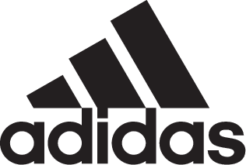

adidas Soccer Reveals New Cold Blooded Predator 18+

- New boot is part of the Cold Blooded pack available in stadium, cage and street versions -
- Cold Blooded Predator 18+ is the first new colorway of the re-released Predator and features a bold white and red color scheme -
- Boot to be worn on-pitch by the likes of Dele Alli, Mesut Ozil and Paul Pogba from today -

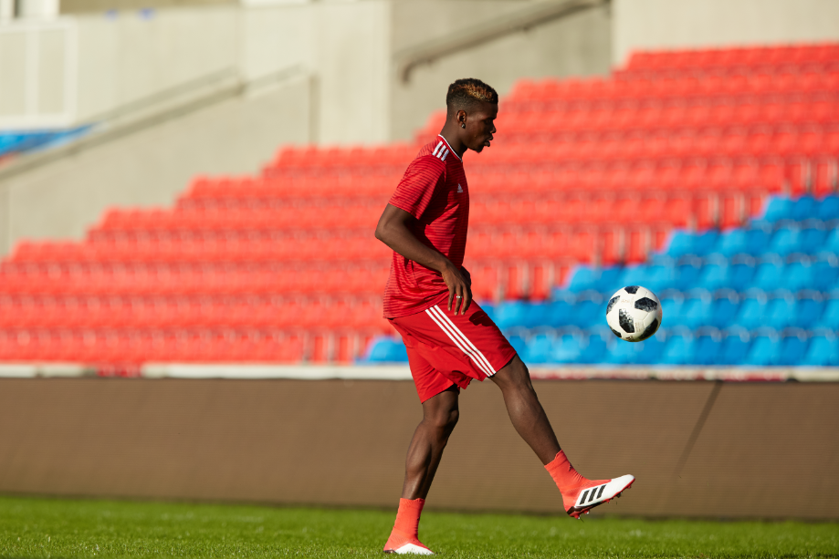

Portland, Ore., January 25, 2018 – adidas Soccer has today launched the first new colorway of the re-released Predator 18+. The Cold Blooded Predator 18+ features as part of the Cold Blooded pack - alongside X and NEMEZIZ silos – and is available in a striking white and red colorway.

The Cold Blooded PREDATOR 18+ is available from today at adidas.com.

The cleat features a PURECUT LACELESS system to deliver maximum surface control while a FORGED KNIT integrated midfoot structure creates medial and lateral stability. It also features a CONTROLFRAME, designed to stabilize movement, while a new hybrid stud tip configuration amplifies rotation and traction. A full-length BOOST™ midsole provides energy return with every step.

The latest Predator 18+ includes a red Primeknit SOCKFIT COLLAR designed to naturally expand to the foot’s shape and ensure a supportive and comfortable fit. The Primeknit material features a layer of CONTROLSKIN that provides optimal grip whatever the conditions, and an ANATOMICAL UPPER mimics the shape of the heel to lock the foot into place.

The Cold Blooded Predator 18+ is also available as a cage shoe. The cage version features the same SOCKFIT COLLAR construction, PURECUT LACELESS upper and CONTROLSKIN as the on-field cleat; along with a full length BOOST™ midsole and traction studs. Following the adidas strategy of taking the shoe from the stadium to the street, the Predator is also available as a lifestyle shoe.

For more information visit http://www.adidas.com/us/soccer and join the conversation on Twitter​ and Instagram​ with #HereToCreate.

-END-

For further media information please visit http://news.adidas.com/US/home/SOCCER or contact:

Cristina Maillo Belda
PR Manager, adidas Soccer
Email: Cristina.maillobelda@external.adidas.com
Tel: 503.915.9129

About adidas Soccer
adidas is the global leader in soccer. It is the official sponsor / official supplier partner of the most important soccer tournaments in the world, such as the FIFA World Cup™, the FIFA Confederations Cup, the UEFA Champions League, the UEFA Europa League, the UEFA European Championships and Major League Soccer. adidas also sponsors some of the world’s top clubs including Manchester United, Real Madrid, FC Bayern Munich, Juventus and AC Milan. Some of the world’s best players also on the adidas roster are Leo Messi, Paul Pogba, Gareth Bale, Karim Benzema, Roberto Firmino, Thomas Müller, Luis Suárez, James Rodríguez, Diego Costa, Mesut Özil, Renato Sanches and Julian Draxler.

