Download high-res imagery for:
Predator 18+ here
NEMEZIZ 17+ 360 AGILITY here
X17+ 360 SPEED here

adidas Soccer Reveals New Cold Blooded Collection

- Cold Blooded collection includes Predator, NEMEZIZ, X and COPA franchises -
- Cold Blooded Predator 18+ is the first new colorway of the re-released Predator and features a bold white and red color scheme -
- NEMEZIZ 17+ 360 AGILITY arrives in latest triple red colorway while X17+ 360 SPEED comes in striking white and red colorway -
- Cold Blooded Predator and NEMEZIZ available in Stadium, Cage and Street versions for all surfaces -

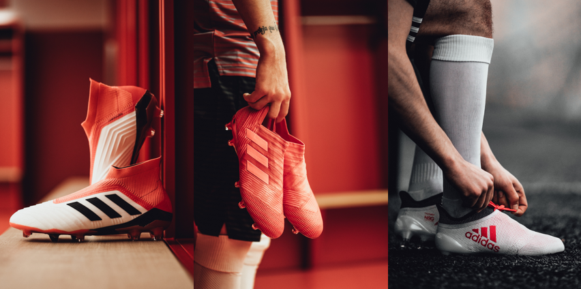

Portland, Ore., January 25, 2017 – adidas Soccer has today completed the launch of the new Cold Blooded collection after the brand unveiled its updated COPA 18.1 silhouette on Jan. 15. In addition to the new COPA, the Cold Blooded collection features the first new colorway of the re-released Predator 18+, as well as updated colorways of the NEMEZIZ 17+ 360 AGILITY and the X17+ 360 SPEED franchises.

All four franchises are available for purchase starting today at adidas.com.

PREDATOR 18+
The Cold Blooded Predator 18+ Stadium boot features:
- A bold white and red colorway to be worn on-field by the likes of Dele Alli, Mesut Ozil and Paul Pogba starting today
- A PURECUT LACELESS system to deliver maximum surface control
- A FORGED KNIT integrated midfoot structure and a CONTROLFRAME designed to create medial and lateral stability
- A new hybrid stud tip configuration that amplifies rotation and traction, and a full-length BOOST™ midsole to provide energy return with every step
- A red Primeknit SOCKFIT COLLAR featuring a layer of CONTROLSKIN and an ANATOMICAL UPPER

The updated Predator 18+ Cage shoe features:
- The same SOCKFIT COLLAR construction, PURECUT LACELESS upper and CONTROLSKIN as the on-field boot
- A full-length BOOST™ midsole and traction studs

The new Predator 18+ is also available in a lifestyle shoe for soccer players to take their game from the stadium to the street.

NEMEZIZ 17+ 360 AGILITY
The Cold Blooded NEMEZIZ 17+ 360 AGILITY Stadium boot features:
- A triple red colorway to be worn by the game’s most agile players
- An AGILITYBANDAGE with TORSIONTAPES technology to deliver the perfect fit
- A TORSIONFRAME outsole with TORSIONRIBS to provide dynamic push off support
- The new AGILITYKNIT 2.0 interlocking yard structure to provide a soft touch, and a lightweight, adaptable feel

The new NEMEZIZ Cage and Street silos offer the same red colorway as the on-field cleat, as well as the same performance technology.

X17+ 360 SPEED
The Cold Blooded X17+ 360 SPEED Stadium boot features:
- A bold white colorway with a red graphic design to be worn on-field by some of adidas’ brightest stars, including Luis Suárez, Gabriel Jesus and Gareth Bale
- NON STOP GRIP (NSG) finish, providing unrivalled levels of control
- PURECUT SOCK SYSTEM, with laces hidden under an upper layer
- SPRINTFRAME outsole to create stability when changing direction at high speed

The Cold Blooded X17+ Cage shoe includes the same features as the stadium boot, plus a gum finish used on the outsole.

For more information visit http://www.adidas.com/us/soccer and join the conversation on Twitter​ and Instagram​ with #HereToCreate.

- END -

For further media information please visit http://news.adidas.com/US/home/SOCCER or contact:

Cristina Maillo Belda
PR Manager, adidas Soccer
Email: Cristina.maillobelda@external.adidas.com
Tel: 503.915.9129

About adidas Soccer
adidas is the global leader in soccer. It is the official sponsor / official supplier partner of the most important soccer tournaments in the world, such as the FIFA World Cup™, the FIFA Confederations Cup, the UEFA Champions League, the UEFA Europa League, the UEFA European Championships and Major League Soccer. adidas also sponsors some of the world’s top clubs including Manchester United, Real Madrid, FC Bayern Munich, Juventus and AC Milan. Some of the world’s best players also on the adidas roster are Leo Messi, Paul Pogba, Gareth Bale, Karim Benzema, Roberto Firmino, Thomas Müller, Luis Suárez, James Rodríguez, Diego Costa, Mesut Özil, Renato Sanches and Julian Draxler.

