EMBARGOED UNTIL FRIDAY 19 JANUARY 2018 AT 9:00 AM ET /// 6:00 AM PT
Download high-res imagery and video here

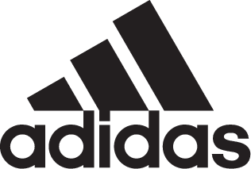

adidas and Major League Soccer Reveal the 2018 Official Match Ball

-NATIVO’s latest update features new surface texture and paneling to optimize flight, touch and surface glide-
-New backing foam contains 40% recycled materials-
-Ball will be first seen at MLS SuperDraft in Philadelphia and debut on-pitch during MLS Preseason -

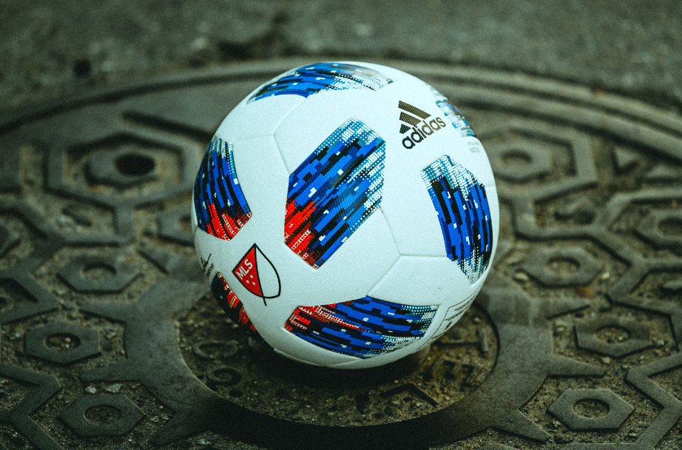

Portland, Ore. January 19, 2018 – adidas and Major League Soccer today premiered the newest design of the NATIVO, the Official Match Ball for the 2018 MLS season. Newly constructed with an updated panel design and sustainable materials, this reimagined release marks the fourth ball in the NATIVO series to-date.

The newest adidas NATIVO is available for purchase today at adidas.com and MLSstore.com.

Incorporating some of the most innovative materials in sports, the ball is constructed with a unique six mono-panel configuration via thermobonding technology, which provides smooth, even performance and zero water uptake. Moreover, new backing material uses 40% completely sustainable materials made from sugar cane and recycled paper, leading to superior and improved ball flight and surface glide.

An upgraded look from the Official Match Ball of seasons past, the Nativo’s redesigned skin features pixelated patchwork details in bright blue and red, which represents motifs from North American history as well as a blended, unified border between the United States and Canada. The patches and new rhombus carcass construction offers premium surface structure designed to provide improved grip, touch, stability and aerodynamics that players can take from the stadium to the street.

“Soccer is a global sport that transcends beyond borders,” said Ernesto Bruce, Senior Director for adidas Soccer. “The new design of the 2018 MLS Official Match Ball is our way of embracing and celebrating unity on the pitch, while offering a superior performance ball for all levels of athletes across North America.”

The new ball will be first seen today during the MLS SuperDraft in Philadelphia, as adidas Soccer and MLS and its clubs celebrate their commitment to youth development. Afterwards, the ball will be seen on-pitch during the MLS preseason games, and throughout the league’s 23rd season, which begins on Saturday, March 3 when defending MLS Cup champions Toronto FC host Columbus Crew SC in the league’s opening match.

For more information visit http://www.adidas.com/us/soccer and join the conversation on Twitter​ and Instagram​ with #HereToCreate.

-END-

For further media information please visit http://news.adidas.com/US/home/SOCCER or contact:

Cristina Maillo Belda
PR Manager, adidas Soccer
Email: Cristina.maillobelda@external.adidas.com
Tel: 503.915.9129

About adidas Soccer
adidas is the global leader in soccer. It is the official sponsor / official supplier partner of the most important soccer tournaments in the world, such as the FIFA World Cup™, the FIFA Confederations Cup, the UEFA Champions League, the UEFA Europa League, the UEFA European Championships and Major League Soccer. adidas also sponsors some of the world’s top clubs including Manchester United, Real Madrid, FC Bayern Munich, Juventus and AC Milan. Some of the world’s best players also on the adidas roster are Leo Messi, Paul Pogba, Gareth Bale, Karim Benzema, Roberto Firmino, Thomas Müller, Luis Suárez, James Rodríguez, Diego Costa, Mesut Özil, Renato Sanches and Julian Draxler.

