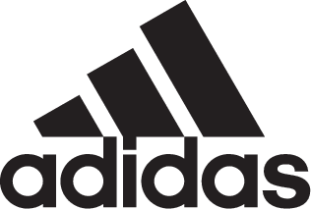

adidas Soccer Launches COPA 18+ TR PREMIUM

- COPA 18+ TR PREMIUM arrive in navy blue and grey colorways –
- Features a Primeknit upper and BOOST™ midsole for a lifestyle-focused look -

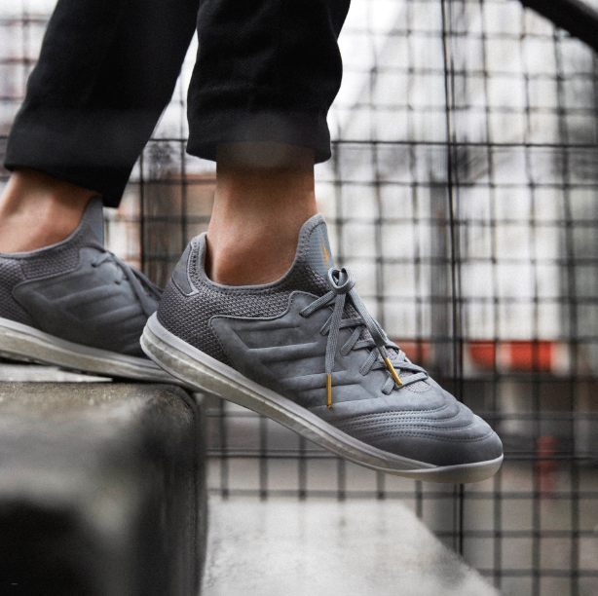

Portland, Ore., January 18, 2018 – adidas Soccer has today released the COPA 18+ TR PREMIUM, a lifestyle sneaker designed for the streets.

COPA18+ feature a Primeknit collar which wraps the foot to provide adaptive support and ultralight comfort, combined with a Premium Nubuck upper that produces a soft but durable feel.

A supportive compression inner sock construction and fold-over tongue delivers optimal fit, while a full-length BOOST™ midsole offers energy return with every step.

Double-stitched lines emphasize the signature quilted toe while a rubber outsole, premium metal lace tips and block navy blue and grey coloring deliver a lifestyle-focused look designed for the streets.

For more information visit http://www.adidas.com/us/soccer and join the conversation on Twitter​ and Instagram​ with #HereToCreate.

- END -

For further media information please visit http://news.adidas.com/US/home/SOCCER or contact:

Cristina Maillo Belda
PR Manager, adidas Soccer
Email: Cristina.maillobelda@external.adidas.com
Tel: 503.915.9129

About adidas Soccer
adidas is the global leader in soccer. It is the official sponsor / official supplier partner of the most important soccer tournaments in the world, such as the FIFA World Cup™, the FIFA Confederations Cup, the UEFA Champions League, the UEFA Europa League, the UEFA European Championships and Major League Soccer. adidas also sponsors some of the world’s top clubs including Manchester United, Real Madrid, FC Bayern Munich, Juventus and AC Milan. Some of the world’s best players also on the adidas roster are Leo Messi, Paul Pogba, Gareth Bale, Karim Benzema, Roberto Firmino, Thomas Müller, Luis Suárez, James Rodríguez, Diego Costa, Mesut Özil, Renato Sanches and Julian Draxler.

