EMBARGOED UNTIL MONDAY 15th JANUARY, 10AM CET
Download high-res images and film here

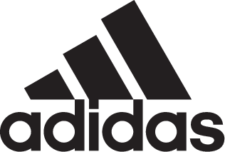

adidas Soccer Launches Latest Cleat In The Copa Franchise: COPA18.1

- COPA18.1 arrives in bold black, red and white colorway -
- The cleat is an upgrade on the COPA17, featuring new innovations –
- COPA18.1 also available in a cage version -

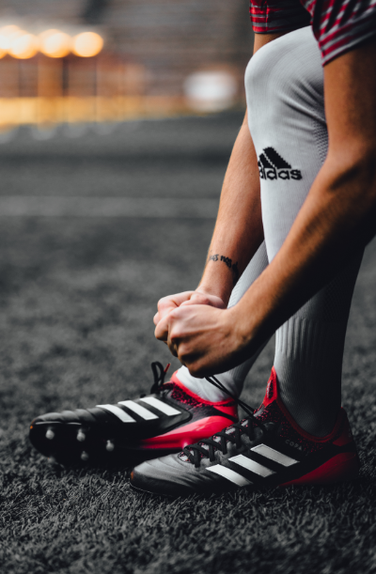

Portland, Ore., January 15, 2018 – adidas Soccer has today revealed COPA18.1, the latest release in the COPA franchise, designed with support and comfort at its heart. Originally launched in the late ‘70s with the COPA Mundial, the COPA family has outclassed opposition teams all over the world for the last 38 years.

Benefiting from the most advanced performance materials, COPA18.1 combines the upper from the COPA17 with an all-new Leather Embossed Vamp and innovative Sock Construction System, making it the most lightweight COPA to date and providing more stability than ever.

It features a classic, premium K-leather upper for unrivalled ball touch and optimum comfort. An internal X-Ray Vamp Cage brings the foot closer to the ball to reduce slippage, while a Compression Fold-Over Tongue provides improved supportive fit and stability.

The Comfort Internal Construction features foam pads and the new molded Ortholite Sockliner offering an enhanced cushioning experience for unmatched comfort.

A Sprintframe plate provides stability while Conical Studs Tips have been aligned in a classic set-up for smooth ground penetration, with a modern arch in the midfoot area for increased stability

COPA18.1 is also available in a cage shoe and features the same fold-over tongue, compression sock construction and premium K-leather upper as the on-field cleat. A BOOST™ midsole, EVA strip and rubber outsole provides the tools required to dominate the cage.

For more information visit http://www.adidas.com/us/soccer and join the conversation on Twitter​ and Instagram​ with #HereToCreate.

- END -

For further media information please visit http://news.adidas.com/US/home/SOCCER or contact:

Cristina Maillo Belda
PR Manager, adidas Soccer
Email: Cristina.maillobelda@external.adidas.com
Tel: 503.915.9129

About adidas Soccer
adidas is the global leader in soccer. It is the official sponsor / official supplier partner of the most important soccer tournaments in the world, such as the FIFA World Cup™, the FIFA Confederations Cup, the UEFA Champions League, the UEFA Europa League, the UEFA European Championships and Major League Soccer. adidas also sponsors some of the world’s top clubs including Manchester United, Real Madrid, FC Bayern Munich, Juventus and AC Milan. Some of the world’s best players also on the adidas roster are Leo Messi, Paul Pogba, Gareth Bale, Karim Benzema, Roberto Firmino, Thomas Müller, Luis Suárez, James Rodríguez, Diego Costa, Mesut Özil, Renato Sanches and Julian Draxler.

