**BUDDY UP TO BETTER YOURSELF**

 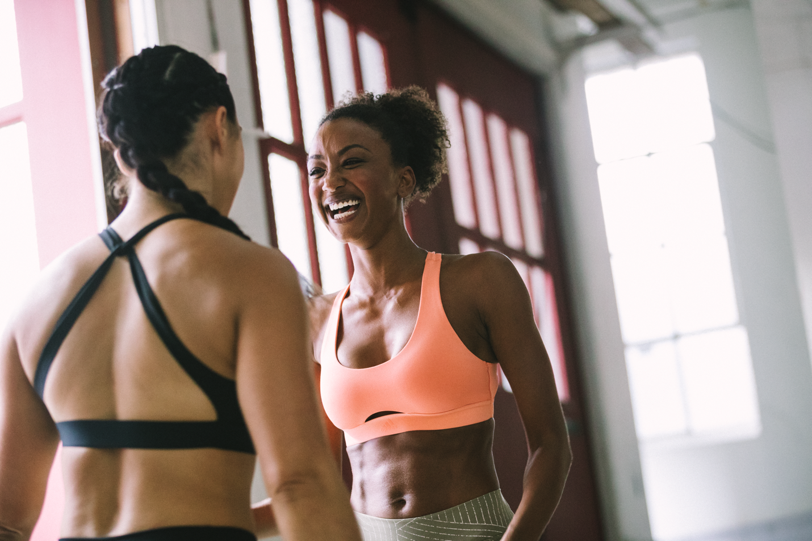

Everyone struggles with motivation at some point in her workout journey. Don’t beat yourself up – it’s human nature to be tempted to hit the snooze button on a harsh winter day. But there is a sure-fire method to keep you on track and reach your goals. It’s time to find a workout buddy, now.

Motivation? Tick. Correct form? Tick. Fun? Double tick. This month, fitness, fashion and food enthusiast **Meagan Kong** and yoga instructor **Danielle Acoff** invited us to join their circuit session as they powered through it together for extra motivation, accountability and drive.

**Meagan says**: *“Working out with a friend gives you that extra motivational edge.  Whether it’s teamwork or healthy competition, together you’ll squat lower, run harder and lift heavier.  I consider my online community invisible workout buddies who I check in with daily to give me the motivation to get out and get it done.”*

**Daniella adds**: *“There’s something quite magical about working out with a friend. Not only will it motivate you, but you will likely learn and grow from one another, too.”*

Push through new moves in ultimate comfort in the high-rise, flattering **Believe This Tight**, ideal for yoga and pilates sessions with its flexible, soft fabric. Meanwhile, work out in style in the seasonal version of the **All Me Bra**, a light support garment featuring compression technology, a beautiful back construction and removable moulded cups.

**Who keeps you motivated? Share your buddy workouts with us**

@meagankong @yellabella @adidaswomen #HereToCreate

**See the full SS18 Bras & Tights collection here:**

[www.adidas.com/training_women](http://www.adidas.com/training_women)