adidas x Parley unveil the latest swimming collection through the lens of Olympian Coralie Balmy
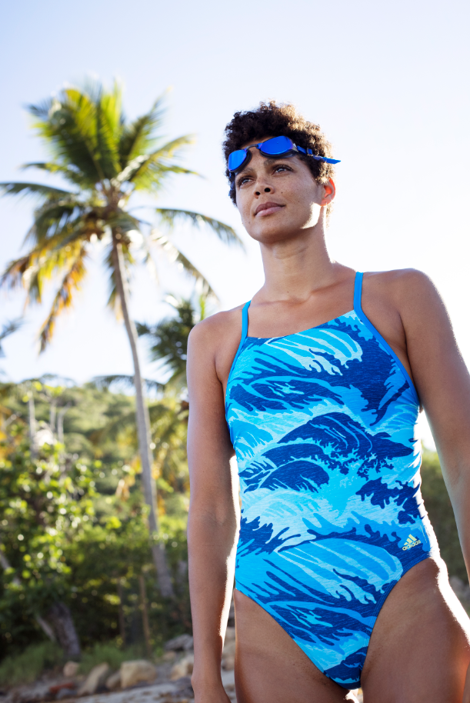

– The story of Ecologist and athlete –Coralie Balmy– inspires the next generation of swimmers–
– The new designs and colourways of the adidas x Parley swimming collection were created and inspired through the lens of Coralie’s work as a Marine Biologist–
–adidas swim continues to cement its role as a leader in sustainability and innovation –

Herzogenaurach, 11th December 2017- adidas, leader in innovative and sustainable swim apparel, today announces the latest collection under the adidas x Parley partnership, told through former 200 m freestyle (short course) World Record holder and Ecologist, Coralie Balmy.

In the latest chapter under adidas’ latest on-going commitment to the oceans, the adidas x Parley SS18 collection is a chance to educate the next generation of swimmers. Ingrained in Coralie’s upbringing, life as an athlete and her passion for the oceans, is her tireless work to educate local youth in the Martinique on the protection and preservations our oceans. The designs and colourways of the SS18 collection were created and inspired through the lens of Coralie’s work as a Marine Biologist. From the conception, where she discussed the fit with the team, to the visual design, discussing marine life with the product designers, right through to testing of the product, checking its quality in chlorine water, Coralie’s work is evident the entire way through.

Coralie Balmy, adidas x Parley ambassador and ecologist said, “I’ve been so lucky to be part of the adidas x Parley collaboration. Not only have I been able to combine two of my personal passions, swimming and marine biology, but I have been able to educate people, on the ways we can all help care for our oceans.”

“As first and foremost a performance product, the adidas and Parley team wanted to ensure that the needs of athletes were incorporated in the design, as well as creating a product that supports adidas’ approach to eco-innovation. I am delighted to continue my ongoing partnership with adidas swim, as it empowers and motivates all to look after the oceans for future athletes.”

Reflecting on the source of its material, the SS18 collection repurposes oceans threats, such as fishnets and debris, into thread, to create performance swimwear. New for this season, the collection expands to suit athletes that use swimming as part of their training regime, with a range of silhouettes designed to suit all swimming levels and ensure the highest level of comfort. Updates includes a high-neck and mid-leg for flattering fit, with the addition of swimming trunks and boxers.

As with previous collections, Econyl® is the fundamental material used to create swimwear in this collection. For SS18, the visual design includes hand sketch wave graphics in blue hues, which represent the striking movement of the world’s oceans.

The SS18 adidas x Parley swim range will be available online from December 11th on adidas.com/swimming and in adidas retail stores worldwide starting at 38 EUR for men and 48 EUR for women RRP.

-ENDS-

Emma Falconer Hall– Hill + Knowlton Strategies
Email: Emma.FalconerHall@hkstrategies.com
Tel: +442074133063

