NEW ADIDAS ULTRABOOST LACELESS

- adidas’ laceless silhouette released in South Africa, in two new colourways
- World-renowned BOOSTTM sole and advanced PrimeKnit technologies make the removal of laces a reality, creating adidas’ most minimalist and style-focused design to date
- Available for purchase from 6th December 2017
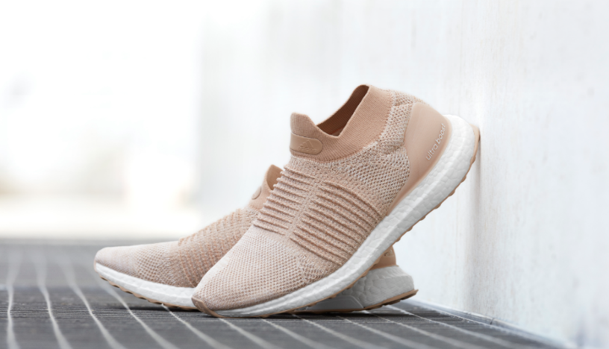

South Africa, 15th November 2017: adidas launches a new addition to the UltraBOOST footwear family without laces, the adidas UltraBOOST Laceless on 6th December.

adidas’ constant focus on innovation and style, paired with a drive to supply the most advanced and ground-breaking technologies, has led to the creation of the UltraBOOST Laceless – a shoe specifically designed to make your running experience the most effortless yet.

The new silhouette incorporates advanced PrimeKnit technologies, making the removal of laces a reality, and the world-renowned BOOSTTM sole which, when combined, ultimately allows the wearer to unleash their full potential in adidas’ most minimalist and style-focused design to date.

adidas has broken down barriers by working closely with athletes to test and re-work its renowned PrimeKnit upper to create a compression fit which supports and guarantees peak performance from the wearer without the need for laces. This sock-like fit paired with a collar construction design offers the wearer a perfect fit and permits the foot to move in harmony with the silhouette. Integrated Forged PrimeKnit also provides midfoot support and lockdown, with Aramis expansion zones around the metatarsal flex point.

Pieter Warnich, Senior Manager BU Running adidas SA, said: “This is our most streamlined high-performance running shoe yet. The sleek, minimalistic design without laces gives runners the style and confidence to shake off all distractions and concentrate solely on what matters most: to be greater every run.”

UltraBOOST Laceless will be available on adidas.co.za, in adidas performance stores and at participating retail outlets at a retail price of R3299 from 6th December. Follow the conversation at @adidasZA on Instagram and Twitter using #ultraboost.

END
NOTES TO EDITOR

About adidas
adidas is a global designer, developer and marketer of athletic footwear, apparel and accessories with the mission to be the leading sports brand in the world. Brand adidas is part of the adidas Group, a corporation that includes brands such as Reebok and TaylorMade.
For questions or more information please contact:
Kele Shomang
By Design Communications
Consultant
Email: k.shomang@bdcomms.co.za
Tel: +27 82 067 6401

Lauren Haakman
adidas South Africa
PR manager
Email: Lauren.Haakman@adidas.com

