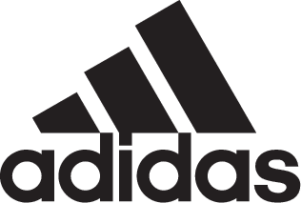

adidas Soccer Launches NEMEZIZ in New Skystalker Colorway

- NEMEZIZ 17+ 360 AGILITY arrives in latest bold black, red and gold colorway -
- Designed for the game’s most agile players -
- Available in Stadium, Cage and Street versions for all surfaces -

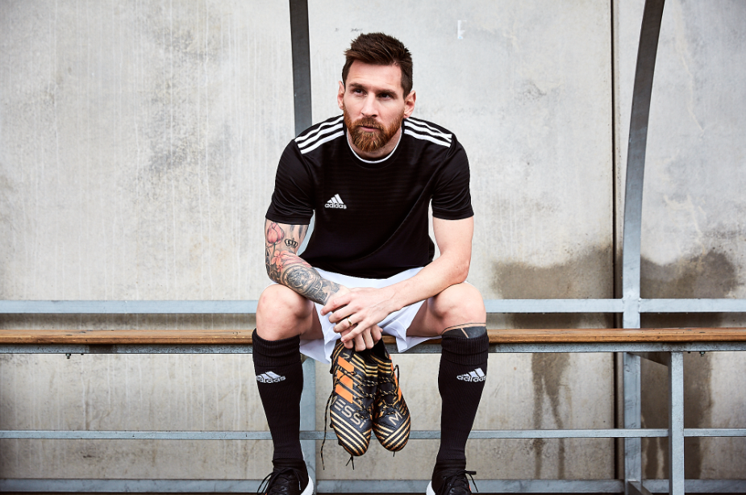

Portland, Ore., November 29, 2017 – adidas Soccer released today a bold new black, red and gold colorway for the NEMEZIZ 17+ 360 AGILITY, a cleat designed to enhance the performance of the game’s most agile players. The cleat is inspired by the idea of ‘taping’, a process used commonly in sport to deliver security, support and adaptability. The new design is part of the Skystalker pack – also available in Predator, X and Copa models.

Available from today at http://www.adidas.com/us/soccer and adidas retail stores, the latest NEMEZIZ colorway includes an AGILITYBANDAGE with TORSIONTAPES technology, designed to deliver the perfect fit by ensuring the foot remains locked in place. A dual-lock collar secures the ankle and allows for explosive change of direction.

The gold TORSIONFRAME outsole features an ultra-lightweight construction and TORSIONRIBS to provide dynamic push off support, a vital feature for agile movement. The new AGILITYKNIT 2.0 interlocking yarn structure provides a soft direct touch and a lightweight, adaptable feel.

To ensure players can experience the same level of agility in any setting, Skystalker NEMEZIZ 17+ 360 AGILITY is also available in both Cage and Street versions. Featuring the same black and red colors as the on-field cleat, both the cage and street shoes feature the same performance technology, giving the most agile players the same tools to support their agility in the cage and on the street.

For more information visit http://www.adidas.com/us/soccer and join the conversation on Twitter​ and Instagram​ with #HereToCreate.

- END -

For further media information please visit http://news.adidas.com/US/home/SOCCER or contact:

Cristina Maillo Belda
PR Manager, adidas Soccer
Email: Cristina.maillobelda@external.adidas.com
Tel: 503.915.9129

About adidas Soccer
adidas is the global leader in soccer. It is the official sponsor / official supplier partner of the most important soccer tournaments in the world, such as the FIFA World Cup™, the FIFA Confederations Cup, the UEFA Champions League, the UEFA Europa League, the UEFA European Championships and Major League Soccer. adidas also sponsors some of the world’s top clubs including Manchester United, Real Madrid, FC Bayern Munich, Juventus and AC Milan. Some of the world’s best players also on the adidas roster are Leo Messi, Paul Pogba, Gareth Bale, Karim Benzema, Roberto Firmino, Thomas Müller, Luis Suárez, James Rodríguez, Diego Costa, Mesut Özil, Renato Sanches and Julian Draxler.

