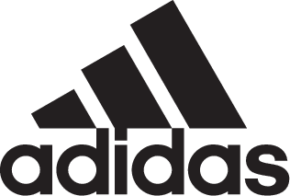

adidas Soccer Unveils New Skystalker X17+ 360 SPEED

- Latest release features bold bronze, red and black colorway -
- Skystalker X17+ 360 SPEED to be worn by the game’s most explosive players -
- Key features include PURECUT SOCK SYSTEM, NON STOP GRIP (NSG) and a SPRINTFRAME outsole -

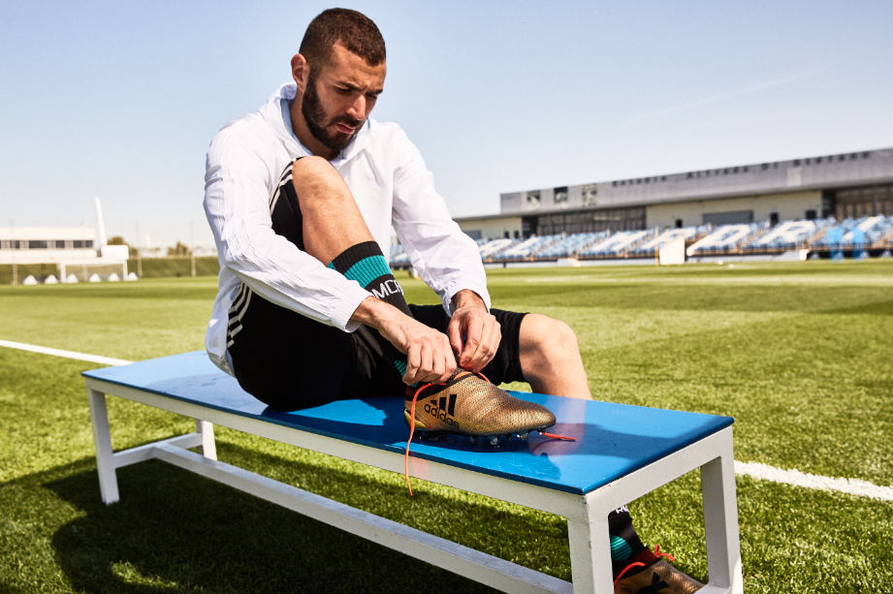

Portland, Ore., November 29, 2017 – adidas Soccer has today unveiled the Skystalker X17+ 360 SPEED, part of the Skystalker collection also available in NEMEZIZ, Predator and Copa silos. The cleat will be worn on-field by some of adidas’ brightest stars, including Gareth Bale, Luis Suárez and Gabriel Jesus.

Available from today at http://www.adidas.com/us/soccer and adidas retail stores, the Skystalker X17+ 360 SPEED is also offered in a Cage version.

The Skystalker X17+ Stadium cleat features:
- Bronze, black and red colorway
- NON STOP GRIP (NSG) finish, giving players unrivalled levels of control
- PURECUT SOCK SYSTEM, which sees laces hidden under an upper layer
- SPRINTFRAME outsole to create stability during high-speed changes of direction

The Skystalker X17+ Cage shoe features:
- Same details as per stadium cleat, but with gum finish used on the outsole

For more information visit http://www.adidas.com/us/soccer and join the conversation on Twitter​ and Instagram​ with #HereToCreate.

- END -

For further media information please visit http://news.adidas.com/US/home/SOCCER or contact:

Cristina Maillo Belda
PR Manager, adidas Soccer
Email: Cristina.maillobelda@external.adidas.com
Tel: 503.915.9129

About adidas Soccer
adidas is the global leader in soccer. It is the official sponsor / official supplier partner of the most important soccer tournaments in the world, such as the FIFA World Cup™, the FIFA Confederations Cup, the UEFA Champions League, the UEFA Europa League, the UEFA European Championships and Major League Soccer. adidas also sponsors some of the world’s top clubs including Manchester United, Real Madrid, FC Bayern Munich, Juventus and AC Milan. Some of the world’s best players also on the adidas roster are Leo Messi, Paul Pogba, Gareth Bale, Karim Benzema, Roberto Firmino, Thomas Müller, Luis Suárez, James Rodríguez, Diego Costa, Mesut Özil, Renato Sanches and Julian Draxler.

