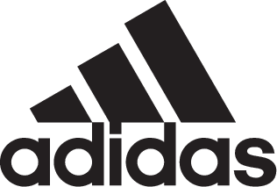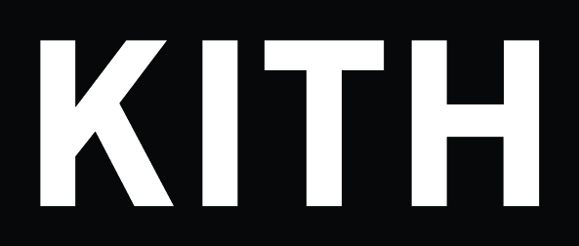

adidas Soccer and Kith Reveal Season 2

- Los Angeles Rays introduced as Kith’s newest soccer club –
- adidas’ most innovative technology featured in this fall/winter collection -

Portland, Ore., November 3, 2017 – adidas Soccer and Kith reprise their partnership to launch their collaborative Season 2 campaign. The duo expounds on their last release by introducing Kith’s newest soccer club – the Los Angeles Rays. The Rays join Kith’s New York-based Cobras and Miami-based Flamingos clubs, which serve as the focal points of this collection.

Whereas Season 1 took place in the spring, Season 2 makes its mark in the fall/winter as temperatures grow colder and players must maintain warmth while performing. To accomplish this, the product has been designed featuring some of adidas’ most innovative technologies, such as Climacool, Primaloft and more.

Season 2 is an elevation of its predecessor in every facet, which includes a third team, an expansive collection of 82 different styles, and most notably, official sponsors for each team jersey. The sponsorship line-up includes Coca-Cola for the Cobras, Chase Bank for the Flamingos, and Samsung for the Rays. Each team is outfitted in identical silhouettes that have been color-blocked in three variations.

The apparel line is accompanied by six new footwear styles that meet the stadium to street needs of each team with street and turf models. For the street, adidas Soccer and Kith utilized the Nemeziz UltraBOOST 17+ silhouette, which combines adidas’ most disruptive laceless soccer upper with a BOOST sole unit. The upper is designed using Torsion Tape for lockdown fit and advanced durability. The turf model stays within the Nemeziz franchise, opting for the Nemeziz 17.1 silhouette due to its thinner Climacool tooling. Kith modified the 17.1 upper by removing the laces, thus maintaining laceless footwear styles across the range. Both the street and turf models feature intarsia Kith logo hits throughout the Torsion Tape, while 3M accents the lateral side Three Stripes.

The collection is completed by a full assortment of accessories including game socks, caps, beanies, neck gaiters, reversible duffel bags, and more.

The adidas Soccer x Kith Season 2 collection is available from today at Kith shops and on Kith.com.

For more information visit http://www.adidas.com/us/soccer and join the conversation on Twitter​ and Instagram​ with #HereToCreate.

- END -

For further media information please visit http://news.adidas.com/US/home/SOCCER or contact:

Cristina Maillo Belda
PR Manager, adidas Soccer
Email: Cristina.maillobelda@external.adidas.com
Tel: 503.915.9129

About adidas Soccer
adidas is the global leader in soccer. It is the official sponsor / official supplier partner of the most important soccer tournaments in the world, such as the FIFA World Cup™, the FIFA Confederations Cup, the UEFA Champions League, the UEFA Europa League, the UEFA European Championships and Major League Soccer. adidas also sponsors some of the world’s top clubs including Manchester United, Real Madrid, FC Bayern Munich, Juventus and AC Milan. Some of the world’s best players also on the adidas roster are Leo Messi, Paul Pogba, Gareth Bale, Karim Benzema, Roberto Firmino, Thomas Müller, Luis Suárez, James Rodríguez, Diego Costa, Mesut Özil, Renato Sanches and Julian Draxler.

