Avoid the distractions and break into the zone with the new Alphabounce
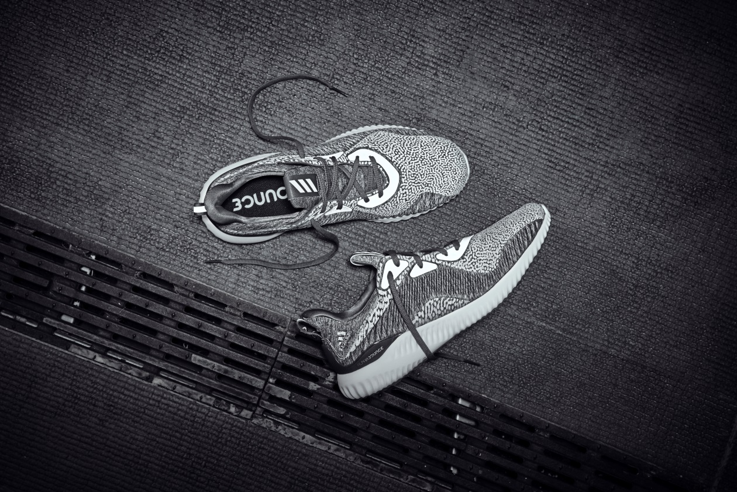
South Africa, 04th October 2017 – adidas unveils AlphaBOUNCE Reflective Silver, the latest colourway update to the AlphaBOUNCE franchise, offering an adaptive fit and feel for runners and versatile athletes.
AlphaBOUNCE was developed using a motion capture technology called Aramis, which measures mechanics of the foot during movement. Based on motion capture insights during a runner’s stride, the defining features of AlphaBOUNCE were designed to offer support or expansion where the athlete needs it most.
The defining features of the silhouette include:
Reflective features – A light sensitive print and reflective eyelet pods shine when exposed to light, helping you stand out.
Forged meshed upper – A seamless mesh material designed with areas of support and stretch to help ensure a custom fit that adapts to every move.
Bounce midsole – An innovative cushioning system that provides enhanced comfort and flexibility to users.

The Alphabounce range is available at select adidas performance stores, select Cross Trainer stores and on adidas ecomm at a retail price of R1999. Follow the conversation at @adidasZA on Instagram and Twitter using #alphabounce and #adidasrunners.

-END-
For questions or more information please contact:
NOTES TO EDITOR

About adidas
adidas is a global designer, developer and marketer of athletic footwear, apparel and accessories with the mission to be the leading sports brand in the world. Brand adidas is part of the adidas Group, a corporation that includes brands such as Reebok and TaylorMade.

For questions or more information please contact:
Kele Shomang
By Design Communications
Consultant
Email: k.shomang@bdcomms.co.za
Tel: +27 82 067 6401

Lauren Haakman
adidas South Africa
PR manager
Email: Lauren.Haakman@adidas.com

