adidas athletes inspire the next generation at the Z.N.E Pulse Activation in Sandton City
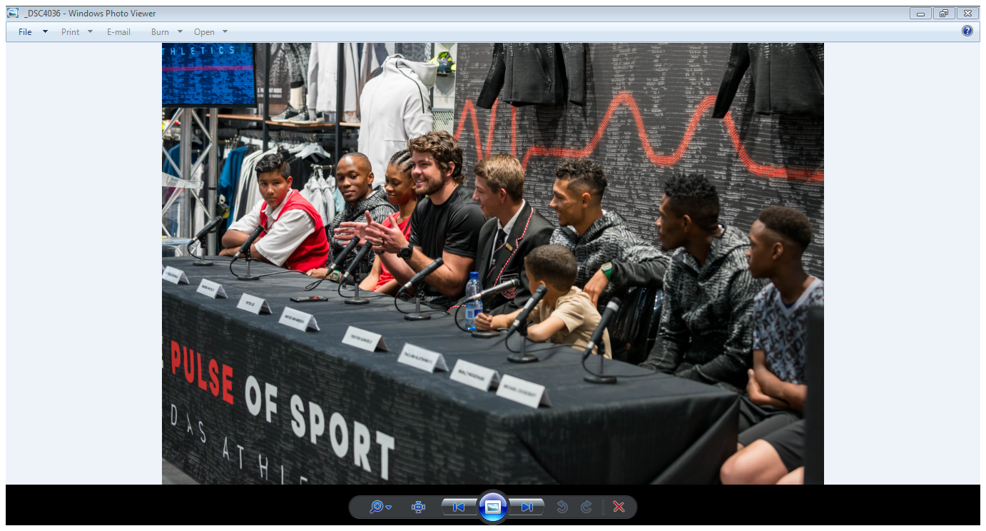

Johannesburg: On 7 September, adidas Athletics in celebration of the Z.N.E Pulse collection together with adidas ambassadors Wayde van Niekerk, Akani Simbine, Thulani Hlatshwayo and Warren Whiteley, surprised a young aspirant athlete to a shopping experience at the new adidas performance store in Sandton City Mall.
Athletes engaged with aspirant athletes on a social media call to action and each athlete selected their winner. The young athletes thought they were being casted for an adidas advert when their respective hero surprised them creating a once-in-a-lifetime moment. The young athletes were lost for words upon meeting their hero’s and were fitted with heartrate monitors that registered their Pulse in this heartbeat of sport experience. Later that day they sat confidently next to each athlete in a media conference, recounting their experiences and what the day meant to each of them.
“We push ourselves to train harder for the next generation to see that it doesn’t matter who you are or where you come from, you can achieve any goal if you work hard enough for it”, said Wayde van Niekerk.
“Thank you to adidas for arranging this experience for young athletes to stay motivated in sport and remind us of the responsibility we carry as athletes. I was humbled listening to the life of these young athletes, one often forgets the challenges that school children face today”, said Springbok Captain Warren Whiteley.
To follow the conversations keep a look out for #ThePulseOf and #ZNE @adidasZA on Instagram and Twitter.
-Ends-
Notes to Editors:
About adidas Athletics

The adidas Athletics category has a mission to reinvigorate and revolutionize the badge of sport as an object of desire. It recognizes the need for athletic expression off the field of play, whatever the field of play. Bridging the gap between athletes’ style and their life of sport, it champions a unique and fresh point of view, celebrating and highlighting the untold stories of innovation that get under the skin of sport.

For further media information please contact:
Kele Shomang
By Design Communications
Consultant
Email: k.shomang@bdcomms.co.za
Tel: +27 82 067 6401

Tebogo Kgosi
adidas South Africa
PR manager
Email: Tebogo.Kgosi@adidas.com
Tel: +27 (11) 798 6900

