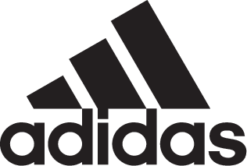

adidas Launches adidas Soccer x Paul Pogba Capsule Collection Season II

- New range co-designed with one of the game’s most creative players -
- Collection includes footwear, apparel and accessories designed for the street -
- Range available through adidas stores and specialist fashion and soccer retailers -

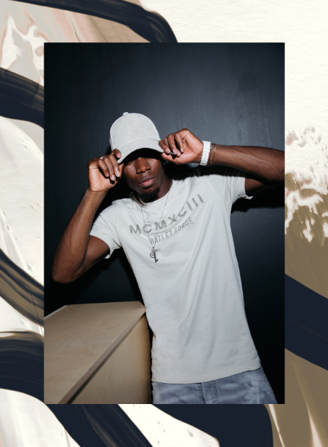

Portland, Ore., October 23, 2017 – adidas Soccer has teamed up with Paul Pogba once again to launch the second season of the adidas Soccer x Pogba Capsule Collection. The range channels Pogba’s famous style – both on and off the field – using earthy tones to represent his African roots and the inclusion of a classic desert camouflage pattern.

The range includes two street versions, the new PP ACE 17+, which feature a bold desert camouflage print. Both versions feature BOOST technology for maximum energy return on any surface.

The collection goes well beyond footwear, including apparel and accessories for a complete streetwear look. Standout pieces include a new beige and gold bomber jacket, a sleek and stylish backpack and a specially designed ‘Paris’ jersey, featuring a desert print with bold reflective font across the front. The range also includes other items such as a cap, track pants, tees and a signature ball.

To celebrate the launch of the range, adidas Soccer and Pogba worked on a new film that gives an insight into the creative world of the Manchester United midfielder. It shows Pogba’s inspirations on and off the field and sees him demonstrate his creativity as a designer, soccer player and dancer, all set to a contemporary “GQOM“ music track, produced specifically for this collection.

The film, like the range, celebrates the full scope of Pogba’s creativity and can be watched here: https://youtu.be/9TqzEv6us6I

The new collection will be available to purchase in fashion and trend specific stores such as KITH NY. It will also be available via adidas.com/pogba_collection and the New York City adidas Flagship store.

For more information visit http://www.adidas.com/us/soccer and join the conversation on Twitter​ and Instagram​ with #HereToCreate.

- END -

For further media information please visit http://news.adidas.com/US/home/SOCCER or contact:

Cristina Maillo Belda
PR Manager, adidas Soccer
Email: Cristina.maillobelda@external.adidas.com
Tel: 503.915.9129

About adidas Soccer
adidas is the global leader in soccer. It is the official sponsor / official supplier partner of the most important soccer tournaments in the world, such as the FIFA World Cup™, the FIFA Confederations Cup, the UEFA Champions League, the UEFA Europa League, the UEFA European Championships and Major League Soccer. adidas also sponsors some of the world’s top clubs including Manchester United, Real Madrid, FC Bayern Munich, Juventus and AC Milan. Some of the world’s best players also on the adidas roster are Leo Messi, Paul Pogba, Gareth Bale, Karim Benzema, Roberto Firmino, Thomas Müller, Luis Suárez, James Rodríguez, Diego Costa, Mesut Özil, Renato Sanches and Julian Draxler.

