STADIUM EMBARGOED UNTIL FRIDAY 29TH SEPTEMBER, 10AM CET
Please download high res images here

adidas Soccer Unveils New Pyro Storm X17+ 360 SPEED

- Latest release features bold orange and black colorway -
- Pyro Storm X17+ 360 SPEED to be worn by the game’s most explosive players -
- Key features include PURECUT SOCK SYSTEM, NON STOP GRIP (NSG) and a SPRINTFRAME outsole -

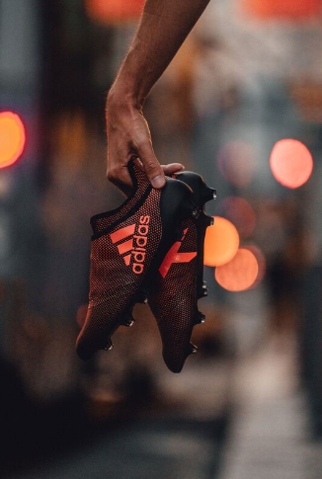

Portland, Ore., September 29, 2017 – adidas Soccer unveiled today the Pyro Storm X17+ 360 SPEED as part of the Pyro Storm collection. The boot will be worn on the field by some of adidas’ brightest stars, including Gareth Bale, Luis Suárez and Gabriel Jesus.

The Pyro Storm X17+ Stadium cleat features:
- Striking two-tone orange and black colorway
- NON STOP GRIP (NSG) finish, giving players unrivalled levels of control
- PURECUT SOCK SYSTEM, which sees laces hidden under an upper layer
- SPRINTFRAME outsole to create stability during high-speed changes of direction

The Pyro Storm X17+ Cage shoe features:
- Same details as per stadium cleat, but with gum finish used on the outsole

Pyro Storm X17+ 360 SPEED is available from today at adidas.com and adidas retail stores.

For more information visit http://www.adidas.com/us/soccer and join the conversation on Twitter​ and Instagram​ with #HereToCreate.

- END -

For further media information please visit http://news.adidas.com/US/home/SOCCER or contact:

Cristina Maillo Belda
PR Manager, adidas Soccer
Email: Cristina.maillobelda@external.adidas.com
Tel: 503.915.9129

About adidas Soccer
adidas is the global leader in soccer. It is the official sponsor / official supplier partner of the most important soccer tournaments in the world, such as the FIFA World Cup™, the FIFA Confederations Cup, the UEFA Champions League, the UEFA Europa League, the UEFA European Championships and Major League Soccer. adidas also sponsors some of the world’s top clubs including Manchester United, Real Madrid, FC Bayern Munich, Juventus and AC Milan. Some of the world’s best players also on the adidas roster are Leo Messi, Paul Pogba, Gareth Bale, Karim Benzema, Roberto Firmino, Thomas Müller, Luis Suárez, James Rodríguez, Diego Costa, Mesut Özil, Renato Sanches and Julian Draxler.

