STADIUM EMBARGOED UNTIL FRIDAY 29TH SEPTEMBER, 10AM CET
Please download high res images here

adidas Soccer Launches New Colorway for NEMEZIZ, the cleat for the agile creator

- Pyro Storm NEMEZIZ 17+ 360 AGILITY comes in striking orange and black colorway -
- NEMEZIZ 17+ 360 AGILITY designed for the game’s most agile players -
- Available in Stadium, Cage and Street versions for players looking to dominate any setting -
- World’s greatest player, Leo Messi, to wear his own signature colorway -

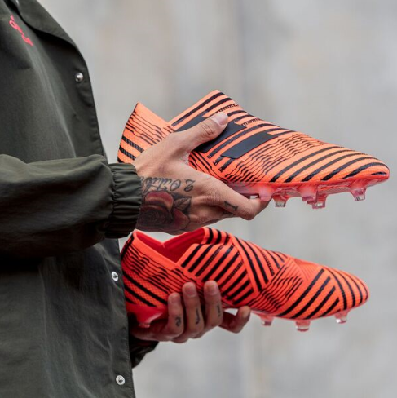

Portland, Ore., September 29, 2017 – adidas Soccer released today a bold new orange and black design for NEMEZIZ 17+ 360 AGILITY – the brand’s latest cleat innovation. Built to enhance the performance of the game’s most agile players, NEMEZIZ 17+ 360 AGILITY is inspired by the idea of ‘taping’, a process used commonly in sport to deliver security, support and adaptability.

The new Pyro Storm cleat includes an AGILITYBANDAGE with TORSIONTAPES technology, designed to deliver the perfect fit by ensuring the foot remains locked in place. A dual-lock collar secures the ankle in place and allows for explosive change of direction.

The TORSIONFRAME outsole features an ultra-lightweight construction and TORSIONRIBS to provide dynamic push off support, which is vital for agile movement. The new AGILITYKNIT 2.0 interlocking yarn structure provides a soft direct touch and a lightweight, adaptable feel.

To ensure players can experience the same level of agility in any setting, Pyro Storm NEMEZIZ 17+ 360 AGILITY is also available in both Cage and Street versions. Featuring the same orange and black colors as the on-field cleat, both the cage and street shoes feature the same TORSIONTAPES and AGILITYKNIT 2.0, giving the most agile players the same tools to support their agility in the cage and on the street.

The latest pack also includes a specially designed colorway, a white shoe with bright orange adidas three stripes, for the best player in the world, Leo Messi.

The Pyro Storm NEMEZIZ 17+ 360 AGILITY is available from today at adidas.com and adidas retail stores.

For more information visit http://www.adidas.com/us/soccer and join the conversation on Twitter​ and Instagram​ with #HereToCreate.

- END -

For further media information please visit http://news.adidas.com/US/home/SOCCER or contact:

Cristina Maillo Belda
PR Manager, adidas Soccer
Email: Cristina.maillobelda@external.adidas.com
Tel: 503.915.9129

About adidas Soccer
adidas is the global leader in soccer. It is the official sponsor / official supplier partner of the most important soccer tournaments in the world, such as the FIFA World Cup™, the FIFA Confederations Cup, the UEFA Champions League, the UEFA Europa League, the UEFA European Championships and Major League Soccer. adidas also sponsors some of the world’s top clubs including Manchester United, Real Madrid, FC Bayern Munich, Juventus and AC Milan. Some of the world’s best players also on the adidas roster are Leo Messi, Paul Pogba, Gareth Bale, Karim Benzema, Roberto Firmino, Thomas Müller, Luis Suárez, James Rodríguez, Diego Costa, Mesut Özil, Renato Sanches and Julian Draxler.

