STADIUM EMBARGOED UNTIL FRIDAY 29TH SEPTEMBER, 10AM CET
Please download high res images of ACE 17+ PURECONTROL here and COPA 17 here

adidas Soccer Reveals New Colorway for ACE 17+ PURECONTROL

- Pyro Storm ACE 17+ PURECONTROL an explosive orange and black orange colorway -
- Stadium, Cage and Street versions available for players who like to control the game in any setting -
- Stadium cleat to be worn on-field by the likes of Paul Pogba, Dele Alli and Mesut Ozil -

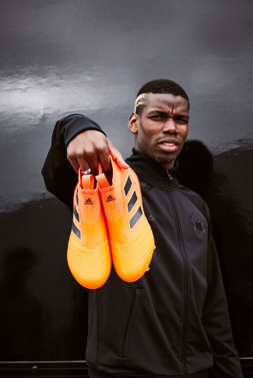

Portland, Ore., September 29, 2017 – adidas Soccer revealed today the Pyro Storm collection. The newly redesigned range features adaptations of the on-field, cage and street ACE 17+ PURECONTROL with a vibrant new colorway made for players who bring the heat to any pitch.

The ACE 17+ PURECONTROL Stadium cleat features:
- A PRIMEKNIT upper to ensure zero wear-in time
- A PURECUT Sock System designed to lock the foot in place while adjusting to complex movements
- Bold new colorway featuring three vibrant tones of orange, with the iconic adidas three stripes in black
- Iconic BOOST sole delivering elite energy return

The ACE 17+ PURECONTROL Cage shoe features:
- The same orange colorway as the on-pitch boot
- A PRIMEKNIT upper and NON STOP GRIP (NSG) film to deliver close ball control
- A stretchable layer of TECHFIT material optimizing comfort
- A BOOST heel counter and the adidas three stripes in black

The Pyro Storm ACE 17+ PURECONTROL collection is completed by the Street shoe, which features:
- A three-piece PRIMEMESH material
- A TECHFIT color coating on the three stripes
- A full-length BOOST midsole

The Pyro Storm ACE 17+ PURECONTROL will be available to purchase from today at adidas.com and adidas retail stores.

For more information visit http://www.adidas.com/us/soccer and join the conversation on Twitter​ and Instagram​ with #HereToCreate.

- END -

For further media information please visit http://news.adidas.com/US/home/SOCCER or contact:

Cristina Maillo Belda
PR Manager, adidas Soccer
Email: Cristina.maillobelda@external.adidas.com
Tel: 503.915.9129

About adidas Soccer
adidas is the global leader in soccer. It is the official sponsor / official supplier partner of the most important soccer tournaments in the world, such as the FIFA World Cup™, the FIFA Confederations Cup, the UEFA Champions League, the UEFA Europa League, the UEFA European Championships and Major League Soccer. adidas also sponsors some of the world’s top clubs including Manchester United, Real Madrid, FC Bayern Munich, Juventus and AC Milan. Some of the world’s best players also on the adidas roster are Leo Messi, Paul Pogba, Gareth Bale, Karim Benzema, Roberto Firmino, Thomas Müller, Luis Suárez, James Rodríguez, Diego Costa, Mesut Özil, Renato Sanches and Julian Draxler.

