New team, new stripes, one goal
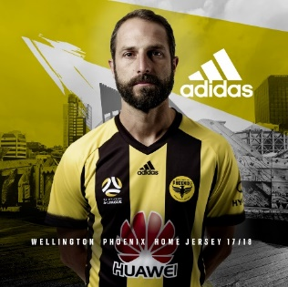
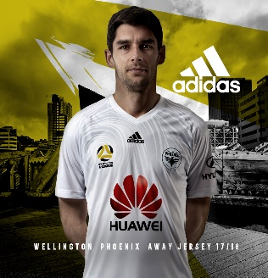

- adidas unveils new strip for 2017/18 season -
- home and away kit reflects new Hyundai A-League branding -
New Zealand, 31 August, 2017 – adidas Football has today unveiled the highly-anticipated Wellington Phoenix home and away strips for the 2017/2018 A-league season.

Both designs deliver bold updates on previous strips whilst maintaining the rich heritage of the country’s only A-League team, clever design throughout showcases a heightened sense of pride in both their team and the New Zealand capital.

The bold black and yellow stripes of the home jersey recognise the teams’ daring and courageous approach entering the new season. By the heart of each player sits the new team logo, the first update to the club insignia since joining the A-League. Within the logo sits a new Phoenix, the ten strands of the wings and the tail represent a strong and unified starting XI. E Rere Te Keo, a Maori inscription, specifically recognises Wellington as home “the resounding call” of the taniwha Ngake, urging the team to strive to work ever harder.

In stark contrast, the new away strip shows off a clean, white look. The subtle swirls on the chest, a visual cue to the iconic winds of their home city.

Both jerseys, a collaborative venture between the Wellington Phoenix and adidas, see a refined fit to enable maximum movement and comfort on pitch. The inclusion of the moisture wicking innovation, adidas Climalite technology, ensures players remain cool and dry even in the toughest climates.

Fans can show their ultimate support by purchasing the new Wellington Phoenix range. The new home and away jerseys are available in men and youth sizes. The range will be stocked at all football specialist and major sporting goods retailers, adidas stores, and online at www.adidas.co.nz

-ends-

For further information, please contact:
Cassidy Meredith
Spark PR & Activate
M: +6421 752 586
E: cassidy.meredith@sparkactivate.co.nz

About adidas Football:
adidas is the global leader in football. It is the official sponsor / official supplier partner of the most important football tournaments in the world, such as the FIFA World Cup™, the FIFA Confederations Cup, the UEFA Champions League, the UEFA Europa League and the UEFA European Championships. adidas also sponsors some of the world’s top clubs including Manchester United, Real Madrid, FC Bayern Munich, Juventus and AC Milan. Some of the world’s best players also on the adidas roster are Leo Messi, Paul Pogba, Gareth Bale, Luis Suárez and Mesut Özil.

