**cid:image001.png@01D2FE2D.99230C00**

**adidas Soccer and New York City FC Kick Off Fashion Week, Bring Soccer from the Stadium to the Street**

**- Guests in attendance included NYCFC players Mikey Lopez and Jonathan Lewis -**

**- Held at #NYCFCHouse, in Manhattan’s Meatpacking District, the event featured a live performance by DJ Sliink -**

**- Taking inspiration from the streets of NY and soccer, the venue celebrated the intersection of sport and culture -**

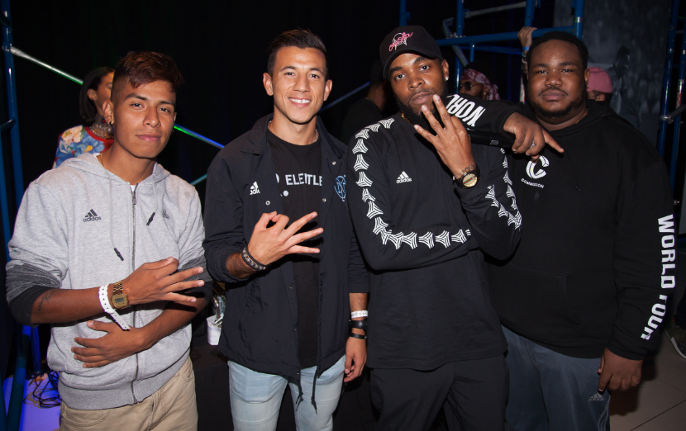

**NEW YORK, September 7, 2017 –** On the back of a 1-0 win versus Sporting KC on Wednesday night, adidas Soccer and New York City Football Club kicked off New York’s Fashion Week by taking the sport of soccer from the stadium to the street at the club’s first-ever Pop-Up shop and experiential space in the heart of Manhattan’s Meatpacking District.

Guests in attendance, which included NYCFC players Mikey Lopez and Jonathan Lewis, local influencers and soccer fans from the Tri-State area, were treated to a live performance by NYC-based hybrid dance music artist DJ Sliink. In addition, they were able to collaborate with local artists to create personalized memorabilia.

Located at 446 West 14th Street, the four story location took inspiration from the energy of the city and its obstacles to design a space that intersects sport and culture. As guests entered the store, they were greeted with high energy videos underscoring New York’s relationship with street soccer, an experience that translated throughout the venue.

Surrounded by adidas Soccer’s latest stadium to street NEMEZIZ collection, guests had the chance to experience the connection between the city and the sport by interacting with the street players and influencers featured in the videos and in the instore gallery of local NYC soccer stories.

Open through Sep. 21, the #NYCFCHouse will continue to feature a series of soccer-related events, viewing parties, access to exclusive product releases, and a full assortment of team merchandise available for purchase.

For more information visit [**http://www.adidas.com/us/soccer**](http://www.adidas.com/us/soccer) and [**https://www.nycfc.com/house#popup**](https://urldefense.proofpoint.com/v2/url?u=https-3A__www.nycfc.com_house-23popup&d=DwMFaQ&c=o6x-uYg5urBaLMPPRuq64I5b6ZOFWaPdobkZ8TbBW7M&r=uV_geiGmJMpRdSyozaiJPxvvN26JOC2zyXjsukZhVAQ&m=DpQiC5Q4rEXqW9uZylJhm7rMoBWLDsrny82CswztCXY&s=nWMDRTJDtTCEdoSwlDg9CiKi_wwFaNCd3nuLj7tOlyI&e=) and join the conversation on [Twitter](https://twitter.com/adidassoccer)​ and [Instagram](https://www.instagram.com/adidasfootball/)​ with [#HereToCreate](https://www.instagram.com/explore/tags/heretocreate/).

**- END -**

**For further media information please visit** [**http://news.adidas.com/US/home/SOCCER**](http://news.adidas.com/US/home/SOCCER) **or contact:**

|  |  |
| --- | --- |
| Cristina Maillo Belda  PR Manager, adidas Soccer  Email: [Cristina.maillobelda@external.adidas.com](mailto:Cristina.maillobelda@external.adidas.com)  Tel: 503.915.9129 |  |

**About adidas Soccer**

adidas is the global leader in soccer. It is the official sponsor / official supplier partner of the most important soccer tournaments in the world, such as the FIFA World Cup™, the FIFA Confederations Cup, the UEFA Champions League, the UEFA Europa League and the UEFA European Championships and Major League Soccer. adidas also sponsors some of the world’s top clubs including Manchester United, Real Madrid, FC Bayern Munich, Juventus and AC Milan. Some of the world’s best players also on the adidas roster are Leo Messi, Paul Pogba, Gareth Bale, Karim Benzema, Roberto Firmino, Thomas Müller, Luis Suárez, James Rodríguez, Diego Costa, Mesut Özil, Renato Sanches and Julian Draxler.