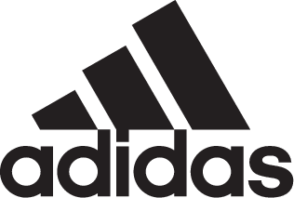

A Classic Reborn: adidas Soccer, David Beckham and Zinedine Zidane Reveal New Predator Precision

- David Beckham features in new Predator Precision launch imagery -
- Zinedine Zidane will launch new boot at an event in adidas Paris Soccer store -
- New Limited Collection cleat brings modern technology to a classic design -
- Latest model re-imagined from the original blue Predator Precision from 2000 -

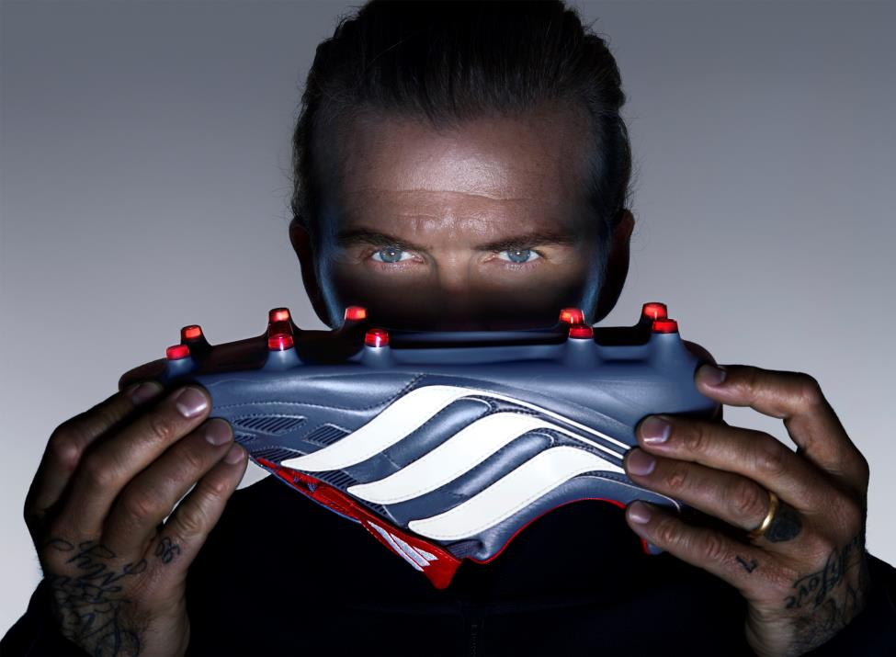

Portland, Ore., September 5, 2017– adidas Soccer has today launched a limited edition version of one of its most iconic cleats – the Predator Precision. Worn by some of the game’s best players, including David Beckham, Zinedine Zidane and Steven Gerrard, the new release has been re-imagined for the soccer players of today with the integration of the latest adidas technologies.

To reveal the cleat, adidas Soccer teamed up with renowned British fashion photographer Nick Knight to capture imagery with David Beckham, one of the players to make the cleat famous in 2000 with pin-point passing and deadly accuracy from set pieces.

The new Predator Precision, part of the Limited Collection range, is a replica of the iconic blue cleat from 2000 and features one-to-one color matching. The use of premium K Leather delivers on performance and offers the cleat a classic look.

Modern adidas technologies, including the introduction of modern tooling and a new lightweight upper, offers today’s soccer players the chance to control the game just as the original did.

The new Predator Precision will be available in limited numbers starting tomorrow at adidas.com and in selected retailers from Sep. 8.

For more information visit http://www.adidas.com/us/soccer and join the conversation on Twitter​ and Instagram​ with #HereToCreate.

- END -

For further media information please visit http://news.adidas.com/US/home/SOCCER or contact:

Cristina Maillo Belda
PR Manager, adidas Soccer
Email: Cristina.maillobelda@external.adidas.com
Tel: 503.915.9129

About adidas Soccer
adidas is the global leader in soccer. It is the official sponsor / official supplier partner of the most important soccer tournaments in the world, such as the FIFA World Cup™, the FIFA Confederations Cup, the UEFA Champions League, the UEFA Europa League, the UEFA European Championships and Major League Soccer. adidas also sponsors some of the world’s top clubs including Manchester United, Real Madrid, FC Bayern Munich, Juventus and AC Milan. Some of the world’s best players also on the adidas roster are Leo Messi, Paul Pogba, Gareth Bale, Karim Benzema, Roberto Firmino, Thomas Müller, Luis Suárez, James Rodríguez, Diego Costa, Mesut Özil, Renato Sanches and Julian Draxler.

