EMBARGOED UNTIL THURSDAY 24TH AUGUST, 6PM CET
Please download high res images here

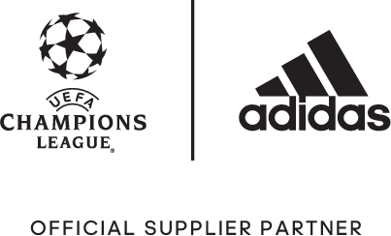

adidas Soccer Reveals Thunderstorm-Inspired Official Match Ball for the UEFA Champions League 2017/18 Group Stage

- New thunderstorm design celebrates the playing style of those competing at Europe’s highest level -
- Ball officially launched during UEFA Champions League draw for 2017/18 -

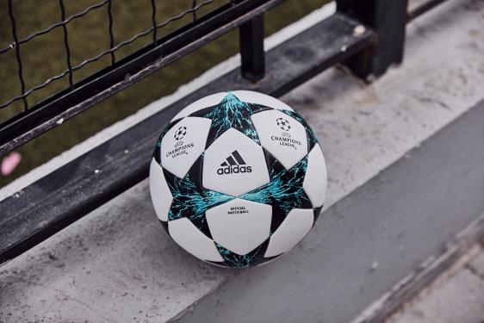

Portland, Ore., August 24, 2017 – adidas Soccer officially revealed today the match ball that will be used in the group stages of this year’s UEFA Champions League.

The new ball features the established star-panel design inspired by the UEFA Champions League Logo that has become a feature of adidas UCL Official Match Balls. The 2017/18 version comes infused with new energy thanks to a dramatic blue and turquoise thunderstorm graphic.

The design ensures optimal performance for players in any condition. An outer texture coating, consistent across all adidas UCL Official Match Balls, offers secure grip and complete control while the thermally bonded star panels provide a seamless surface for an improved first touch. Taking a picture with flash will reveal a thunderstorm graphic on all of the uppers.

The new adidas Soccer UEFA Champions League Official Match Ball is now available on adidas.com and adidas retail stores.

For more information visit http://www.adidas.com/us/soccer and join the conversation on Twitter​ and Instagram​ with #HereToCreate.

- END -

For further media information please visit http://news.adidas.com/US/home/SOCCER or contact:

Cristina Maillo Belda
PR Manager, adidas Soccer
Email: Cristina.maillobelda@external.adidas.com
Tel: 503.915.9129

About adidas Soccer
adidas is the global leader in soccer. It is the official sponsor / official supplier partner of the most important soccer tournaments in the world, such as the FIFA World Cup™, the FIFA Confederations Cup, the UEFA Champions League, the UEFA Europa League and the UEFA European Championships and Major League Soccer. adidas also sponsors some of the world’s top clubs including Manchester United, Real Madrid, FC Bayern Munich, Juventus and AC Milan. Some of the world’s best players also on the adidas roster are Leo Messi, Paul Pogba, Gareth Bale, Karim Benzema, Roberto Firmino, Thomas Müller, Luis Suárez, James Rodríguez, Diego Costa, Mesut Özil, Renato Sanches and Julian Draxler.

