EMBARGOED UNTIL 9th AUGUST 1PM PT
Please download high res images here

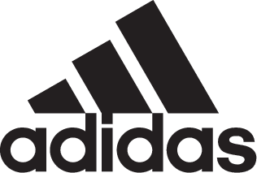

adidas Athletics unveils new Z.N.E. Pulse Collection, the first apparel range to be inspired by athletes’ heartbeats

- Inspired by athletes’ heartbeats and pre-game emotions, adidas Athletics created the
Z.N.E. Pulse Knit Hoodie featuring a unique ‘heartbeat knit’ pattern -
- adidas Athletics has used unique athlete data – to inspire the collection -
- Z.N.E. Pulse Collection will be worn by global athletes including
Paul Pogba and Gareth Bale -

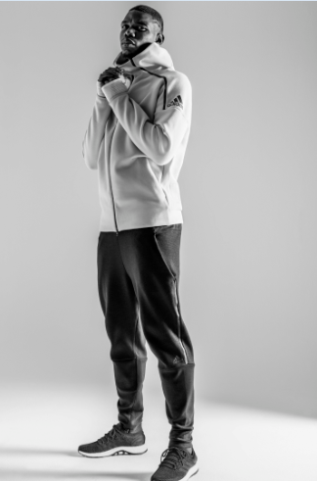

Portland, Ore. / London, UK, August 9, 2017 - adidas Athletics has today unveiled its latest Z.N.E. collection, the first apparel range of its kind to be inspired by the rising heartbeat of athletes before a game.

adidas has worked closely with athletes during the development process, including collecting and analyzing data to help shape the Athletics Pulse range. This focuses on the ‘pulse moment’ when athletes leave the locker room and head towards the field, a moment when their heart rate peaks in anticipation.

At the heart of the collection is the adidas Z.N.E. Pulse Knit Hoodie, crafted with the unique heartbeat knit in breathable merino wool. It is designed to ensure a comfortable fit for every athlete, no matter the sport they compete in.

The collection, which features a variety of knitted and Jacquard hoodie designs, is created to seamlessly move from game day to any day. Its next level craftsmanship is evidenced in the trim details, iconic design markers and functional construction. The knit version also ensures the wearer stays cool when the pre-match heat is on.

"In Athletics, we constantly aim to enable athletes to give their best, by providing them with apparel that makes them feel comfortable and allows them freedom of movement without distraction,” said Christina Schramm, Senior Design Director.

Schramm continued, “Knitting techniques open a huge innovation area for how to create and construct sportswear at the highest level of comfort. The use of functional and innovative yarns, the integration of open and dense structures and the construction of the garments without any seams provide huge functional advantages. This is combined with huge possibilities in terms of the combination of yarn colors, patterns, structures, surfaces and silhouettes – meaning athletes can look and perform great."

The collection will be worn by a selection of leading athletes from across a range of sports. This includes Manchester United midfielder Paul Pogba and Real Madrid forward Gareth Bale, Green Bay Packers quarterback Aaron Rodgers, Houston Astros Shortstop Carlos Correa, basketball stars James Harden and Damian Lillard, track athlete Tori Bowie, leading tennis players Angelique Kerber and Simona Halep, and TV host Rachel DeMita.

“My pulse is up already the night before the race,” said Tori Bowie, multi-medalist in 100m and 200m. “I am focusing on my technique, that’s what I’m thinking of when I concentrate. When I’m walking out in the tunnel, this is the moment I was training for.”

The adidas Athletics Z.N.E. Pulse Collection, from $110 to $200, to is available globally on August 31 and will be available for a pre-sale exclusively on adidas.com starting August 22. Follow the conversation using #ThePulseOf and #ZNE at @adidas on Twitter, Facebook and Instagram.

For more information visit http://www.adidas.com/us/soccer and join the conversation on Twitter​ and Instagram​ with #NEMEZIZ and #HereToCreate.

- END -

For further media information please visit http://news.adidas.com/US/home/SOCCER or contact:

Cristina Maillo Belda
PR Manager, adidas Soccer
Email: Cristina.maillobelda@external.adidas.com
Tel: 503.915.9129

About adidas Soccer
adidas is the global leader in soccer. It is the official sponsor / official supplier partner of the most important soccer tournaments in the world, such as the FIFA World Cup™, the FIFA Confederations Cup, the UEFA Champions League, the UEFA Europa League and the UEFA European Championships and Major League Soccer. adidas also sponsors some of the world’s top clubs including Manchester United, Real Madrid, FC Bayern Munich, Juventus and AC Milan. Some of the world’s best players also on the adidas roster are Leo Messi, Paul Pogba, Gareth Bale, Karim Benzema, Roberto Firmino, Thomas Müller, Luis Suárez, James Rodríguez, Diego Costa, Mesut Özil, Renato Sanches and Julian Draxler.

About adidas Athletics
adidas Athletics mission is to reinvigorate and revolutionize the badge of sport as an object of desire. It recognizes the need for athletic expression off the field of play, whatever the field of play. Bridging the gap between athletes’ style and their life of sport, it champions a unique and fresh point of view, celebrating and highlighting the untold stories of innovation that get under the skin of sport.

