OLYMPIC CHAMPIONS SHAUNAE MILLER-UIBO AND WAYDE VAN NIEKERK DEBUT

WORLD’S FIRST PARLEY RUNNING SPIKE AT THE IAAF WORLD CHAMPIONSHIPS

• The Prime SP Parley is the first sprint spike to combine high-performance 3D knit and

360-degree Primeknit technology for a lighter, more breathable upper

• Each pair contains Parley Ocean Plastic™ which is recycled plastic intercepted from coastal communities before it reaches the ocean

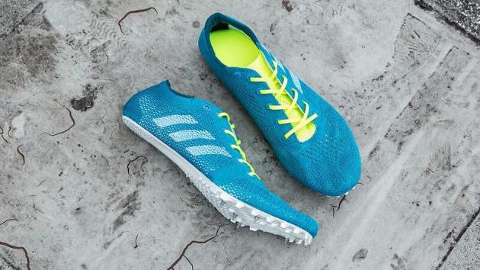

Herzogenaurach/London, August 8th, 2017: Today, at the IAAF World Championships, adidas Running unveiled the first high-performance 3D knitted sprint spike, created with plastic taken from beaches and coastal communities before reaching the oceans, the adidas Prime SP Parley. The silhouette focuses both on the needs of sprinters, by incorporating a Primeknit upper for support and a laser welded frame for reduced weight, and the needs of the world, by integrating Parley Ocean Plastic™ and protecting our oceans from marine plastic pollution.

The new silhouette’s upper combines adidas’ 360-degree Primeknit technology, creating a lighter yet snug fit, whilst fusing together a double layer of Parley knitted yarn to reduce stretch and ensure ultimate support and breathability during performance.

In the sole, each design element contributes to making the wearer’s race the greatest yet. Incorporating a laser welded frame and a reduced size Nano-plate half the size of other spikes, the Parley Prime SP provides support and reduced elevation, allowing a more natural feel. Individually designed and placed with precision pins to minimize breaking force, a unique landing shelf allows sprinters to explode from the starting blocks and use this power to gain momentum throughout the race.

400m world record holder Wayde Van Niekerk said of the shoe, “Choosing a racing spike is one of the most important decisions an athlete can make, but for this year’s IAAF World Championships there was no doubt in my mind that the adidas Prime SP Parley was the one for me. It makes each stride feels natural yet powerful and they are so light I don’t even notice I’m wearing them. I also love how the eye-catching colour helps me stand out on the track.”

Matthias Amm, Category Director, adidas Running said, “It is a privilege to work with world-class athletes, such as Olympic Champions Shaunae Miller-Uibo and Wayde Van Niekerk, and designing products that aid their performance is key. As a result, we have created a design that feels natural and helps athletes perform at their best under immense pressure. By integrating Parley Ocean Plastic™ into the silhouette it allows us to make this about more than just breaking world records, we are helping to save the Oceans, one pair at a time”

To find out more, please visit: adidas.com/Parley.

Follow the conversation at @adidasrunning on Instagram, Twitter and Facebook using #adizero
#adidasParley.

END

For questions or more information please contact:

Global PR adidas Running: Laura.Baum@adidas.com

