adidas by Stella McCartney Unveils US Open Collection
-Signature preppy aesthetic of New York meets high performance tennis gear -
-Outfits to be worn on courts of Flushing Meadows by Caroline Wozniacki and Andrea Petkovic-
-Available now in speciality retailers and online -

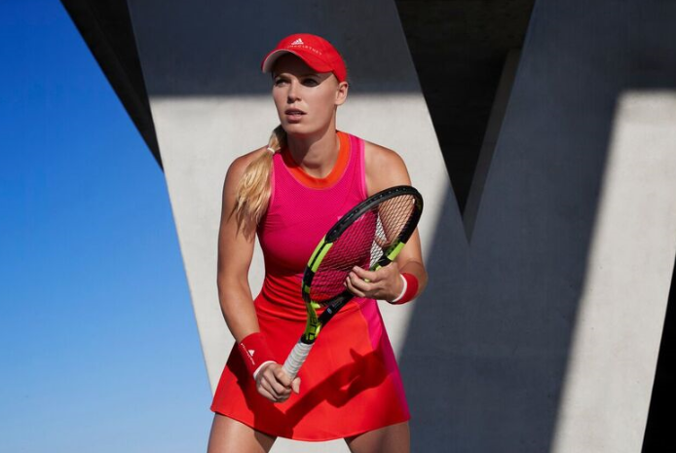

Herzogenaurach, Germany, August 7th 2017: ​adidas by Stella McCartney’s Barricade FW17 US Open collection is unveiled today, ready to finish the Grand Slam season in style. For the final open of 2017, Stella McCartney has taken inspiration from the streets of New York with preppy sport lux neck lines and pleated skirt designs twisted to provide a contemporary finish that combine to meet the performance needs of the professional athlete.

After the all-white of Wimbledon, the US Open sees a return to colour. Available in vibrant pink, red and orange colourway, the collection delivers a strong pop of colour inspired by the New York sunset skyline.

World Number 6, Caroline Wozniacki, will wear the new adidas by Stella McCartney Barricade dress in the stunning pink/orange colourway. Using seamless structures to create a sophisticated and elegant fit, the Barricade dress is sure to make a statement on the US Open courts.

Caroline Wozniacki comments: “New York is the place I call home, so this tournament always feels very special to me. This city is all about style and I'm excited to be wearing the adidas by Stella McCartney Barricade dress in such a beautiful colour. I'm playing well this year and confident that my consistency all season will help me produce my best tennis of the year in front of the crowds that feel like home support.”

Andrea Petkovic will wear the adidas by Stella McCartney Barricade tank and skort. Providing a two piece outfit that is the fusion of style and technical performance, the Barricade tank takes on a white and striking orange aesthetic. In continuity with the adidas Stella McCartney Barricade dress, the tank sees the inclusion of the vibrant pink detailing on the left arm. To be worn alongside the tank, the adidas Barricade skort embraces vintage colour blocked pleating, taking inspiration from the signature New York preppy fashion scene that has led the design of the collection.

The adidas by Stella McCartney Barricade footwear range continues onto the US Open courts. Specifically designed for the female player, the collection includes the 2017 Barricade shoe. Combining quality materials and detailing, the 2017 Barricade shoe will launch in a light grey and white colourway with radiant orange contrast detailing. The choice of footwear for Andrea Petkovic during the US Open, while Caroline Wozniacki will wear the Stella McCartney Barricade BOOST in the striking solar pink and orange colourway.

Featuring BOOST technology to help athletes unleash energy on the court, this shoe is crafted from premium materials and provides the ultimate comfort and technical excellence encapsulated in a beautiful design and colourway. BOOST proprietary cushioning ensures maximum energy return for the long US Open games on the iconic blue courts of Flushing Meadows.

The 2017 adidas by Stella McCartney US Open collection is available now in high end and speciality retailers worldwide, the adidas by Stella McCartney flagship store in Brompton Cross, London and online at http://www.adidas.co.uk/tennis​. Follow the conversation with #aSMC and #mygame

ENDS

For further media information please visit adidas News Stream or contact:
Lindsey Rossell
Email: Lindsey.rossell@hkstrategies.com
Phone: +44 7413 3163

Please also visit:
www.facebook.com/adidaswomen
http://instagram.com/adidaswomen
www.adidas.com/tennis https://twitter.com/adidastennis

Notes to editors:
For imagery see the adidas by Stella McCartney Barricade 2017 US Open Lookbook

About adidas by Stella McCartney
adidas by Stella McCartney collaboration was launched in Spring/Summer 2005 and remains a unique concept for women’s sports performance. The highly innovative sports performance range consists of apparel, footwear and accessory pieces in Tennis, Running, Yoga, Training and Swim

