adidas Soccer Launches New Ocean Storm Colorway For NEMEZIZ

- Ocean Storm NEMEZIZ 17+ 360 AGILITY a striking two-tone navy blue & turquoise colorway -
- NEMEZIZ design feature inspired by the process of taping for increased stability and agility -
- Ocean Storm NEMEZIZ 17+ 360 AGILITY to be worn by Leo Messi, Roberto Firmino & Julian Draxler -

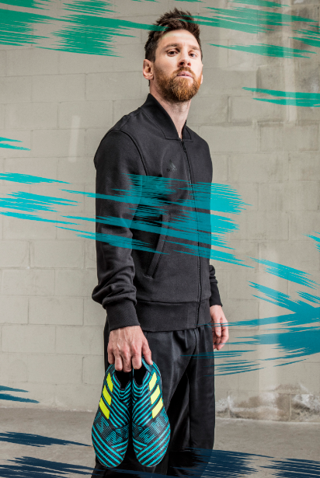

PORTLAND, Ore., July 28th, 2017 – adidas Soccer has today dropped its latest colorway for NEMEZIZ 17+ 360 AGILITY – the brand’s latest cleat innovation. Designed to enhance the performance of the game’s most agile players, NEMEZIZ is inspired by the idea of ‘taping’; a process used commonly in sport to deliver security, support and adaptability.

These unique features are apparent through the cleat’s AGILITYBANDAGE, featuring revolutionary TORSIONTAPES technology to keep the foot locked down and deliver ultimate fit. A dual-lock collar secures the ankle in place to enable explosive change of direction.

The TORSIONFRAME outsole features an ultra-lightweight construction and TORSIONRIBS to provide dynamic push off support; a key feature for agile movement. The new AGILITYKNIT 2.0 interlocking yarn structure provides a soft direct touch and a lightweight, adaptable feel.

The striking new two-tone colorway features dark blue and turquoise trim alongside the classic adidas three stripes in yellow.

To ensure players can experience the same level of agility in any setting, Ocean Storm NEMEZIZ is also available in both Cage and Street adaptations. With the same colorway as the on-field cleat, both the cage and street shoes feature the same TORSIONTAPES and AGILITYKNIT 2.0, giving the most agile players the same tools to support their agility in the cage and on the street.

The Ocean Storm NEMEZIZ collection is available from today on adidas.com and adidas retail stores.

For more information visit http://www.adidas.com/us/soccer and join the conversation on Twitter​ and Instagram​ with #NEMEZIZ and #HereToCreate.

- END -

For further media information please visit http://news.adidas.com/US/home/SOCCER or contact:

Cristina Maillo Belda
PR Manager, adidas Soccer
Email: Cristina.maillobelda@external.adidas.com
Tel: 503.915.9129

About adidas Soccer
adidas is the global leader in soccer. It is the official sponsor / official supplier partner of the most important soccer tournaments in the world, such as the FIFA World Cup™, the FIFA Confederations Cup, the UEFA Champions League, the UEFA Europa League and the UEFA European Championships and Major League Soccer. adidas also sponsors some of the world’s top clubs including Manchester United, Real Madrid, FC Bayern Munich, Juventus and AC Milan. Some of the world’s best players also on the adidas roster are Leo Messi, Paul Pogba, Gareth Bale, Karim Benzema, Roberto Firmino, Thomas Müller, Luis Suárez, James Rodríguez, Diego Costa, Mesut Özil, Renato Sanches and Julian Draxler.

