EMBARGOED UNTIL 21st JULY, 10AM CET
Please download high res images here

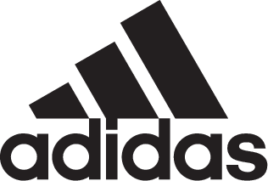

adidas Soccer Launches Third Jerseys Created By Fans for 2017/18 Season

- FC Bayern, Real Madrid CF, Manchester United, Juventus, AC Milan and Flamengo reveal third jerseys designed by fans -
- Third jerseys created and produced as part of adidas Soccer Creator Studio, a digital platform giving fans the chance to design the shirts of these iconic clubs -
- Third jerseys will be worn during the 2017/18 season -

Portland, Ore., July 21st, 2017 – adidas Soccer today revealed the third jerseys for FC Bayern Munich, Real Madrid CF, Manchester United, Juventus, AC Milan & Flamengo for the 2017/18 season, all designed by fans. The new kits were designed and produced using the adidas Soccer Creator Studio platform, channeling and celebrating the creativity of soccer fans all over the world.

The Creator Studio platform allowed fans the opportunity to design the third jerseys for the above six clubs – the ultimate expression of fan creativity. All submissions were voted on by fans in a ‘battle-mode’ that saw the most popular designs shortlisted to a top 100. The winners for each club were then chosen by an expert panel of some of the clubs most iconic players. The selected jerseys – which will be worn on-field during the 2017/18 season – are:

FC Bayern
The jersey represents a modern inversion on classic elements of FC Bayern kit design. The white jersey features thin red stripes down the front of the shirt, fading out as they reach the bottom. Pure white sleeves give it a clean and totally unique look for a FC Bayern shirt, while still channeling classic colors and design from the club’s history.

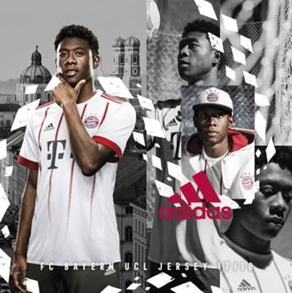

Real Madrid CF
The new third jersey brings a truly unique and creative look to this iconic team. The winning design features a predominantly teal shirt with black stripes on the shoulder and white branding. The design takes inspiration from modern digital design, with a square graphic pattern in two corners breaking up the front of the shirt and representing the disruptive nature of the reigning European Champions.

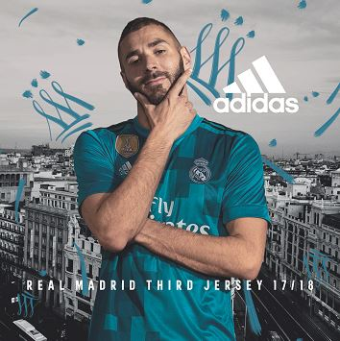

Manchester United
The United third jersey represents the powerful bond between the team and its fans. The light grey shirt is designed with a graphic showing the silhouette of the famous ‘Holy Trinity’ statue outside of the club’s Old Trafford stadium. The statue of club icons Sir Bobby Charlton, George Best and Denis Law represents a golden era in the club’s history which turned into the inspiration for the new third kit.

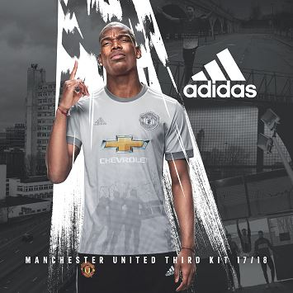

Juventus
The Juventus jersey combines the past and the future in a way perfectly suited to an iconic club that is constantly re-inventing itself on and off the field. The shirt channels the past thanks to a military green color and the inclusion of the famous Juventus black and white stripes across the chest. The shirt brings the club right up to date though, thanks to the inclusion of the club’s sleek new logo – part of its new ‘Black and White and More’ brand identity.

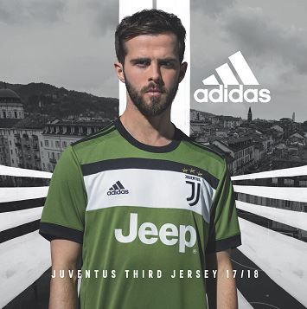

AC Milan
AC Milan’s jersey brings a totally unique twist to a classic design. The kit features the iconic red and black colors of the club, reinterpreted in a new graphic design. A bright red pattern across the chest against an all-black shirt is unlike anything the famous club has ever had before.

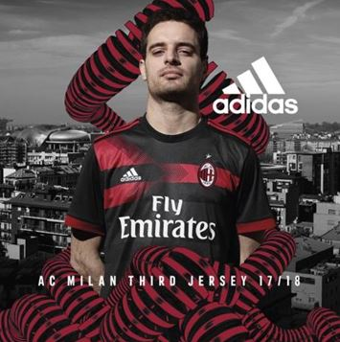

Flamengo
Flamengo, a club known for its iconic jerseys, has a new bright yellow kit with blue trim, paying homage to the club’s energetic and creative style of play. A blue graphic design on the sleeves represents a modern and unique style, making this one of the most creative kits in the club’s history.

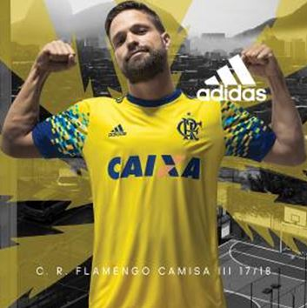

The new jerseys are exclusively available through adidas.com and official club stores starting today.

For more information visit http://www.adidas.com/us/soccer and join the conversation on Twitter​ and Instagram​ with #HereToCreate.

- END -

For further media information please visit http://news.adidas.com/US/home/SOCCER or contact:

Cristina Maillo Belda
PR Manager, adidas Soccer
Email: Cristina.maillobelda@external.adidas.com
Tel: 503.915.9129

About adidas Soccer
adidas is the global leader in soccer. It is the official sponsor / official supplier partner of the most important soccer tournaments in the world, such as the FIFA World Cup™, the FIFA Confederations Cup, the UEFA Champions League, the UEFA Europa League and the UEFA European Championships and Major League Soccer. adidas also sponsors some of the world’s top clubs including Manchester United, Real Madrid, FC Bayern Munich, Juventus and AC Milan. Some of the world’s best players also on the adidas roster are Leo Messi, Paul Pogba, Gareth Bale, Karim Benzema, Roberto Firmino, Thomas Müller, Luis Suárez, James Rodríguez, Diego Costa, Mesut Özil, Renato Sanches and Julian Draxler.

