adidas SPORT17: ‘Create Positivity’ Athlete Q&A’s

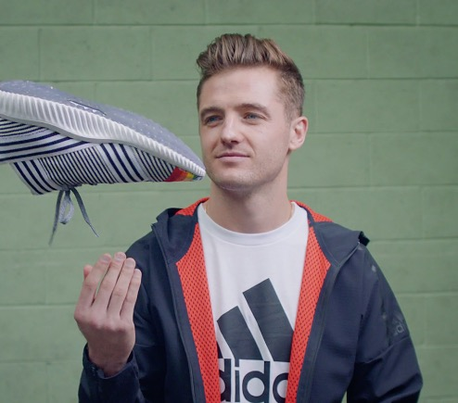
ROBBIE ROGERS
Winger for the LA Galaxy and U.S. Men’s National Soccer Teams

Would you say that sport has positively influenced your life? If so, how?
- Yes, sports (soccer) have been the biggest influence in my life of all. It's allowed me to travel the world. Meeting people from all different cultures, religions, social economic backgrounds and has taught me to be open minded and accepting of all types of people. My sport has been the most fundamental part of my education and I owe everything to it.

Do you have any examples of how sport turned something negative into a positive for you? What did you learn?
- Being a gay man in sports I always felt like an outsider on the inside. It can be a very macho masculine culture which I thought wasn't accepting of gay men and women. My coming out in sports and continuing to play proved not only to myself but to the world that sports are for everyone and better off with all different types of people.

Do you believe that sport brings positivity to a world that feels unsettled? If so, how?
- Yes, for example when you watch the World Cup and the excitement of the fans and their passion, you realize how simple and similar we are. How much happiness and unity a team can bring us. How this event can bring us all together even in a world where especially at the moment we feel so divided and torn apart.

What stands out to you in the "Create Positivity" TV spot?
- I love how the spot celebrates our differences. I also love how creativity on the field and off are our greatest assets. We shine as a team when we take all of our great creative characteristics and work as one team and that is a lesson to learn on and off the field.

How do you use creativity in sport?
- I think of my sport as an art. The movement and athleticism is an artistic performance and I approach every game and practice with that in mind. I like to enjoy the flow of the game and its rhythm as well as put on a show for the fans.

How does creativity impact sport and/or positivity in sport?
- As I've stated above each of us has a unique brand of creativity and it's all of those combined that really makes a great team. It's what creates a great team, a great locker-room, and in the end wins championships.

DAK PRESCOTT
2016 Offensive Rookie of the Year, Quarterback Dak Prescott of the Dallas Cowboys

Would you say that sport has positively influenced your life? If so, how?
- Sport is one thing that has always given me peace in my life, it’s given me opportunity, college scholarship, my career.

Do you have any examples of how sport turned something negative into a positive for you? What did you learn?
- Sport gave me peace through an extremely tough time in my life when I lost my mom. Losing my mom inspired me to play the game for her. On-field adversity is nothing compared to what can happen off the field.

Do you believe that sport brings positivity to a world that feels unsettled? If so, how?
- The majority of people can relate to some type of sport… it’s a common ground where people can come together for the same cause. Sport unites people for one cause.

What stands out to you in the "Create Positivity" TV spot?
- I was amazed by how athletic and creative the kids were. The spot showed how people from different teams, different cultures and different backgrounds in general can come together for one cause, one goal.

How do you use creativity in sport?
- I try to be creative when I have to be… usually that's when a play breaks down and I have to extend it and try to make a negative into a positive.

How does creativity impact sport and/or positivity in sport?
- Creativity brings extra excitement… Dunks, one handed catches, outfielders climbing the wall to catch a home run. Excites your teammates and the crowd.

DEANDRE HOPKINS
Pro Bowl Wide Receiver for the Houston Texans

Would you say that sport has positively influenced your life? If so, how?
- Playing sports positively influenced my life by getting me out of an environment that wasn't going to better my life or my family’s. It gave me an opportunity.

Do you have any examples of how sport turned something negative into a positive for you? What did you learn?
- When my mom went blind when I was very young, I was in a bad place mentally and emotionally. Playing sports gave me a comfort zone where I could escape my problems and positively impact my family’s life.

Do you believe that sport brings positivity to a world that feels unsettled? If so, how?
- Sports taught me and teaches young people today leadership and teamwork skills. These are skills they can use in everyday life - working together with others to achieve one goal.

What stands out to you in the "Create Positivity" TV spot?
- The creativity of the spot really stands out to me. The energy of the team was great and very positive.

How do you use creativity in sport?
- The way I play in general is different - it's my way. It's creative because of my style, the way I catch the ball, my vision - and that creativity is definitely a positive thing.

CARLOS CORREA
2015 Major League Baseball (MLB) American League Rookie of the Year, Shortstop for the Houston Astros

Would you say that sport has positively influenced your life? If so, how?
- Yes - without question. Sport has given me an opportunity to be entertained as a spectator and provided opportunities for individual growth as an athlete. I've enjoyed the challenges presented to me by Sport as an athlete and celebrated the victories and learned from the defeats. In addition, baseball has allowed me to make a living and support myself and my family but also at the same time to provide support to many of those less fortunate than me through my work in community outreach and charity.

Do you have any examples of how sport turned something negative into a positive for you? What did you learn?
- Whenever I have lost or failed, sport has always given me another opportunity to meet those challenges again, learn from my experience, make myself better and have the chance to succeed again. This has taught me to always have faith in myself, keep trying my best and to never give up.

Do you believe that sport brings positivity to a world that feels unsettled? If so, how?
- Sport brings a lot of positivity to the world for those who enjoy watching. It provides a means for people to get together to form a community when getting behind their favorite athletes or teams and also provides an escape for many people from day to day stresses.

What stands out to you in the "Create Positivity" spot?
- Diversity and creativity.

How do you use creativity in sport?
- I chose to form a partnership with adidas based partly on their creative nature in the marketplace and their willingness to have me collaborate on the design of the spikes and other equipment I wear daily on the field, I believe it allows my creativity to show.

How does creativity impact sport and/or positivity in sport?
- I believe creativity leads to innovation and advancement in how we play the game. In Sport, as in life, we are always looking to perform and express ourselves in new, more effective ways.

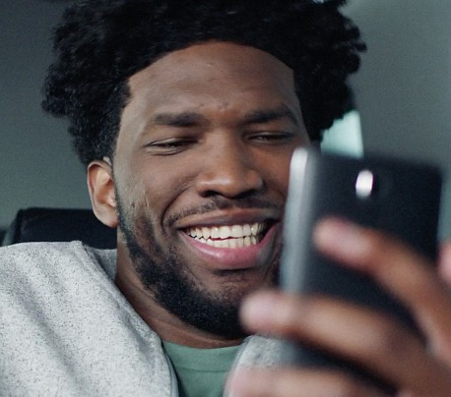
JOEL EMBIID
NBA All-Rookie First Team Center for the Philadelphia 76ers

Would you say that sport has positively influenced your life? If so, how?
- Sport has influenced my life. It allows me to play basketball for a living, so I appreciate it and what it has done for my life.

Do you have any examples of how sport turned something negative into a positive for you? What did you learn?
- Sport helps me get out on the court and relieve stress. It’s my world and allows me to be me.

Do you believe that sport brings positivity to a world that feels unsettled? If so, how?
- Yes, sport definitely brings positivity to an unsettled world, it provides a source of entertainment for people.

How do you use creativity in sport?
- I use creativity every day when I play. Coming up with post moves and what not. Just honestly, you have to be creative and come up with new moves in basketball.

How does creativity impact sport and/or positivity in sport?
- Creativity impacts sport and positivity because it allows one to be different and not follow the mold. Which turns into positivity.

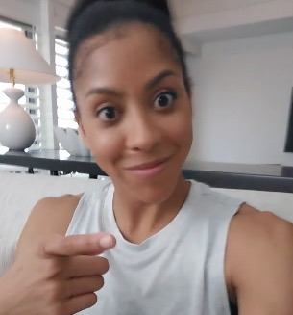
CANDICE PARKER
2016 WNBA World Champion and WNBA Final MVP, forward for the LA Sparks

Would you say that sport has positively influenced your life? If so, how?
- Yes, sports have armed me with the tools to excel at life. As a result of learning lessons like team work and handling success and failure.

Do you have any examples of how sport turned something negative into a positive for you? What did you learn?
- I was injured a great deal early in my career and as a result I was forced to sit on the sideline. My injuries forced me to develop the mental part of my game and to improve my approach and preparation. My injuries made me a better player because I respect the game a great deal more because of them.

Do you believe that sport brings positivity to a world that feels unsettled? If so, how?
- People unite in sport. Through trying times, individuals from different backgrounds come together to celebrate, support and respect competition.
What stands out to you in the "Create Positivity" spot?
- How special it is in this day and age, EVERYONE near and far can share their talents and push others to excel even further, try even harder and to break through boundaries that we thought never possible.

How do you use creativity in sport?
- Every aspect of my game is creativity. I love how every game is a blank slate and it allows me to leave my mark in a different way every time I'm on the floor.

How does creativity impact sport and/or positivity in sport?
- Every player, game, practice, etc. is different and new and exciting in its own way.

# # #

