EMBARGOED UNTIL 3rd JULY, 10AM CET
Please download high res images here

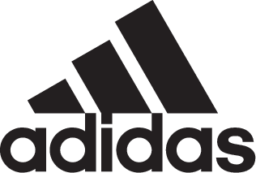

adidas Soccer Reveals Manchester United Home Kit for the 2017/18 Season

- Latest home kit features new button-up collar design -
- Jersey to be worn on pitch for the first time during the club’s pre-season match vs. LA Galaxy on July 15th -

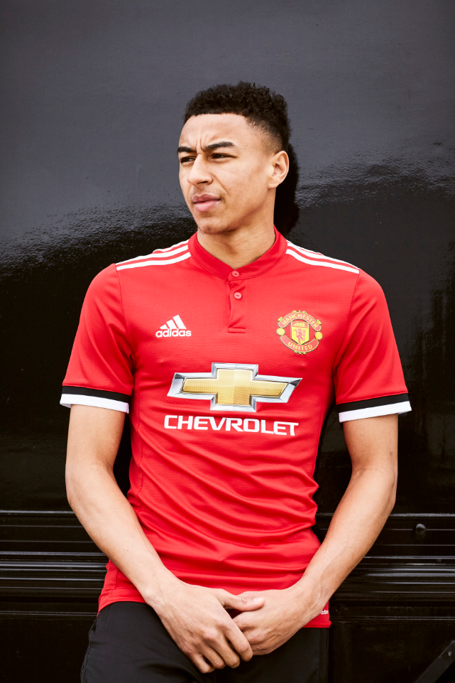

Portland, Ore., July 3rd, 2017 – adidas Soccer has today revealed the Manchester United home jersey for the 2017/18 season, which will be worn for the first time when the club plays the LA Galaxy on July 15th during their preseason tour in the United States. Celebrating the club’s third year with adidas, the new home kit will be worn by the likes of Paul Pogba, Juan Mata and Ander Herrera.

The latest home jersey features a minimalist, sophisticated design which pays homage to some of the classic kits from the past, at the same time as being at the forefront of technical sportswear design with technical, breathable fabrics and mesh engineering.

The jersey features: an all-new button-up collar offering an elegant and contemporary design; the adidas three stripes in white on the shoulders; and red, white and black sleeves to represent the colors of the match-day flags seen at United.

The home jersey is now available on adidas.com and in adidas global retail stores.

For more information visit http://www.adidas.com/us/soccer and join the conversation on Twitter​ and Instagram​ with #HereToCreate.

- END -

For further media information please visit http://news.adidas.com/US/home/SOCCER or contact:

Cristina Maillo Belda
PR Manager, adidas Soccer
Email: Cristina.maillobelda@external.adidas.com
Tel: 503.915.9129

About adidas Soccer
adidas is the global leader in soccer. It is the official sponsor / official supplier partner of the most important soccer tournaments in the world, such as the FIFA World Cup™, the FIFA Confederations Cup, the UEFA Champions League, the UEFA Europa League and the UEFA European Championships and Major League Soccer. adidas also sponsors some of the world’s top clubs including Manchester United, Real Madrid, FC Bayern Munich, Juventus and AC Milan. Some of the world’s best players also on the adidas roster are Leo Messi, Paul Pogba, Gareth Bale, Karim Benzema, Roberto Firmino, Thomas Müller, Luis Suárez, James Rodríguez, Diego Costa, Mesut Özil, Renato Sanches and Julian Draxler.

