EMBARGOED UNTIL 1ST JULY 10AM CET
Please download high res images here

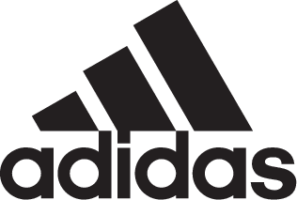

adidas Soccer Reveals New Yellow and Blue Juventus Away Kit for 2017/18 Season

- Distinctive colorway is a throwback to an era of dominance in the 1980s -
- The colors pay tribute to the city of Turin -
- First away kit to feature the club’s new logo and brand identity ‘Black and White and More’ -

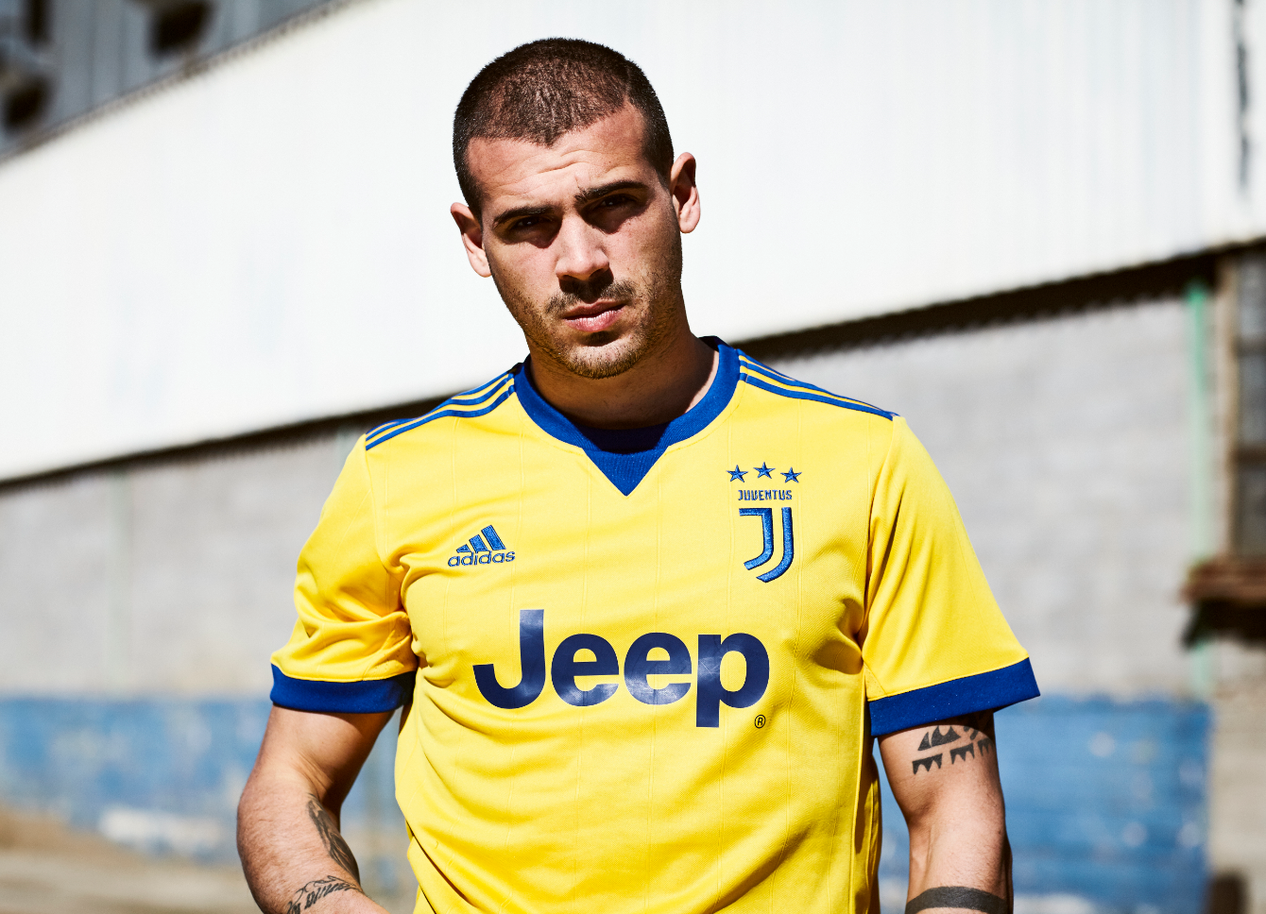

Portland, Ore., July 1st, 2017– In the middle of another period of dominance, adidas Soccer has today released the new away kit for Italian giants, Juventus Football Club. Inspired by one of the club’s golden eras and the city colors of Turin, the new yellow and blue away jersey for the 2017/18 season has been designed with the Bianconeri’s classic away shirts from the 1980s in mind.

The kit comes at a time when the club is once again re-inventing itself, so the retro style from the ‘80s has been given a modern revival to match with the club’s new logo and redesigned identity ‘Black and White and More’.

This new philosophy is running through everything the club does, highlighting its innovative and uncompromising drive forward. The distinctive new ‘J’ logo features the club’s iconic stripes in a sleek and bold style, which in the away kit, the logo stands out in a bold blue color against the yellow shirt.

The new away kit is now available on adidas.com and in adidas global retail stores.

For more information visit http://www.adidas.com/us/soccer and join the conversation on Twitter​ and Instagram​ with #HereToCreate.

- END -

For further media information please visit http://news.adidas.com/US/home/SOCCER or contact:

Cristina Maillo Belda
PR Manager, adidas Soccer
Email: Cristina.maillobelda@external.adidas.com
Tel: 503.915.9129

About adidas Soccer
adidas is the global leader in soccer. It is the official sponsor / official supplier partner of the most important soccer tournaments in the world, such as the FIFA World Cup™, the FIFA Confederations Cup, the UEFA Champions League, the UEFA Europa League and the UEFA European Championships and Major League Soccer. adidas also sponsors some of the world’s top clubs including Manchester United, Real Madrid, FC Bayern Munich, Juventus and AC Milan. Some of the world’s best players also on the adidas roster are Leo Messi, Paul Pogba, Gareth Bale, Karim Benzema, Roberto Firmino, Thomas Müller, Luis Suárez, James Rodríguez, Diego Costa, Mesut Özil, Renato Sanches and Julian Draxler.

