EMBARGOED UNTIL 30th JUNE, 10AM CET
Please download high res images here

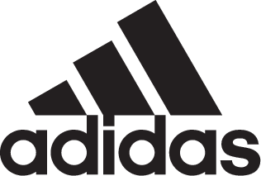

FC Bayern Revive Old Fan Favorite with New adidas Soccer 2017/18 Away Jersey

- New shirt is released to coincide with the 20th anniversary of the club switching their main jersey from red to navy -
- Retro style combines with modern technology thanks to new breathable mesh -

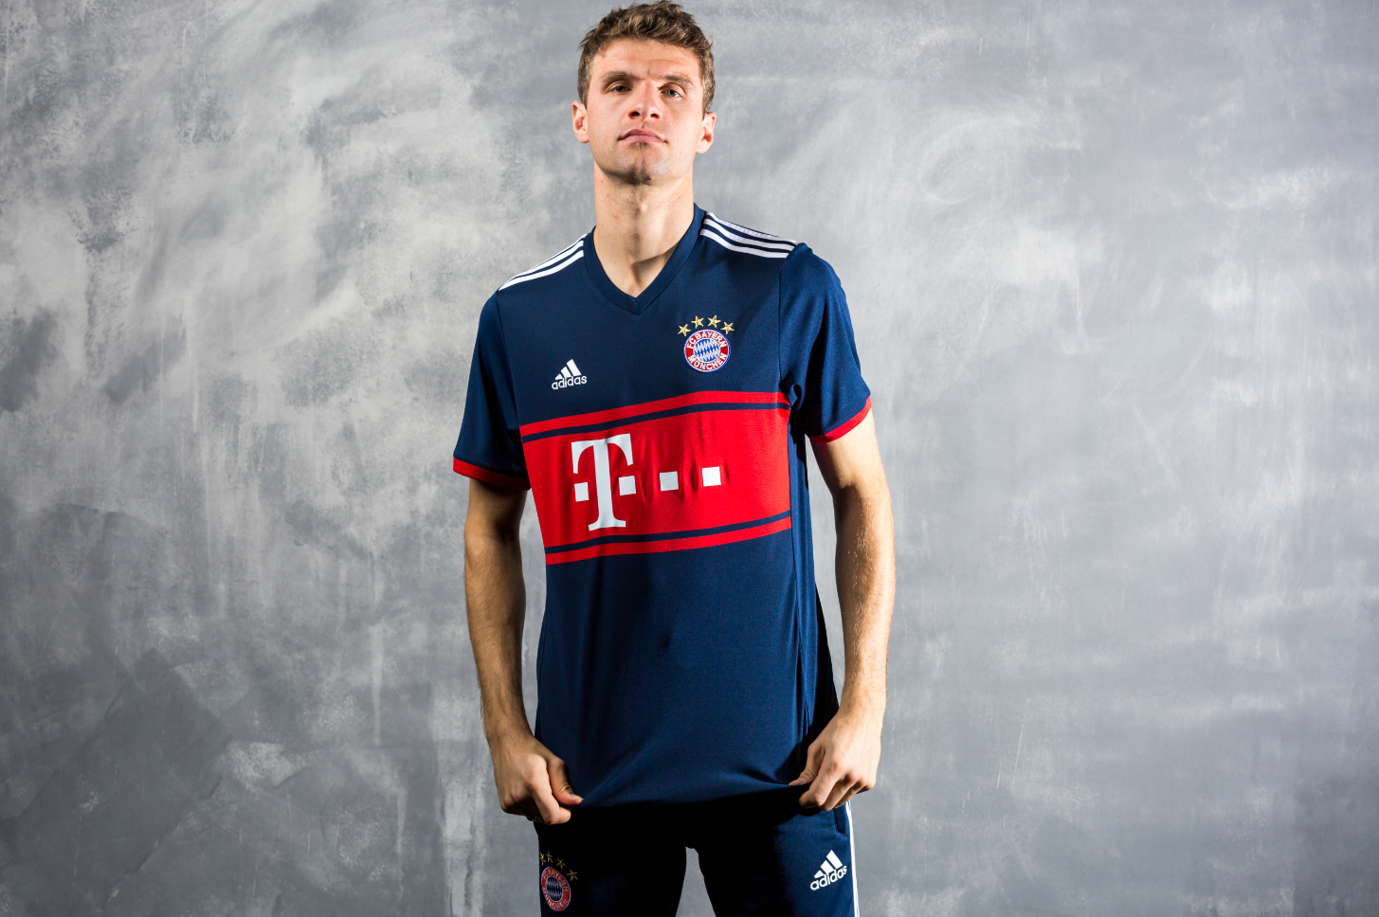

Portland, Ore., June 30th, 2017 – adidas Soccer and German champions, FC Bayern, have today revealed the club’s new away jersey for the 2017/18 season. The new navy kit with red stripes has been released to coincide with the twentieth anniversary of the club switching its home jersey from red to navy.

Fans of the German champions will recognize the design, as it is based on one of the club’s most loved jerseys. The new away kit combines its striking design with the latest adidas Soccer technology. An example of this design-meets-performance approach comes with the red stripe across the shirt. It is made of a highly breathable mesh material, allowing for better air circulation keeping players cool and on top of their game in any conditions.

The away jersey is now available along the home kit on adidas.com and in adidas global retail stores.

For more information visit http://www.adidas.com/us/soccer and join the conversation on Twitter​ and Instagram​ with #HereToCreate.

- END -

For further media information please visit http://news.adidas.com/US/home/SOCCER or contact:

Cristina Maillo Belda
PR Manager, adidas Soccer
Email: Cristina.maillobelda@external.adidas.com
Tel: 503.915.9129

About adidas Soccer
adidas is the global leader in soccer. It is the official sponsor / official supplier partner of the most important soccer tournaments in the world, such as the FIFA World Cup™, the FIFA Confederations Cup, the UEFA Champions League, the UEFA Europa League and the UEFA European Championships and Major League Soccer. adidas also sponsors some of the world’s top clubs including Manchester United, Real Madrid, FC Bayern Munich, Juventus and AC Milan. Some of the world’s best players also on the adidas roster are Leo Messi, Paul Pogba, Gareth Bale, Karim Benzema, Roberto Firmino, Thomas Müller, Luis Suárez, James Rodríguez, Diego Costa, Mesut Özil, Renato Sanches and Julian Draxler.

