EMBARGOED UNTIL 29th JUNE, 10AM CET
Please download high res images here

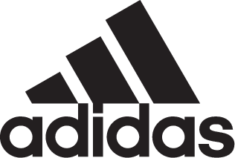

adidas Soccer Reveals New AC Milan Away Jersey for 2017/18 Season

- New white kit combines rich tradition with contemporary design -
- Unique graphic pattern follows retro street trend, inspired by the club’s past -
- White shirt and two tone stripes match the club’s success in European competitions -

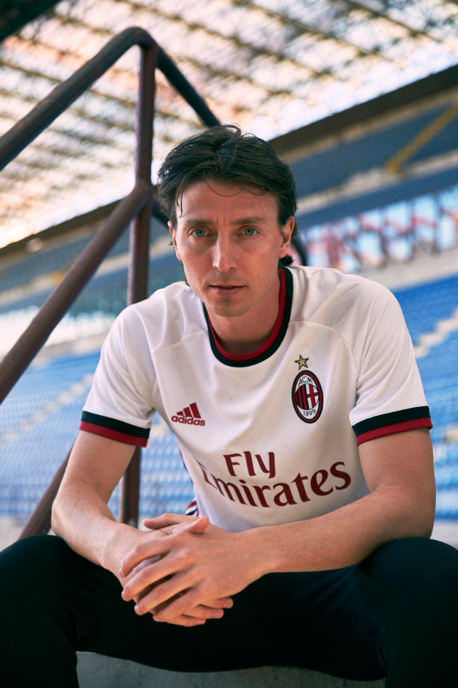

Portland, Ore., June 29th, 2017 – adidas Soccer and AC Milan today revealed a bold new design for the club’s 2017/18 season away jersey. The kit celebrates the past and present of a soccer icon with a new retro graphic design created to match contemporary street style.

AC Milan is a club that combines a rich history with a creative spirit. The new away kit retains the style DNA of the Italian giants while integrating a modern trend in a retro graphic design. For the kit, adidas Soccer designed a graphic pattern to bridge the gap between the past and the present. The graphic is built around a recurring “M” logo.

The logo is inspired by a red and black "M" taken from an AC Milan document in which the club communicated about logos on the jerseys for the 1982/83 and 1983/84 seasons. This logo has been updated with a modern touch.

While innovating on style, the new away jersey nods to the dominant history of the Rossoneri. The white shirt features two-tone red and black stripes, famously seen in the UEFA Champions League winning jerseys of 2002/03 and 2006/07. The design of the collar and cuffs also pays homage to the 1966/67 jersey.

The away kit is now available on adidas.com and in adidas global retail stores.

For more information visit http://www.adidas.com/us/soccer and join the conversation on Twitter​ and Instagram​ with #HereToCreate.

- END -

For further media information please visit http://news.adidas.com/US/home/SOCCER or contact:

Cristina Maillo Belda
PR Manager, adidas Soccer
Email: Cristina.maillobelda@external.adidas.com
Tel: 503.915.9129

About adidas Soccer
adidas is the global leader in soccer. It is the official sponsor / official supplier partner of the most important soccer tournaments in the world, such as the FIFA World Cup™, the FIFA Confederations Cup, the UEFA Champions League, the UEFA Europa League and the UEFA European Championships and Major League Soccer. adidas also sponsors some of the world’s top clubs including Manchester United, Real Madrid, FC Bayern Munich, Juventus and AC Milan. Some of the world’s best players also on the adidas roster are Leo Messi, Paul Pogba, Gareth Bale, Karim Benzema, Roberto Firmino, Thomas Müller, Luis Suárez, James Rodríguez, Diego Costa, Mesut Özil, Renato Sanches and Julian Draxler.

