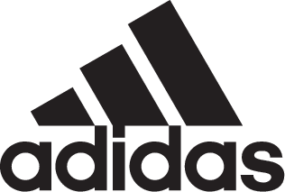

adidas Soccer Reveals 2017/18 Kits For UEFA Champions League Winners Real Madrid

- New kits celebrate the powerful link between the club and the city of Madrid -
- Home jersey features sky blue stripes, inspired by the Madrid sky -
- Black away shirt inspired by the club’s dominant past -

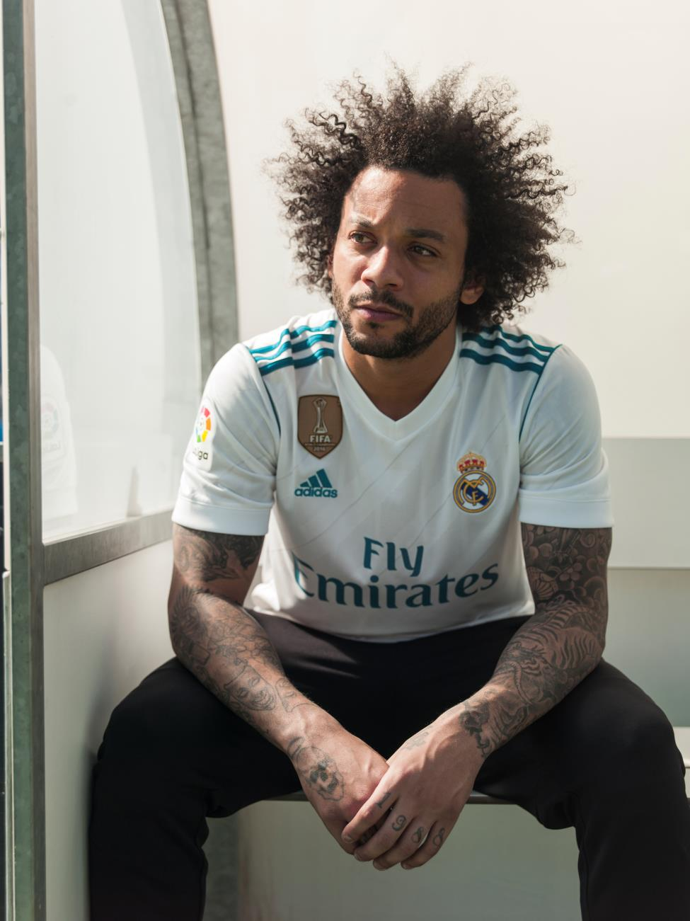

Portland, Ore., June 14th, 2017 – adidas Soccer and Real Madrid today revealed the club’s new jerseys for the 2017/18 season, inspired by the club’s loyal fans – the Madridistas – and the city of Madrid.

The new home jersey is designed to bring the players and fans of Real Madrid closer together with a kit just as suited to the streets of Madrid as it is the Santiago Bernabéu. The introduction of sky blue stripes and branding is inspired by the Madrid sky to represent the connection between the club and the city.

The classic white of Real Madrid is more prominent than ever before thanks to a new stripe design that cuts off at the shoulders. A memorial stamp at the bottom of the jersey commemorates the club’s 115-year anniversary.

The new away jersey draws inspiration from previous black Madrid kits worn by the club in some of its most successful moments. The jersey continues the theme of the home kit with a new trim color – this time with turquoise green stripes. The Real Madrid logo is re-imagined in turquoise green with a neon effect to stand out against the black.

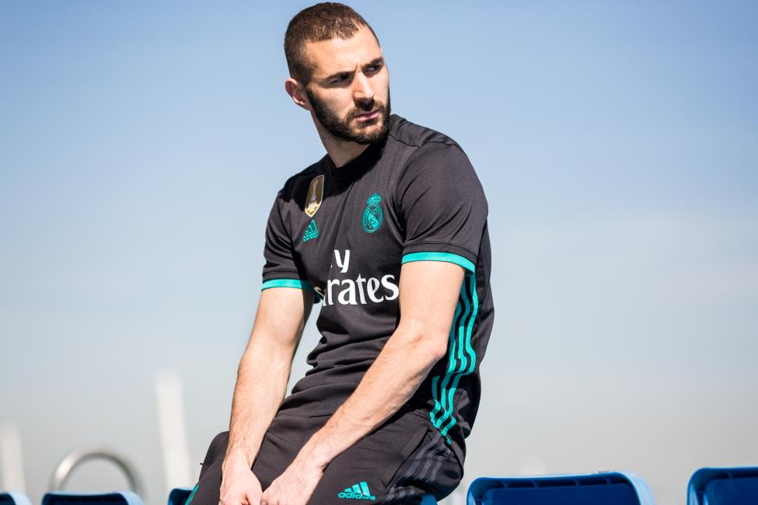

As well as the bold new design, each shirt is built with the latest in adidas performance technology. The use of Climacool technology ensures players stay cool and perform at their best even in the toughest conditions. The kit is made of a new fabric that is softer and more comfortable for players on the field, and the fans off it.

The new home and away jerseys are available from today on adidas.com​ and in adidas global retail stores.

For more information visit http://www.adidas.com/us/soccer and join the conversation on Twitter​ and Instagram​ with #HereToCreate.

- END -

For further media information please visit http://news.adidas.com/US/home/SOCCER or contact:

Cristina Maillo Belda
PR Manager, adidas Soccer
Email: Cristina.maillobelda@external.adidas.com
Tel: 503.915.9129

About adidas Soccer
adidas is the global leader in soccer. It is the official sponsor / official supplier partner of the most important soccer tournaments in the world, such as the FIFA World Cup™, the FIFA Confederations Cup, the UEFA Champions League, the UEFA Europa League and the UEFA European Championships and Major League Soccer. adidas also sponsors some of the world’s top clubs including Manchester United, Real Madrid, FC Bayern Munich, Juventus and AC Milan. Some of the world’s best players also on the adidas roster are Leo Messi, Paul Pogba, Gareth Bale, Karim Benzema, Roberto Firmino, Thomas Müller, Luis Suárez, James Rodríguez, Diego Costa, Mesut Özil, Renato Sanches and Julian Draxler.

