adidas by Stella McCartney Showcases Wimbledon Collection for Muguruza and Wozniacki
- Classic Wimbledon all-white is given an upgrade with textured design -
- Collection inspired by vintage and feminine style -
- Available now in speciality retailers and online -

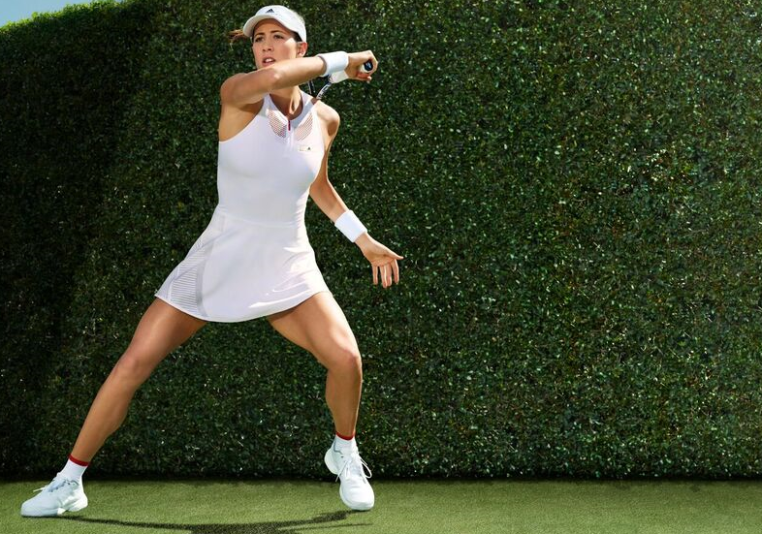

Herzogenaurach, Germany, June 14: adidas by Stella McCartney’s Barricade SS17 Wimbledon collection is set to be worn on the iconic courts of SW19 by World number 7 Garbiñe Muguruza and World number 10 Caroline Wozniacki. The collection – available now – is a fresh approach to the traditional whites at the All England Tennis Club.

For Fall Winter 2017, adidas by Stella McCartney debuts new visual identity inclusive of a fresh logo design which will be featured throughout the collection. This season and beyond, adidas by Stella McCartney celebrates creativity in Tennis, encouraging women to nurture both mind and body on and off court. Demonstrating the brand’s commitment to cutting-edge performance, and inimitable style cues, the Wimbledon collection offers dynamic designs, engineered to support the highest level of performance.

With long-established restrictions on colour at Wimbledon, the adidas by Stella McCartney Barricade Wimbledon collection focuses on texture and finish to offer a modern style that still fits the traditional feel of the tournament. Looking at vintage lingerie in all-white for inspiration, McCartney has developed a collection that adds elegance and innovation to the standard tennis style.

World Number 7, Garbiñe Muguruza, will wear the new adidas by Stella McCartney Barricade dress in white. The 3-in-1 design features a textured look, crafted through blending different knitting techniques. Climacool material enhances the body’s natural temperature regulation; ensuring the athlete is prepared to play in comfort in the unpredictable British weather.

Garbiñe Muguruza comments: “I love to experiment with my style on and off the court but it can be difficult to express your personality at Wimbledon. The combination of different textures makes my dress really stand out; one of the reasons I am really happy to be wearing adidas by Stella McCartney.”

Caroline Wozniacki will wear the adidas by Stella McCartney Barricade tank, which is designed with open mesh detail and a sculptured fit around the body. She will wear this with a matching skirt that features an all-knitted premium finish.

Caroline Wozniacki says: “This season is going great! I’ve been playing some of my best tennis and I’m excited and hopeful to translate that into success at Wimbledon this year. My outfit this year is such a modern twist on the traditional Wimbledon outfit – I’m excited to wear it on court!”

The 2017 adidas by Stella McCartney Wimbledon collection is available now in high end and speciality retailers worldwide, the adidas by Stella McCartney flagship store in Brompton Cross, London and online at http://www.adidas.co.uk/tennis. Follow the conversation with #aSMC and #mygame

ENDS

For further media information please visit
adidas News Stream or contact:
Lindsey Rossell Email: Lindsey.rossell@hkstrategies.com
Phone: +44 7413 3163

Please also visit:
www.facebook.com/adidaswomen
http://instagram.com/adidaswomen
www.adidas.com/tennis
https://twitter.com/adidastennis

Notes to editors:

For imagery see the adidas by Stella McCartney Barricade 2017 Wimbledon Lookbook

About adidas by Stella McCartney
adidas by Stella McCartney collaboration was launched in Spring/Summer 2005 and remains a unique concept for women’s sports performance. The highly innovative sports performance range consists of apparel, footwear and accessory pieces in Tennis, , Running, Yoga, Trainingand Swim

About adidas Tennis
adidas Tennis is represented by top players such as Simona Halep, Angelique Kerber, Garbiñe Muguruza, Caroline Wozniacki, Tomas Berdych, Lucas Pouille, Dominic Thiem, Jo-Wilfried Tsonga, Sascha Zverev and Novak Djokovic (Footwear Only). For more information on adidas Tennis, please visit www.adidas.com/tennis. For additional images please visit our media news room on news.adidas.com and follow us on Twitter or on Instagram under @adidasTennis.

About adidas
The adidas Group is a global leader in the sporting goods industry, offering a broad portfolio of footwear, apparel and hardware for sport and lifestyle around the core brands adidas, Reebok, TaylorMade and CCM Hockey. Headquartered in Herzogenaurach, Germany, the Group employs more than 55,000 people across the globe and generated sales of around € 17 billion in 2015.

