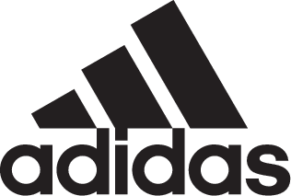

adidas Soccer Reveals New Juventus Home Kit for 2017/18 Season

- New kit is first to feature the club’s new logo and brand identity: ‘Black and White and More’ -
- Italian club will wear the jersey as they chase a record seventh straight Scudetto title -
- Jersey features design detail inspired by iconic Juventus kits of the past -

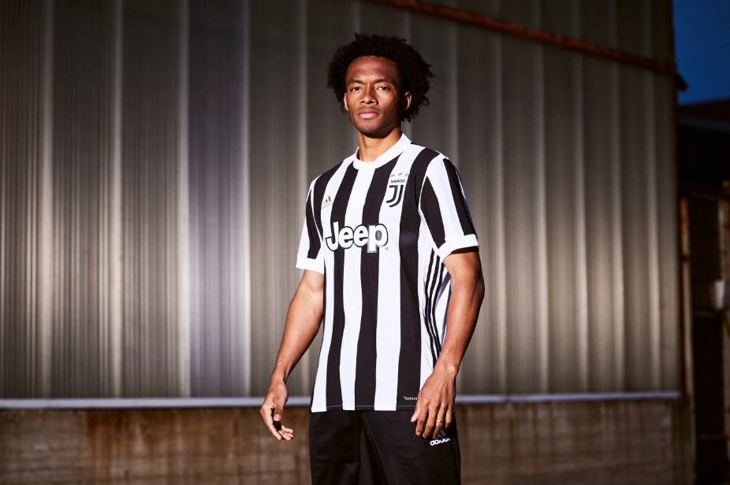

Portland, Ore., June 7th, 2017 – On the back of securing their sixth straight Italian league title, Italian powerhouse Juventus Football Club have revealed their new home kit for the 2017/18 season. The club continues to reinvent itself while honoring the past, as the new kit features inspiration from classic Bianconeri shirts. The jersey also features the new club logo and brand identity for the first time.

Several design details pay homage to iconic Juventus shirt designs of the 1940s. The jersey features a wider black back panel stripe and wider front stripe. As well as the new modern logo, a stand-up collar gives a classical and elegant look.

The new kit will be the first to feature the club’s redesigned identity: ‘Black and White and More’. This philosophy is running through everything the club does, highlighting its innovative and uncompromising drive forward. The distinctive J logo reflects a modern and forward-thinking approach and the start of a new era for one of the world’s most successful clubs.

The new jersey is available from today on adidas.com​ and in adidas global retail stores.

For more information visit http://www.adidas.com/us/soccer and join the conversation on Twitter​ and Instagram​ with #HereToCreate.

- END -

For further media information please visit http://news.adidas.com/US/home/SOCCER or contact:

Cristina Maillo Belda
PR Manager, adidas Soccer
Email: Cristina.maillobelda@external.adidas.com
Tel: 503.915.9129

About adidas Soccer
adidas is the global leader in soccer. It is the official sponsor / official supplier partner of the most important soccer tournaments in the world, such as the FIFA World Cup™, the FIFA Confederations Cup, the UEFA Champions League, the UEFA Europa League, the UEFA European Championships and Major League Soccer. adidas also sponsors some of the world’s top clubs including Manchester United, Real Madrid, FC Bayern Munich, Juventus, Chelsea and AC Milan. Some of the world’s best players also on the adidas roster are Leo Messi, Paul Pogba, Gareth Bale, Karim Benzema, Roberto Firmino, Thomas Müller, Luis Suárez, James Rodríguez, Diego Costa, Mesut Özil, Renato Sanches and Julian Draxler.

