FOR IMMEDIATE RELEASE
Please download high res images of the event here

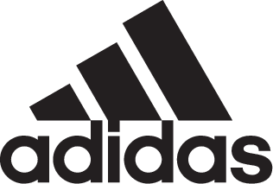

adidas Soccer Talent Join Forces To Celebrate Launch of NEMEZIZ

- Jesse Lingard, Timo Werner and Hakan Calhanoglu launch latest silo -
- Nemeziz available in stadium, cage and street editions -
- Lingard and Ander Herrera showcase the UEFA Europa League trophy -

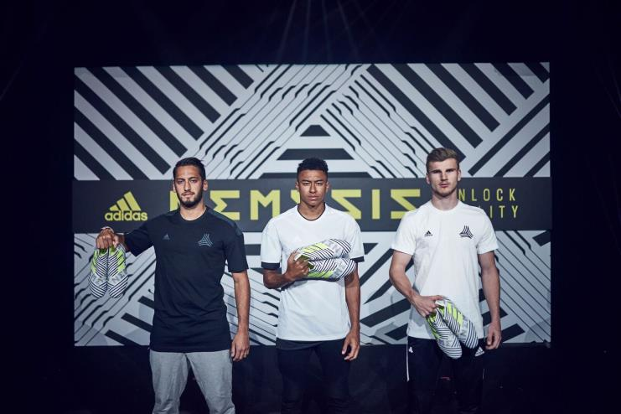

LONDON, June 1st, 2017 – adidas Soccer today celebrated its latest footwear innovation, NEMEZIZ, with an event attended by some of the game’s top talent.

NEMEZIZ players Jesse Lingard, Timo Werner and Hakan Calhanoglu took to the stage to reveal the latest boot from adidas Soccer before attendees were treated to a glimpse of the UEFA Europa League trophy.

The latest boot drop is designed to deliver security, support and adaptability – three key things for the game’s most agile players. The unique AGILITYBANDAGE features revolutionary TORSIONTAPES technology to keep the foot locked down and deliver ultimate fit, while a dual-lock collar secures the ankle in place to enable explosive change of direction.

Nemeziz is now available on adidas.com. For more information visit http://www.adidas.com/us/soccer and join the conversation on Twitter​ and Instagram​ with #HereToCreate.

- END -

For further media information please visit http://news.adidas.com/US/home/SOCCER or contact:

Cristina Maillo Belda
PR Manager, adidas Soccer
Email: Cristina.maillobelda@external.adidas.com
Tel: 503.915.9129

About adidas Soccer
adidas is the global leader in soccer. It is the official sponsor / official supplier partner of the most important soccer tournaments in the world, such as the FIFA World Cup™, the FIFA Confederations Cup, the UEFA Champions League, the UEFA Europa League, the UEFA European Championships and Major League Soccer. adidas also sponsors some of the world’s top clubs including Manchester United, Real Madrid, FC Bayern Munich, Juventus, Chelsea and AC Milan. Some of the world’s best players also on the adidas roster are Leo Messi, Paul Pogba, Gareth Bale, Karim Benzema, Roberto Firmino, Thomas Müller, Luis Suárez, James Rodríguez, Diego Costa, Mesut Özil, Renato Sanches and Julian Draxler.

