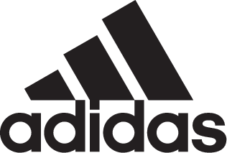

Adidas Soccer Launches Dust Storm, the Latest Colorway for the ACE 17+ PURECONTROL and X17

- Dust Storm X17 and ACE 17+ PURECONTROL to debut in the UEFA Champions League Final –
- Stadium, Cage and Street versions of ACE 17+ PURECONTROL available from May 31st –
- X17 available in Stadium and Cage -
- Latest colorway also available in adidas’ new franchise, NEMEZIZ -

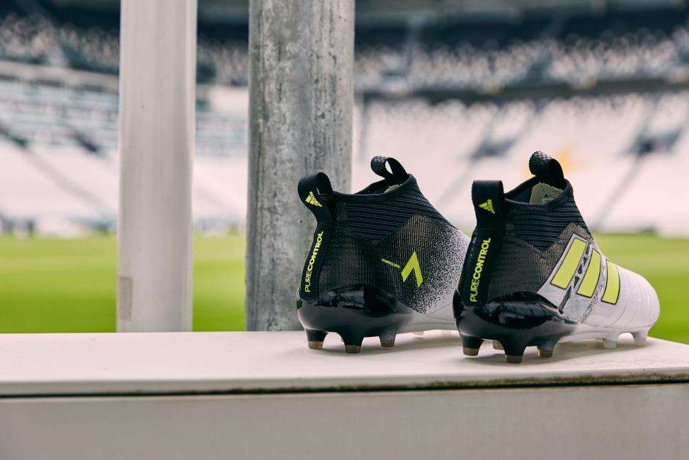

Portland, Ore., May 31st, 2017 – adidas Soccer launched today the Dust Storm collection, featuring on-field, cage and street adaptions of the ACE 17+ PURECONTROL and on-field and cage versions of the X17. The stadium cleats will be worn on-field for the first time in Saturday’s UEFA Champions League Final in Cardiff.

The Dust Storm ACE 17+ PURECONTROL features a PURECUT Sock System - designed to lock the foot in place while adjusting to complex movements and a 360 degree fully PRIMEKNIT upper to ensure zero wear-in time. The two-tone colorway features a white upper, black heel counter and Sock System with classic three stripes in yellow. The cleat also features the iconic adidas BOOST sole to deliver unrivalled energy return with every step.

The Dust Storm ACE 17+ PURECONTROL Cage version features the same two-tone black and white colorway as the on-field boot. It includes a PRIMEKNIT upper with a layer of NSG film to provide close ball control and a stretchable layer of TECHFIT material to optimize comfort.

The ACE 17+ Street shoe completes the Dust Storm collection. The predominantly grey color is constructed with a three-piece PRIMEMESH material for a lifestyle-focused look. A TECHFIT color coating covers the three stripes while a full-length BOOST midsole enhances the lifestyle look.

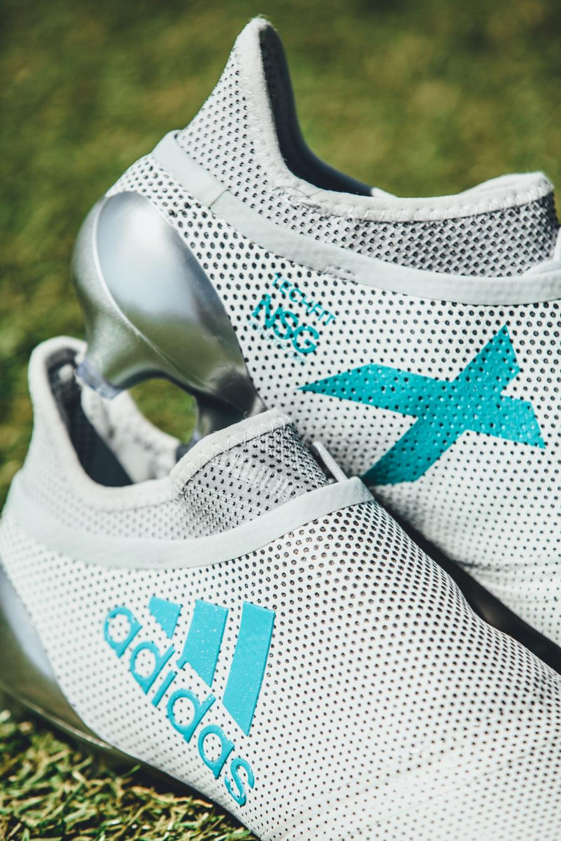

The new Dust Storm X17 features a striking light grey and turquoise colorway. The boot has a NON STOP GRIP (NSG) finish to optimize ball control. Built for speed, the X17 features a PURECUT SOCK SYSTEM, hiding laces underneath an upper layer and a SPRINTFRAME outsole to create stability during high-speed changes of direction. The Dust Storm X17 is also available in a cage version, in the same light grey and turquoise colorway as the stadium boot.

The Dust Storm collection is available from today on adidas.com and adidas retail stores.

For more information visit http://www.adidas.com/us/soccer and join the conversation on Twitter​ and Instagram​ with #HereToCreate.

- END -

For further media information please visit http://news.adidas.com/US/home/SOCCER or contact:

Cristina Maillo Belda
PR Manager, adidas Soccer
Email: Cristina.maillobelda@external.adidas.com
Tel: 503.915.9129

About adidas Soccer
adidas is the global leader in soccer. It is the official sponsor / official supplier partner of the most important soccer tournaments in the world, such as the FIFA World Cup™, the FIFA Confederations Cup, the UEFA Champions League, the UEFA Europa League, the UEFA European Championships and Major League Soccer. adidas also sponsors some of the world’s top clubs including Manchester United, Real Madrid, FC Bayern Munich, Juventus, Chelsea and AC Milan. Some of the world’s best players also on the adidas roster are Leo Messi, Paul Pogba, Gareth Bale, Karim Benzema, Roberto Firmino, Thomas Müller, Luis Suárez, James Rodríguez, Diego Costa, Mesut Özil, Renato Sanches and Julian Draxler.

