adidas Soccer Reveals New AC Milan 2017/18 Home Kit

- Jersey features a simple, elegant design inspired by two iconic periods in the club’s history -
- Jersey will be worn for the first time in AC Milan’s final home game of the 2016/17 season -

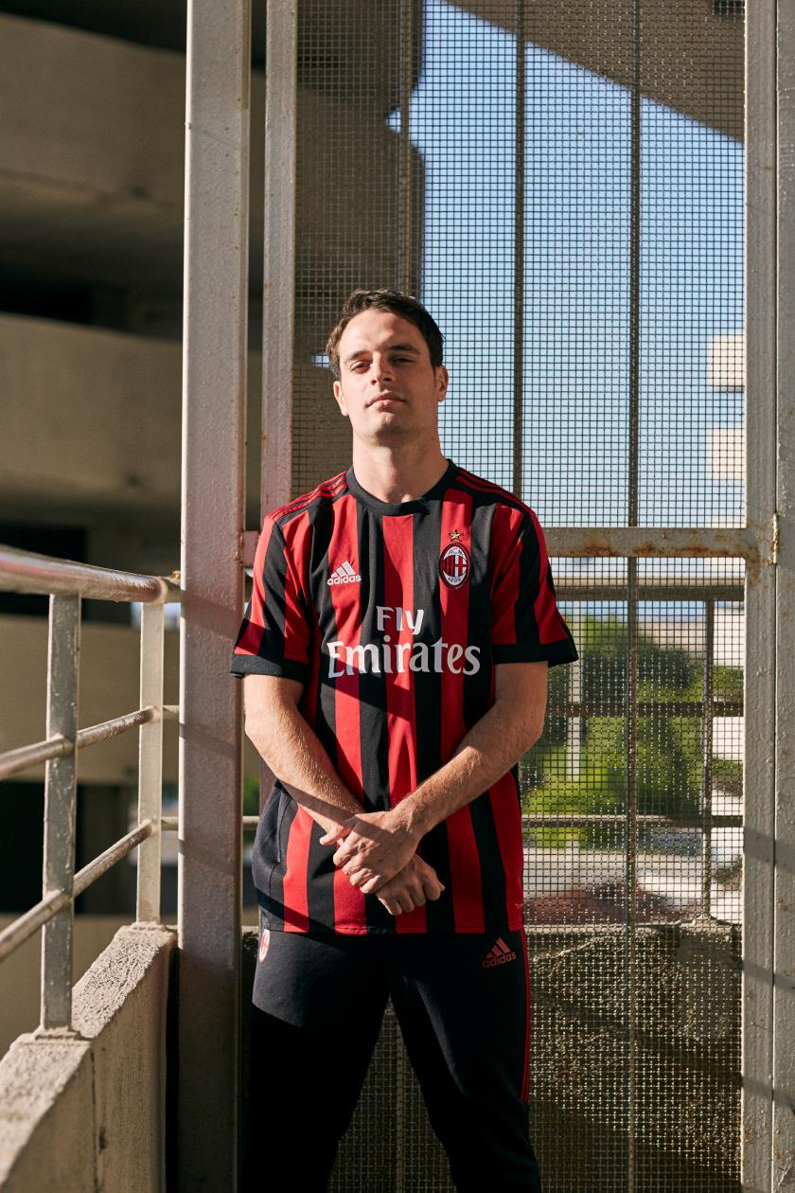

Portland, Ore., May 19th, 2017 – adidas Soccer today revealed the new AC Milan home kit for the 2017/18 season. The simple and elegant design invokes the club’s iconic heritage, taking inspiration from two dominant periods in the club’s history.

The first source of inspiration was the 10-year period from 1950-1960. This was the decade in which the club reaffirmed its superiority in the Italian Championship by winning four titles. Taken from the kit design used throughout the 1950s are features such as the crew neck and the red stripe that runs down the middle of the jersey.

The width of the famous black and red stripes was inspired by the period between 1987/88–1997/98 where the club established itself as a dominant European power and grew its global fan base. This decade saw the club claim 17 out of the 29 trophies it has won in total throughout the club’s history.

The inspiration for the design is further enhanced by choice of font for names and numbers on the back of the shirt, which is similar to what was worn by the great champions of those years.

This golden era of modern dominance coincided with the club re-establishing its relationship with adidas and was used as the second source of inspiration for the bold and classic design of the 2017/18 jersey.

The kit is completed by white shorts and white socks with red stripes. The jersey will be worn for the first time in AC Milan’s final home game of the season against Bologna on the May 21st. An alternative option with black socks and black shorts with red stripes is also available.

The jersey is available from today on adidas.com and on store.acmilan.com.

For more information visit http://www.adidas.com/us/soccer and join the conversation on Twitter​ and Instagram​ with #HereToCreate.

- END -

For further media information please visit http://news.adidas.com/US/home/SOCCER or contact:

Cristina Maillo Belda
PR Manager, adidas Soccer
Email: Cristina.maillobelda@external.adidas.com
Tel: 503.915.9129

About adidas Soccer
adidas is the global leader in soccer. It is the official sponsor / official supplier partner of the most important soccer tournaments in the world, such as the FIFA World Cup™, the FIFA Confederations Cup, the UEFA Champions League, the UEFA Europa League, the UEFA European Championships and Major League Soccer. adidas also sponsors some of the world’s top clubs including Manchester United, Real Madrid, FC Bayern Munich, Juventus, Chelsea and AC Milan. Some of the world’s best players also on the adidas roster are Leo Messi, Paul Pogba, Gareth Bale, Thomas Müller, Luis Suárez, James Rodríguez, Diego Costa and Mesut Özil.

