adidas Athletics Reveals the Z.N.E Travel Hoodie
The 2nd instalment of the hugely successful Z.N.E Hoodie Franchise which launched adidas ATHLETICS in September 2016
- The Z.N.E Travel Hoodie that launches April 2017 celebrates hectic athlete schedules, affording them the best in comfort, functionality and style as they travel to competitions around the globe
- World Class local track athlete Wayde van Niekerk joins other Local and Global assets in bringing you insights into athlete travel.

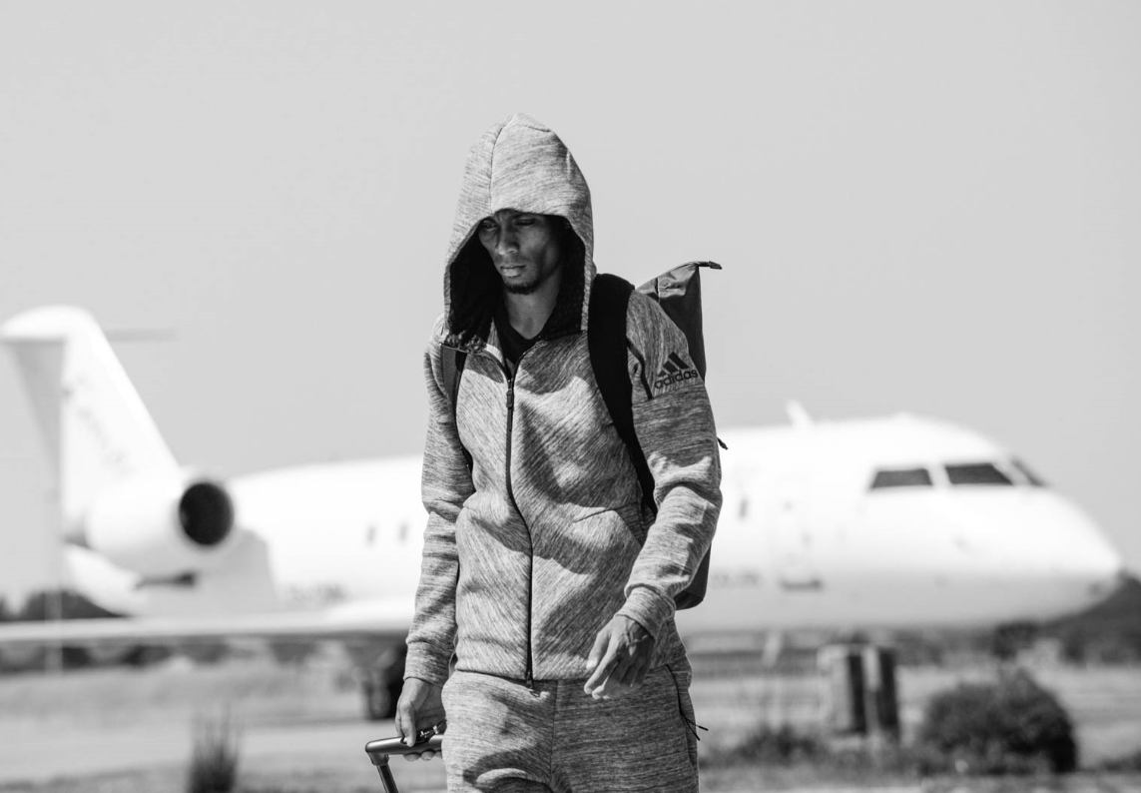

Cape Town, 19 April 2017– adidas Athletics today revealed its latest offering – the Z.N.E. Travel hoodie – designed to ensure complete focus and help athletes all over the world remove distractions and maximise their preparation as they travel to and between competing.

For any athlete, from the very top of sport to the amateur game, travel is a part of competition. Whether across town, a country or the world, the journey to competition is a critical part of pre-event preparation. Maintaining focus in these crucial hours is a genuine challenge for athletes, and that’s why adidas Athletics has today revealed the Z.N.E. Travel hoodie.

Since its launch in September, over 18,000 athletes worldwide have been equipped with the first edition of the Z.N.E hoodie. The hugely successful product has now evolved into the Travel version, with new features added to the innovative design to make it an essential item for any athlete travelling to compete.

The Z.N.E Travel hoodie features an oversized ‘sleeping hood’ to block out noise and allow for sleep and relaxation when travelling. Built into the premium, heavyweight cotton/polyester/elastane blend are a series of easy-access hidden pockets constructed to keep key travel items close at hand. The game-changing comfort of the original Z.N.E has been reengineered in softer fabric especially designed for the athlete on the road.

The innovative product will go straight into the kit bag of some of the world’s leading athletes. Stars including Siya Kolisi and Cheslyn Kolbe (who join van Niekerk and Simbine) will be equipped with the Z.N.E Travel hoodie as they travel the world on their individual journeys to be the best in their chosen sports.

The athletes will provide insights through a social media activation calling consumers to engage with the intent of winning a one-on-one shopping experience with these assets and style gurus who will be styled and shot and livestreamed paparazzi style alongside these icons within an adidas concept store educating consumers on the athleisure offering within adidas performance stores.

Brett Burgess, adidas Senior Manager for Training said, “adidas’ core mission is to provide the very best for the athlete. With the inception of adidas Athletics we have focused on making conditions perfect for athletes in their crucial pre and post game preparation.

A huge part of this is travelling to compete, it’s crucial that athletes are able to get into the zone and focus on the competition ahead or reflect on their performance when they travel and we’ve worked with athletes to design a range that meet these needs.”

The adidas Z.N.E Travel hoodie and Z.N.E Travel collection will be available online and in stores from 19 April 2017. These will see athletes and influencers bringing to life their own Travel stories.

The adidas Z.N.E Travel Hoodie is available at Total Sports, adidas retail stores and adidas ecom at R2599. To learn more, visit www.adidas.co.za Follow @adidasZA on Twitter and Instagram and use the hashtag #findfocus to join the conversation.
- ENDS -
For further media information please contact:
adidas South Africa
Tebogo Kgosi
PR manager
Email: Tebogo.Kgosi@adidas.com
Tel: 011 798 6900

By Design Communications
Peter Mokoko
Consultant
Email: p.mokoko@bdcomms.co.za
Tel: 071 537 8886

About adidas athletics
adidas athletics mission is to reinvigorate and revolutionise the badge of sport as an object of desire. It recognises the need for athletic expression off the field of play, whatever the field of play. Bridging the gap between athletes’ style and their life of sport, it champions a unique and fresh point of view, celebrating and highlighting the untold stories of innovation that get under the skin of sport.

