Predator Mania Returns in Limited Edition with the adidas champagne pack

– The classic colorway famously worn by David Beckham has been reborn –
– Latest limited edition colorway available in ACE 17+, X 16+, Predator Mania, Copa and UltraBOOST models –
– Imagery of Beckham with bright red tongue pays homage to late 90’s Predator Mania ads –

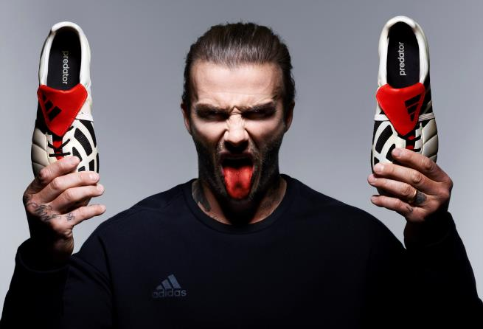

Portland, Ore., May 2nd, 2017 – adidas Soccer revealed today the latest products from the limited collection built on one of its most iconic colorways. The new adidas champagne pack pays homage to the infamous cream and red colorway associated with one of soccer’s most esteemed boots, the Predator Mania. The pack features the very latest technical innovations, making it the perfect coming together of the old and the new.

To celebrate the re-release of the Mania, adidas Soccer has teamed up with David Beckham to produce an array of striking imagery which pays homage to the Predator adverts from the late 1990’s. The portrait shots of Beckham focus on the Mania’s most identifiable feature– its iconic red tongue.

The adidas champagne pack includes the ACE 17+ PURECONTROL, designed with a red PURECUT Sock System – to lock the foot in place while adjusting to complex movements – and cream 360 degree fully PRIMEKNIT upper to ensure zero wear-in time. The boot also features an adidas BOOST sole to deliver unrivalled energy return with every step.

The X16+ PURECHAOS features a PURECUT SOCK SYSTEM, covering the laces to deliver ultimate fit. A NON STOP GRIP (NSG) finish allows for unrivalled ball control, while a SPRINTFRAME outsole is engineered to create stability during high-speed movements.

Sam Handy, Vice President of Design, adidas Soccer, said: “The champagne colorway was one of adidas Soccer’s most iconic for our most iconic boot, the adidas Predator Mania. With the new adidas champagne pack, we’ve been able to fuse a classic colorway with our modern on-pitch and off-pitch innovations, giving it the modern twist that we know soccer lovers want.”

The Predator Mania features a cream-colored upper and stitched-in Predator technology. As well as the distinctive asymmetrical lacing, the Mania features welded Predator rubber pads on top of the vamp to offer increased power and accuracy and a modernized outsole, featuring a Sprintframe construction to provide lightweight support and balance.

The ACE 16+ PURECONTROL UltraBOOST also features in the new adidas champagne pack. It brings together the Primeknit upper from adidas football and the industry leading BOOST technology used in adidas Running products in order to meet players’ off-field needs.

The final product in the adidas champagne pack is the Copa, continuing adidas’ celebration of 35 years of the famous boot. Like the original Copa, the upper is made of K-Leather, delivering a premium and sleek aesthetic.

The adidas champagne pack will be available tomorrow in the U.S. on adidas.com and at select retailers nationwide.

For more information visit http://www.adidas.com/us/soccer and join the conversation on Twitter​ and Instagram​ with #NeverFollow​.

- END -

For further media information please visit http://news.adidas.com/US/home/SOCCER or contact:

Cristina Maillo Belda
PR Manager, adidas Soccer
Email: Cristina.maillobelda@external.adidas.com
Tel: 503.915.9129

About adidas Soccer
adidas is the global leader in soccer. It is the official sponsor / official supplier partner of the most important soccer tournaments in the world, such as the FIFA World Cup™, the FIFA Confederations Cup, the UEFA Champions League, the UEFA Europa League and the UEFA European Championships. adidas also sponsors some of the world’s top clubs including Manchester United, Real Madrid, FC Bayern Munich, Juventus, Chelsea and AC Milan. Some of the world’s best players also on the adidas roster are Leo Messi, Paul Pogba, Gareth Bale, Thomas Müller, Luis Suárez, James Rodríguez, Diego Costa and Mesut Özil.

