adidas unveils new 2017 Roland Garros line

- Statement colour blocking offers a modern twist on traditional tennis looks -
- Collection inspired by Stade Roland Garros -
- Barricade franchise gets new colourways for tournament -

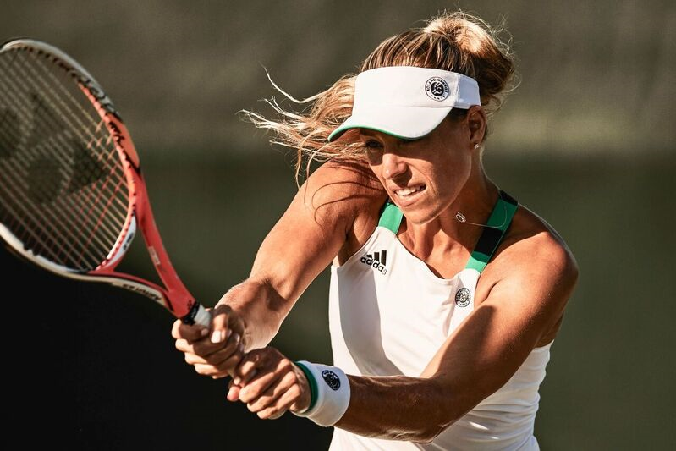

Herzogenaurach, Germany 31 March 2017: adidas Tennis today unveiled the Roland Garros line up to be worn by the best in the game. Players including Angelique Kerber, Kristina Mladenovic, Jo-Wilfried Tsonga, Dominic Thiem and Sascha Zverev will debut the brand new performance wear on the famous clay courts of Roland Garros this summer.

The Roland Garros line takes inspiration from the bold colours that set the scene of the Parisian Grand Slam tournament. Statement colour blocking in green, white and grey is accentuated with bold emblems –providing a contemporary finish to the classic tennis look.

The collection is built to keep athletes comfortable in a multitude of conditions, with a combination of Clima technologies and mesh detail offering ventilation and quick evaporation of sweat.

The men’s collection includes a polo, which will be worn by Thomas Berdych and Jo-Wilfried Tsonga, and tee, to be worn by Dominic Thiem and Sascha Zverev - both with a unique contrast colour band along the hemline.

Worn by Jo-Wilfred Tsonga, the Barricade 2017 BOOST flagship footwear features the integration of BOOST technology for ultimate energy return. The Roland Garros version comes in black/white/green – providing a strong visual colour base for Jo-Wilfried Tsonga’s dynamic play.

The Barricade 2017 Roland Garros footwear is built for the power player and will be worn by Dominic Thiem. Providing the upmost stability on the court, the Barricade 2017 continues to optimise cushioning and rebound through the foot whilst playing. Available in white/grey/orange.

The women’s collection includes the Roland Garros line dress, featuring bi-tonal colour pleating along the hem for a modern twist on classic feminine pleats. The dress will be worn by Kristina Mladenovic and is available in two colourways (green/white and grey/white). Angelique Kerber will debut the tank and skort, which also includes bi-tonal pleats in green/white. Both will wear the adizero ubersonic 2 women’s footwear which comes in green/white/orange.

Lotta Jurica Design Director adidas Tennis explains: “For this collection we wanted to encompass the colours and style of Roland Garros within the design, which is why we’ve focused on colour blocking in the traditional green associated with the tournament as well as classic tennis silhouettes. The inclusion of Clima technologies means that athletes can be confident they will be comfortable on the court, which is crucial in the unpredictable conditions of Roland Garros.”

The 2017 adidas Roland Garros line will be available on the 15th of April online at http://www.adidas.com/tennis.

ENDS

For further media information please contact:
Lindsey Rossell
lindsey.rossell@hkstrategies.com
+44 (0) 207 413 3163

Notes to editors:

About adidas Tennis
adidas Tennis is represented by top players such as Simona Halep, Angelique Kerber, Garbiñe Muguruza, Kristina Mladenovic, Caroline Wozniacki, Tomas Berdych, Lucas Pouille, Dominic Thiem, Jo-Wilfried Tsonga, Sascha Zverev and Novak Djokovic (Footwear Only). For more information on adidas Tennis, please visit www.adidas.com/tennis. For additional images please visit our media news room on news.adidas.com and follow us on Twitter or on Instagram under @adidasTennis.

About adidas
The adidas Group is a global leader in the sporting goods industry, offering a broad portfolio of footwear, apparel and hardware for sport and lifestyle around the core brands adidas, Reebok, TaylorMade and CCM Hockey. Headquartered in Herzogenaurach, Germany, the Group employs more than 55,000 people across the globe and generated sales of around € 17 billion in 2015.

