EMBARGOED UNTIL 31TH March 10AM CET
Please see high res images for:
X16+ Purechaos here;
MESSI 16+ Pureagility here;
and COPA 17.1 here

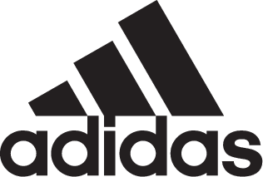

adidas Soccer launches complete Turbocharge collection

- Turbocharge X16+ Purechaos, MESSI 16+ Pureagility and COPA 17.1 all included in today’s launch -
- Turbocharge X16+ Purechaos offers in stadium, cage and street silos in green colorway -
- Gold and black colors featured in the Turbocharge MESSI 16+ Pureagility –
- Turbocharge COPA 17.1 completes collection with a black and gold colorway -

Portland, Ore. March 31st, 2017 – adidas Soccer completes today its Turbocharge collection with the unveiling of the X16+ Purechaos, the MESSI 16+ Pureagility and the COPA 17.1.

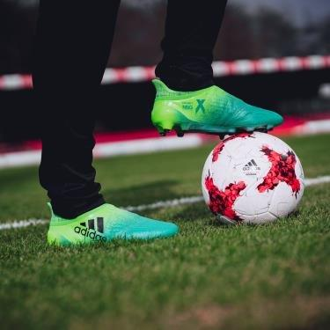

The Turbocharge X16+ Purechaos features:
- Striking two-tone green colorway
- NON STOP GRIP (NSG) finish, giving players unrivalled levels of control
- PURECUT SOCK SYSTEM, which sees laces hidden under an upper layer
- SPRINTFRAME outsole to create stability during high-speed changes of direction

The Turbocharge X16+ Purechaos will be available in the following models:
- Stadium: details as outlined above
- Cage: details as per stadium cleat, but with gum finish used on the outsole
- Street: industry-leading BOOST technology in a predominantly grey colorway

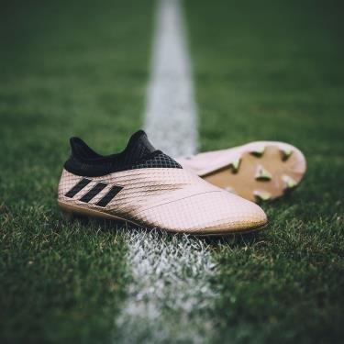

The Turbocharge MESSI 16+ Pureagility offers:
- A gold upper, black PURECUT SOCK SYSTEM and green studs
- A SPRINTFRAME outsole delivering stability when changing direction at high-speed
- AGILITYKNIT used on the boot to ensure zero wear-in time is required

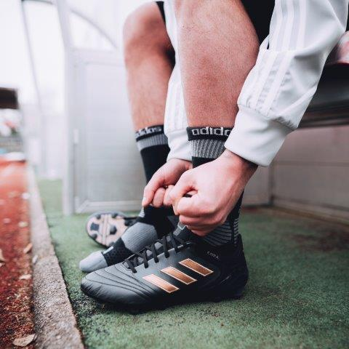

The Turbocharge COPA 17.1 features:
- Black premium K-LEATHER UPPER for unrivalled ball touch and optimal comfort
- A geometrical SPRINTFRAME construction and a stud configuration that deliver stability
- A COMPRESSION TONGUE for improved fit

The complete Turbocharge collection is available now in the U.S. on adidas.com and at select retailers nationwide.

For more information visit http://www.adidas.com/us/soccer and join the conversation on Twitter​ and Instagram​ with #NeverFollow​.

- END -

For further media information please visit http://news.adidas.com/US/home/SOCCER or contact:

Cristina Maillo Belda
PR Manager, adidas Soccer
Email: Cristina.maillobelda@external.adidas.com
Tel: 503.915.9129

About adidas Soccer
adidas is the global leader in soccer. It is the official sponsor / official supplier partner of the most important soccer tournaments in the world, such as the FIFA World Cup™, the FIFA Confederations Cup, the UEFA Champions League, the UEFA Europa League and the UEFA European Championships. adidas also sponsors some of the world’s top clubs including Manchester United, Real Madrid, FC Bayern Munich, Juventus, Chelsea and AC Milan. Some of the world’s best players also on the adidas roster are Leo Messi, Paul Pogba, Gareth Bale, Thomas Müller, Luis Suárez, James Rodríguez, Diego Costa and Mesut Özil.

