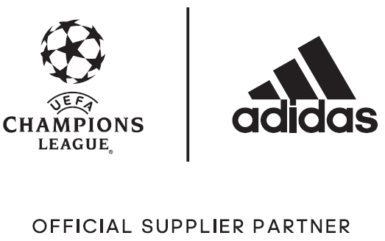

adidas Unveils Welsh Dragon-Inspired Official Match Ball for the UEFA Champions League Knock Out Stages and Final

– Ball design is inspired by famous national symbol of Wales –
– Ball will be used during the knock-out phases and final in Cardiff –
– Design from the ball also features in new limited collection adidas Dragon Pack boot range –

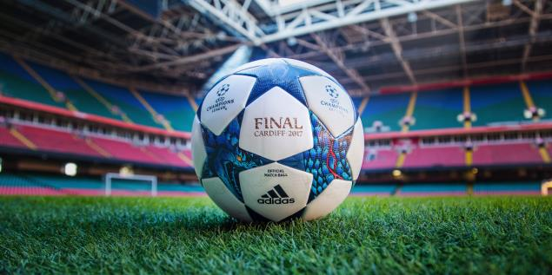

Herzogenaurach, 13th February – With the UEFA Champions League returning for its crucial final stages, adidas today unveiled the Official Match Ball that will be used as Europe’s best teams compete for the trophy.

Celebrating the nation of Wales, which will host this year’s final, the ball’s unique design features a striking dragon print – inspired by the national emblem, which famously features prominently on the Welsh flag.

The adidas team, who travelled to Cardiff as part of the design process, drew inspiration from the power and strength the dragon represents in Celtic mythology – with the dragon print designed to represent the ferocity with which the final stages are played.

The ball also delivers the performance benefits required to match the standard of the players set to light up the latter stages of the competition – the likes of Messi, Bale, Suarez and Müller. Its outer coating texture is consistent with all the adidas UEFA Champions League Official Match Balls and provides optimal grip, while the thermally-bonded star panel design provides a seamless surface for improved first touch.

The adidas Final Cardiff 2017 ball will be used on field during UEFA Champions League matches from 14th February up until and including the final on 3rd June.

The dragon design has also inspired a new Limited Collection boot range known as Dragon Pack. The latest boot drop features the same design elements, combined with the usual technical innovations. The Dragon Pack features both the X and ACE ranges, which are adapted for on-pitch and cage silos.

The X16 features the dragon design imagined in a striking white colourway. A coating of NON STOP GRIP (NSG) film gives players unrivalled levels of control, with a SPRINTFRAME outsole offering stability during high-speed changes of direction. A PURECUT SOCK SYSTEM sees laces hidden under an upper layer for a pure first touch.

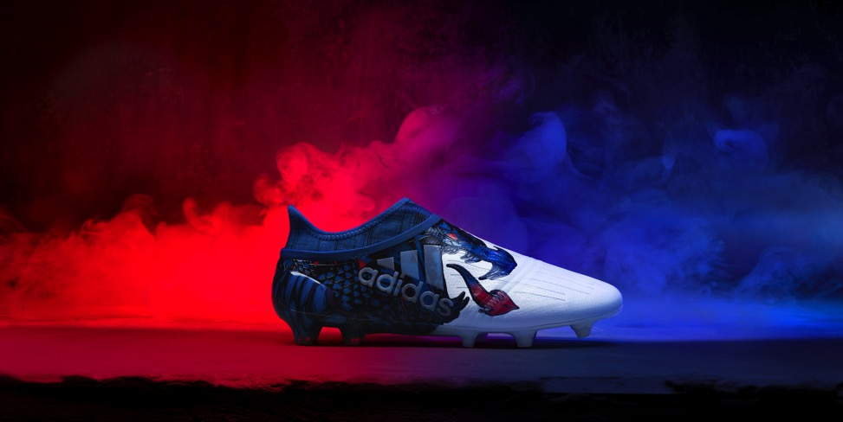

The X16 cage version, which includes the same NSG, SPRINT FRAME and PURECUT SOCK SYSTEM as the stadium version, features a gum finish on the outside to provide extra protection on the most challenging of surfaces.

The Dragon Pack ACE17+ PURECONTROL comes in a black colourway. Designed for flexibility and control, a 360 degree fully PRIMEKNIT upper ensures zero wear-in time and is protected by an ultra-thin NON STOP GRIP (NSG) film to provide increased levels of grip. adidas’ industry-defining BOOST technology also features, delivering an unrivalled energy return.

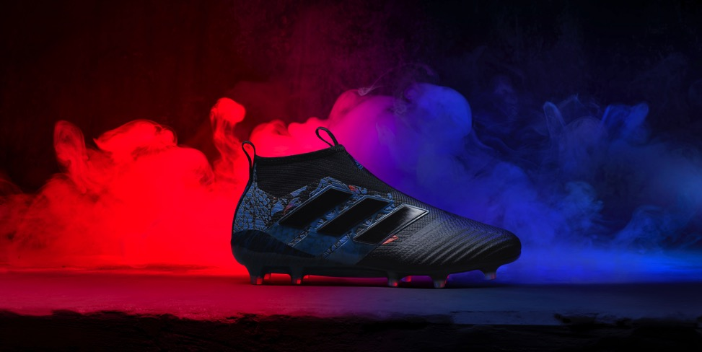

The collection also includes the ACE 17+ PURECONTROL cage version, featuring a PRIMEKNIT upper with a layer of NSG film to provide close ball control. A stretchable layer of TECHFIT material optimises comfort, whilst a black EVA strip features above the heel’s BOOST to offer stability.

For further information please visit adidas.com/football or go to facebook.com/adidasfootball or follow @adidasfootball on twitter to join the conversation.

- END -

For further media information please visit http://news.adidas.com/GLOBAL/home/FOOTBALL or contact:

Simon Bristow
Global PR Director
Email: simon.bristow@adidas.com
Tel. +49 160 485 1388

Max McLaren
Global Football PR Manager
Email: max.mclaren@adidas.com
Tel: +49 9132 84 73915

Notes to Editors:

About adidas Football:
adidas is the global leader in football. It is the official sponsor / official supplier partner of the most important football tournaments in the world, such as the FIFA World Cup™, the FIFA Confederations Cup, the UEFA Champions League, the UEFA Europa League and the UEFA European Championships. adidas also sponsors some of the world’s top clubs including Real Madrid, FC Bayern Munich, AC Milan, Flamengo and Chelsea. Some of the world’s best players also on the adidas roster are Leo Messi, Gareth Bale, Thomas Müller, Arjen Robben, James Rodriguez, Karim Benzema and Bastian Schweinsteiger.

