https://photos-1.dropbox.com/t/2/AADGtoUtA_QvFHsthMg1nAUj7Gx6DY3dy7WoRx4x3iSgBg/12/576581935/png/32x32/1/_/1/2/badge_of_sport_logo_bwp_v1.png/ELrfltEEGPtTIAIoAg/oEYgsAvzae2jTMdzyQbUwZpyldBTOwuTrtv24NG0m8c?size=800x600&size_mode=3

**adidas Soccer releases new Blue Blast ACE 16+ UltraBOOST**

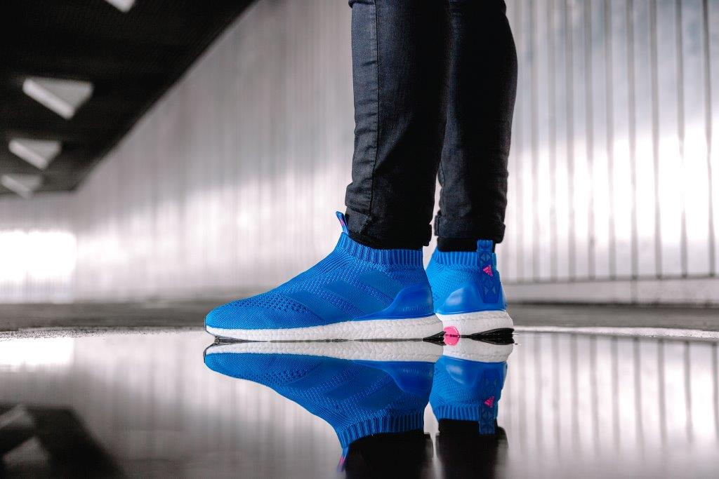

**Portland, Ore., January 31, 2017** - adidas Soccer launches today the Blue Blast ACE 16+ UltraBOOST, merging the best from adidas Soccer and adidas Running. The limited edition release is part of the wider Blue Blast Collection which includes the ACE 17+ PURECONTROL and X16 on-pitch, cage and street silos, as well as the MESSI 16, and will be available for purchase in limited quantities by invitation at the adidas Brand Flagship New York store in Fifth Avenue.

For further information please visit **adidas.com/us/soccer** or go to **facebook.com/adidassoccer** or follow **@adidassoccer** on twitter to join the conversation.

**- END -**

**For further media information please visit** [**http://news.adidas.com/US/home/SOCCER**](http://news.adidas.com/US/home/SOCCER) **or contact:**

|  |  |
| --- | --- |
| Cristina Maillo Belda  PR Manager, adidas Soccer  Email: [Cristina.maillobelda@external.adidas.com](mailto:Cristina.maillobelda@external.adidas.com)  Tel: 503. 915.9129 |  |

**About adidas Soccer**

adidas is the global leader in soccer. It is the official sponsor / official supplier partner of the most important soccer tournaments in the world, such as the FIFA World Cup™, the FIFA Confederations Cup, the UEFA Champions League, the UEFA Europa League, the UEFA European Championships and Major League Soccer. adidas also sponsors some of the world’s top clubs including Manchester United, Real Madrid, FC Bayern Munich, Juventus, Chelsea and AC Milan. Some of the world’s best players also on the adidas roster are Leo Messi, Paul Pogba, Gareth Bale, Thomas Müller, Luis Suárez, James Rodríguez, Diego Costa and Mesut Özil.